

SIP-Telephony Service Interface

Overview

SIP-TSI Overview Version 1.0
March 24, 2000

Gregory D. Girard Scott Hoffpauir
Chief Technology Officer Vice President of Engineering
Iperia, Inc. Broadsoft, Inc.

SIP-Telephony Service Interface Overview

(SIP-TSI Overview Version 1.0)

Abstract
A method is described to enable voice and facsimile telephony applications running on an application server to communicate with a softswitch through a data network, according to a fully-specified Telephony Service Interface (TSI). Based upon IETF RFC 2543 on “Session Initiation Protocol”¹ (SIP), this SIP-Telephony Service Interface (SIP-TSI) is capable of supporting a level of telephony application functionality commensurate with Time Division Multiplex device interfaces used in legacy PSTN voice and facsimile telephony applications. Through the SIP-TSI, a telephony application running on an application server may remotely invoke telephony operations by employing the softswitch as a proxy to both call control and DSP functionality provided by the media gateways (MG) under its control. A typical softswitch controls one or more MGs. Each MG provides network switching fabric and digital signal processing (DSP) functionality accessible to the softswitch. An application running on an application server sends messages to the softswitch requesting activation of a DSP operation for a specified media stream. According to a one of several control protocols (e.g. Media Gateway Control Protocol, IPDC, H.248), the softswitch subsequently instructs the appropriate MG associated with that media stream to activate the indicated DSP algorithm. A MG fully compliant with SIP-TSI supports four types of DSP operations: (i) facsimile transmit, (ii) facsimile receive, (iii) tone and voice signal transformation, and (iv) tone and voice signal detection. Upon completing a DSP operation or upon detecting some monitored network-related event, the MG transmits an indication to the softswitch, which the softswitch then transmits back to the requesting application. Communication between an application running on an application server and the softswitch relies upon message passing to achieve a simple and extensible “pure data” TSI. TSI message passing proceeds through an IP data network, in accordance with SIP. Utilizing the SIP “INFO Method,” adjunct mid-session control messages are passed between a SIP User Agent in an application server and a SIP User Agent in the softswitch utilizing the SIP signaling pathway established for initial call setup. The same or similar IP data network is used to transport voice or facsimile bearer channel content directly between the application server’s bearer channel interface and the appropriate MG. Summarily, a SIP-TSI is established in which both media and signaling/control pathways pass through a data network utilizing the softswitch as a virtualized connectivity resource capable of simultaneously managing call control, media transmission and digital signal processing operations.

1.0 Background
To assist in understanding the SIP-TSI method, it is helpful to first establish a reference Telephony Service Interface based upon a PSTN computer-telephone integration model. The Telephony Service Interface for the PSTN, hereafter referred to as the PSTN-TSI, is described in this section as a generalized exemplar of configurations commonly deployed today. It is the intent of this document to disclose a next generation of the legacy PSTN-TSI in the form of a SIP-TSI. This next generation SIP-TSI is intended for use in network architectures that are typically hybrids of PSTN and packet-voice technologies; packet-voice technologies transport voice over IP, ATM, and Frame Relay network segments. Next generation network architectures utilize a variety of alternative signaling technologies such as SIP. Thus, by applying the SIP Telephony Service Interface method (SIP-TSI), the legacy PSTN model is advanced to a model that does not require the use of Time Division Multiplex (TDM) and digital signal processing (DSP) hardware in an application server, but instead exploits the switching and digital signal processing capacity of MG devices that are integral to a data-centric telephony network architecture.

1.1 Reference PSTN Telephony Service Interface
In both the next generation network and the PSTN, an application server is the computing element in which the application logic executes. The term “application” is here used in the most general sense. It should be understood as referring to any intelligent entity that requires the ability to create, delete, modify, or monitor network connections as part of its task to render a service. As a result, the term “application” may refer to an entity that renders a calling card service, an 800 number translation network feature, a Centrex feature set, a voice mail service, a subscriber-oriented “find-me” service, or even something as basic as call-forwarding triggered upon the detection of a “ring-no-answer” condition. Basic applications such as dial tone service or call-forwarding are often described as network features; however in this discussion, no distinction is made between an application or feature, and services of either classification shall be referred to generically as “applications.” As a result, the scope of SIP-TSI utility extends to all intelligent network logic capable of rendering services of any type. In general, application logic in the application server makes requests to local or remote devices in order to create calls, answer calls, route calls or perform a range of digital signal processing telephony operations. In the PSTN, most application servers incorporate a telephony switching matrix under local software control while other application servers interact directly with a PSTN switch’s internal switching matrix utilizing an Intelligent Network (IN) interface. The SIP-TSI method replaces functionality achieved using either/both PSTN application server interfacing techniques. But with all PSTN interfaces (TDM or IN) telephony applications control a host switching matrix through a software interface, so as to manage calls terminating into that switching matrix. The typical PSTN telephony application answers incoming calls or originates its own calls, managing each call control operation. Intelligent Network interfaces are typically constrained to supporting only the simplest of call control application tasks; therefore, the PSTN reference model most comparable to the SIP-TSI is the more flexible configuration in which an application server physically incorporates its own TDM interface. The SIP-TSI is capable of supporting a level of telephony application functionality commensurate with state-of-the-art Time Division Multiplex device interfaces of this type used in legacy PSTN voice and facsimile telephony applications.

This TDM switching fabric (or “switching matrix”) is typically connected to the PSTN using T1/E1 or Primary Rate Interface (PRI). All of these interfacing technologies carry bearer channel content and some degree of signaling information. Typically SS7 or Simple Message Desk Interface may be utilized to establish the physical signaling pathway necessary to acquire Dialed Number Information Service packets for the purpose of identifying to whom the call was originally directed. Most TDM interfaces are equipped with some DSP capability. Various DSP algorithms are used to detect and measure DTMF tones or measure voice energy levels. Digital signal processors are typically available as an accessory hardware component for TDM products. A bearer channel in the TDM switching matrix may be routed through a DSP resource designed to recognize DTMF digit waveforms appearing in bearer channel content. When the DSP resource detects a specific DTMF digit, it generates an event that is propagated to a telephony application instance that may be listening for DTMF digits.

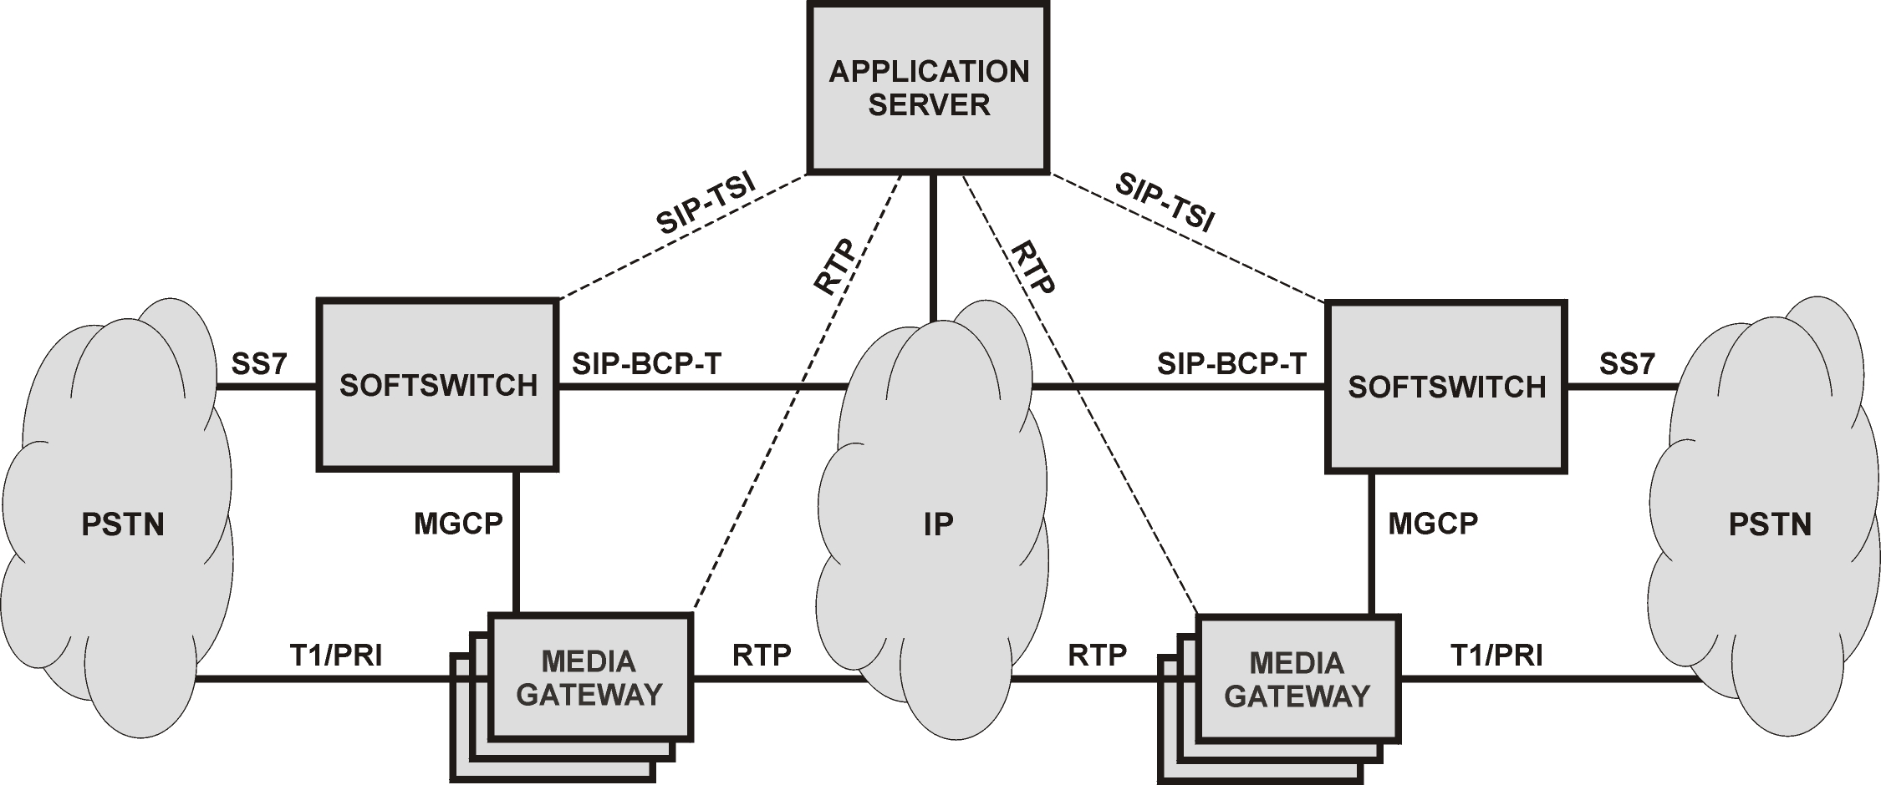

Figure 1
Application Server and SIP-TSI in the Next Generation Network Architecture

1.2 Transition to Data-Centric Model
Figure 1 depicts the basic architecture of a next generation voice-over-IP network and shows how a representative APPLICATION SERVER and SIP-TSI both fit into this new model. The representative MEDIA GATEWAY (MG) refers to a programmable telecommunications switch that contains interfaces to both PSTN and packet-based networks. Its purpose is to provide switching fabric capable of maintaining interconnections across multiple telephony connectivity domains, such as PSTN, voice-over-IP or voice-over-ATM. MGs usually maintain the ability to apply DSP algorithms to media pathways that they interconnect. As the primary switching element in next generation network architectures, a MG may be used in conjunction with PSTN switching technologies. It does not contain all of the logic necessary to route calls or invoke subscriber services. The representative SOFTSWITCH is a software program that contains the logic necessary to route calls, invoke services, and perform other interconnection operations in accordance with programmable policies stored in a database. The SOFTSWITCH utilizes one or more MGs to create the necessary network interconnections and employs signaling gateways to translate between its internal signaling format and the specific signaling formats used by connectivity domains it is configured to support. In this way, the next generation of networks isolates network call routing logic from switching infrastructure so that services residing in the signaling/control network plane (e.g. dial-tone, long-distance calling, voice mail) may be transparently deployed across a range of switching infrastructure technologies. By comparison, network logic and switching fabric are tightly coupled in the PSTN, often to the point where network services are effectively extensions to the switching infrastructure. As a result, PSTN services are not easily extensible to alternative switching technologies and the choice between PSTN switching infrastructure and PSTN basic services is often indecipherable.

RFC 2543 on Session Initiation Protocol¹ is a call control and signaling protocol that has the ability to interoperate seamlessly across multiple telephony connectivity domains. It is generally viewed as a highly suitable protocol for signaling between softswitches (for network interoperability) and for signaling between network terminals. It is also generally agreed that since telephony application servers share the same functional interface requirements as those defined for both softswitches and network terminals, SIP is an appropriate protocol choice for a next generation network interface to an application server. Even with many extensions^{2, 4, 5, 6, 8, 9}, SIP lacks functions required to support a telephony service interface in the next generation network that achieves a level of functionality comparable with the legacy PSTN-TSI. Architecturally, SIP resides exclusively in the signaling and control layer of the network and has little interaction with the underlying network switching layer, which is comprised primarily of MGs. Currently, SIP enables softswitches to exchange little more than the bare minimum of information required to setup media transmission pathways through MGs in the underlying switching layer.

The described SIP-TSI method builds upon the SIP model so as to incorporate essential telephony application functions that are available using a PSTN-TSI. It transitions the legacy PSTN-TSI to a data-centric model by exploiting the switching and digital signal processing capacity of MG devices. SIP-TSI incorporates alternative mechanisms for both media and signaling pathways. Instead of embedding a switching matrix in an application server and controlling it as a local resource, the SIP-TSI uses a softswitch as an intermediary to ultimately transmit messages to a MG. Those messages instruct the MG to perform operations directly analogous to those performed using local call control and DSP resources in the legacy PSTN model. A data-oriented bearer channel connection between an application server and a MG may be established for the purpose of playing voice prompts, transmitting facsimiles, or recording voice content as required by the application. There is no local switching fabric incorporated into the physical application server, thus connections are created, deleted, and interconnected through the switching matrix in the MG under the control of the softswitch, relying on existing network infrastructure resources.

2.0 SIP-Based Telephony Service Interface
This section describes details related the SIP-TSI method. The SIP-TSI presents an application server with the same feature set achievable by the state-of-the-art reference PSTN-TSI presented in section 1.1. Section 2.1 below describes the architecture required to support the SIP-TSI and the following section 2.2 outlines the detailed SIP-TSI functionality with respect to individual feature implementations. The functionality section includes a discussion of message-passing semantics.

2.1 SIP-TSI Architecture
Figure 2 presents a more focused architectural view of the SIP-TSI; relationships between the representative architectural elements of APPLICATION SERVER, SOFTSWITCH, and MEDIA GATEWAY are depicted in greater detail. The SOFTSWITCH functions as a proxy to voice and facsimile bearer channel switching resources embedded in MGs directly under its control. The MGs contain digital signal processors and the appropriate algorithms to perform the following transformations and detections on media pathways associated with a call: (i) transmit a facsimile to a PSTN network endpoint using a facsimile modem protocol; (ii) receive a facsimile transmitted from a PSTN endpoint using a facsimile modem protocol; (iii) detect and interpret tones on a voice pathway; (iv) generate tones on a voice pathway; (v) detect voice onset on a voice pathway; and (vi) detect voice offset on a voice pathway. In addition, the MGs are called to utilize specific codecs for media pathways and perhaps other functions such as those related to conference control. A partially compliant MG may not support every DSP function defined by SIP-TSI, in which case the APPLICATION SERVER must supplement MG DSP capabilities by installing local DSP devices.

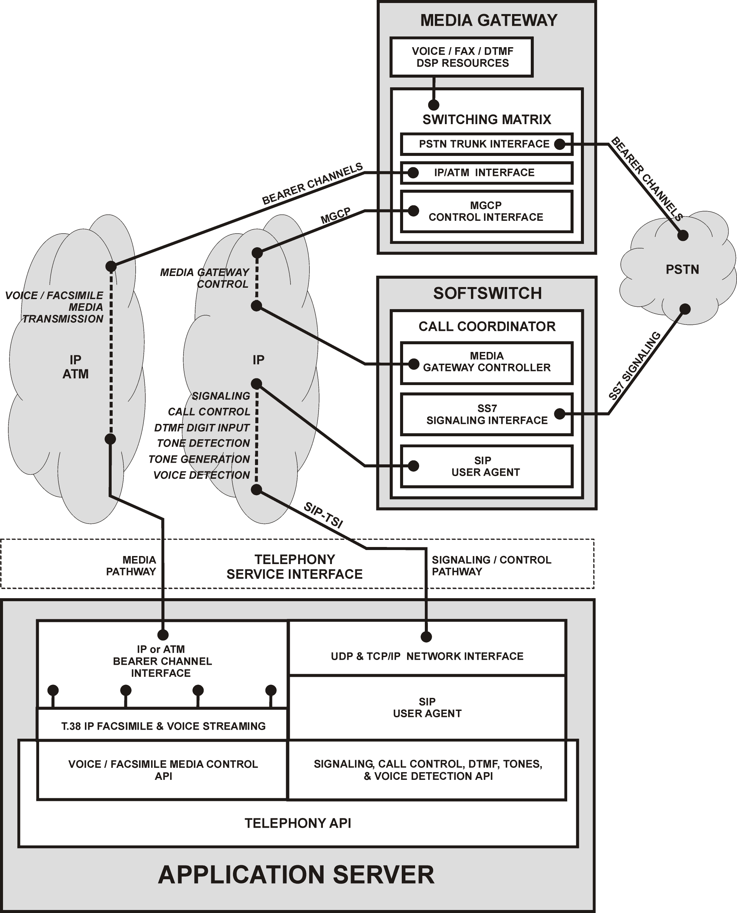
Figure 2
Architectural View of SIP-Telephony Service Interface to Softswitch

2.1.1 Call Control and Signaling Interactions with the Softswitch
Using a SIP User Agent Client (UAC), telephony applications running on the APPLICATION SERVER may create connections between any two network endpoints in any connectivity domain (IP, ATM, PSTN, etc.) that is addressable by the SOFTSWITCH and the MGs under its control. The APPLICATION SERVER also contains a SIP User Agent Server (UAS); thus it may respond to invitations from various network endpoints to join calls. In this way, the APPLICATION SERVER may register a range of network endpoints accessible to the SOFTSWITCH according to the SIP REGISTER Method, thereby making its service-enabled network endpoints known to the SOFTSWITCH. When the SOFTSWITCH determines that it should invoke an application (feature or service) running on the APPLICATION SERVER, it may INVITE an APPLICATION SERVER network endpoint into the call, essentially transferring control to it. A BYE operation by the APPLICATION SERVER releases the call from its control; the BYE from the APPLICATION SERVER is the same as if the APPLICATION SERVER “hung up” the call. The SOFTSWITCH can then decide if it needs to continue processing the call. As an example, a voice mail application may be executed on the APPLICATION SERVER whenever the SOFTSWITCH INVITEs a certain network endpoint registered by the APPLICATION SERVER for that purpose. To extend the example into a PSTN voice messaging model, one may apply the Internet Draft on SIP Best Current Practice for Telephony Interworking which serves to “encapsulate a variety of PSTN signaling types including but not limited to SS7, and Q.931.” ² In this way, the application running on the APPLICATION SERVER may determine the PSTN dialing number to which the call was originally addressed (DNIS) and therewith respond already in the knowledge of the number dialed by the original caller. In this way, SIP call control functionality is married with PSTN signaling to create seamlessly integrated teleservices and feature sets.

2.1.2 Integrated Bearer Channel Interface
In the SIP-TSI architecture, the APPLICATION SERVER contains a bearer channel interface so that it may function as a media server. A telephony application running on the APPLICATION SERVER may be INVITEd into a call as a user or INVITE itself into a call. The APPLICATION SERVER then becomes a network connection endpoint for the purpose of transmitting or receiving bearer channel content to or from another network endpoint. In communicating with a remote network endpoint, an application on the APPLICATION SERVER may collect DTMF digit sequences or analyze speech content on a voice pathway emanating from a specific user in a call. The application may “play” a voice prompt to the user. In response, the user may press digit keys or use spoken commands to invoke application features or alter the flow of application execution. In conjunction with voice-navigated user interfaces (using automatic speech recognition for spoken command input), the application may wish to enable a “barge-in” feature when it detects the user’s voice. Such a “barge-in” feature would allow the user to speak another command and change application behavior while the application was currently busy playing prompts or voice message content to the user as a result of a previous command.

2.1.2 Support for Facsimile Transmission
The ability to transmit and receive facsimiles is considered a basic functional requirement for telephony applications. Utilizing the SIP-TSI method, the application may transmit facsimiles to a remote network endpoint, or receive facsimiles from a remote endpoint, according to the Recommendation T.38 Procedures for Real-Time Group 3 Facsimile Communication Over IP Networks³. T.38 support is integrated into the APPLICATION SERVER such that its facsimile transmission functions are invoked transparently. Facsimile media stream content may be detected when a “T.38” codec selection is indicated in the Session Description Protocol record associated with a particular network endpoint. Accordingly, through the selection or detection of appropriate codecs (using the SIP INVITE Method), the application may utilize a single logical media pathway alternately for facsimile or voice transmission in the same session.

2.1.3 Message Passing through the SIP Signaling Pathway
Figure 2 shows the SIP signaling pathway established during call setup used as the conduit for all communication between the APPLICATION SERVER and the User Agent in the SOFTSWITCH. A collection of session control messages are conceived as adjuncts to the existing SIP message set. These session control messages extend the call control functionality of SIP to include support for digital signal processing and other features. Semantically similar to SIP messages, the session control messages include both “requests” and “responses.” A set of appropriate responses is provided for each request. The Internet Draft on the SIP INFO Method provides a “general-purpose mechanism to carry session control information along the SIP signaling pathway.”⁴ Just as this method is suitable for transmitting session control information between SIP User Agents (traversing the signaling pathway through SIP proxy servers), it is also appropriate for transmitting session control information between the SIP User Agent in the APPLICATION SERVER and the SIP User Agent or proxy server in the SOFTSWITCH. In a typical scenario, the APPLICATION SERVER transmits a session control request message to the SOFTSWITCH using the INFO Method and the SOFTSWITCH then transmits a response to that request back to the APPLICATION SERVER using the INFO Method. In effect, a minor “session control protocol” is tunneled through the SIP signaling pathway using the INFO Method. It is incumbent upon the UAS in the SOFTSWITCH to recognize the session control request message contained within INFO transmissions, and to respond accordingly. The messages transmitted using the INFO Method are defined explicitly by SIP-TSI and are constructed of abstract notations. By design, these abstract notations do not create syntactic dependencies between SIP-TSI and any single one of the several possible MG control protocols that may be utilized by the SOFTSWITCH to control MGs. By the use of the INFO Method, it is the goal of this SIP-TSI method not to attempt a re-definition or revision of SIP, but more to supplement the SIP-BCP-T interface between the APPLICATION SERVER and the SOFTSWITCH; these adjunct session control messages make possible telephony application features that are mostly minor increments over existing SIP functions and almost universally recognized as necessary to the deployment of commercially competitive telephony services.

2.1.4 General Applicability of SIP-TSI
Figure 2 shows the SOFTSWITCH containing the UAS; however, in practice, that SOFTSWITCH is more than likely to contain a SIP proxy server acting on behalf of some other UAS. In any event, the SIP-TSI method relies upon a UAS somewhere in the network to interpret and respond to the session control request message. The consequence of this design is that any User Agent may use the SIP-TSI method to communicate with any other compliant User Agent. Thus, a SIP terminal device containing a User Agent may respond to the session control messages directly without the SIP proxy server, i.e. without an intervening softswitch interpreting the session control messages. If the User Agent does not support the session control messages, the messages will be ignored by called User Agent Server. Unlike application interfaces based on an API embedded in a softswitch, SIP-TSI does not rely on a specific softswitch architecture or particular programming language, either of which is likely to contain vendor-specific dependencies that may complicate application server interoperability.

Since the SIP-TSI method resides at and below the Open System Interconnection (OSI) reference model Session Layer, any number of OSI Presentation Layers may be mounted on top of it. It is conceivable to construct a Parlay or Java Telephony Application Programmer’s Interface (JTAPI) as OSI Presentation Layers that utilize SIP-TSI to support implementation of their various methods. As a specific example, the Parlay API calls for a General Call Control Service (GCCS) component that is required to bind the abstract Parlay API layer to an underlying network control layer. For an application utilizing the Parlay API to operate in a next generation network architecture, that GCCS component would be implemented to directly call SIP-TSI network interface methods. It is an objective of the SIP-TSI not to impose an application programmer interface, but instead to expand the network interface capabilities of those currently in use.

2.2 SIP-TSI Functionality
Consistent with the reference PSTN-TSI, there exists a body of basic telephony application features that transcend any single application. These features are fundamental to even the simplest telephony application. “Basic features” today must include support for “hands-free” applications where the user navigates menus and features by voice command only. Individually, such application features may be straightforward to implement if appropriate expertise is available. Many features can be implemented on an application server simply by installing DSP devices or by direct manipulation of the media streams terminating on an application server’s bearer channel interface. But as a complete set, implementation represents a significant body of work that is usually considered well outside of the scope of “application development.” To limit application development to those capable of implementing application interfaces that incorporate signal processing devices and real-time media stream analysis presents a significant barrier to entry for many application developers. It also seems contrary to the open development model promised by the next generation network architecture. Given that the functional capabilities of reference PSTN-TSI described in section 1.1 are essential to supporting even modest improvements over today’s core Class 5 feature sets, it would seem that very little true advancement in network service capabilities will be quickly realized if each next generation network application developer is required to build system-level support for each basic telephony feature into their application product. Consequently, the SIP-TSI has as its primary objective, the incorporation of a common telephony application feature set into the network infrastructure itself (into a softswitch) according to the prescribed SIP-TSI model. As a result, application servers utilizing SIP-TSI will no longer be called to continually re-implement commonly used telephony application features nor will it be necessary for application servers to be provisioned with expensive DSP device complements. In the next generation network, switching fabric and DSP resources become shared infrastructure resources that are not statically replicated in application servers, but are instead dynamically allocated on demand.

2.2.1 Call Control Operations
SIP and applicable extensions already proposed through the IETF SIP working group are exploited as a means to achieve the call control operations defined for the SIP-TSI method. In most cases, the SIP INVITE Method is utilized in concert expanded SIP header fields and particular message-passing semantics contained within these IETF proposed SIP extensions. Call control operations supported by the SIP-TSI method are listed below, with references to proposed SIP extensions where applicable:

- Network-independent call set-up (initiation) and tear-down¹
- Multi-party call control¹
- Call transfer^{5, 6}
- Access to network addressing information, e.g. DNIS²
- Hold/Resume⁶

2.2.2 Media Transmission Operations
The SIP-TSI method provides for transmitting media to and from a user through the media pathway established for the call. The media typically passes through a MG under control of a softswitch. The purpose of voice transmission is usually for playing application prompts, playing recorded messages, or for recording the user’s voice input using any number of available codecs selected according to RFC 2327 on SDP: Session Description Protocol⁷. Facsimile transmission is viewed by the SIP-TSI method as the selection of a T.38 codec for a media pathway. The supporting architecture depicted in Figure 2 provides for PSTN-to-IP/IP-to-PSTN facsimile transmission gateway functionality to be embedded in the MG. A fully-compliant MG shall support real-time facsimile transmission between a facsimile modem operating at a PSTN network endpoint and an IP endpoint operating according to T.38. The MG also supports connections between two IP endpoints according to T.38. From the perspective of an application server, the following generalized media transmission functions are supported:

- Transmit voice to user
- Receive voice transmitted from user
- Transmit facsimile to user³
- Receive facsimile Transmitted from user³

2.2.3 Digital Signal Processing Operations
SIP call control operations are supplemented with needed DSP functionality. To date, a method has been proposed to transmit individual DTMF digits in the signaling pathway using the INFO Method⁴ and a competing technique proposes using specialized RTP packets to carry DTMF digits in the media stream⁸. Voice compression algorithms cannot always accurately preserve DTMF tones in the voice media stream; thus certain DTMF tones might be lost when transported between MGs. Both of the proposed methods have focused upon preserving DTMF digits from ingress to egress MG and not as much on telephony application requirements. Subsequent to the release of those proposals, it has come to be considered (by many MG manufacturers) impractical from a resource utilization perspective to actively detect and transmit every DTMF digit press for every media stream passing through a MG, unless required to preserve those waveforms during compression. The interface between a telephony application and a softswitch is complex and not well served by a simplistic, resource-intensive DTMF tone propagation technique, particularly in the case of multi-party calls where it becomes implementation dependent (ambiguous) when trying to determine which conferee originated the tone. For many applications, particularly those involving third-party call control in which there is no media pathway to the application server, the RTP approach to DTMF is unworkable because there is not necessarily a conduit for DTMF digit information.

An IETF proposal Internet Draft on SIP INFO Method for DTMF Digit Transport and Collection⁹ relies upon message-passing between an application server and a softswitch. It dovetails well with the overall SIP-TSI approach and is referenced as the preferred method for DTMF collection according to the SIP-TSI. This DTMF digit collection method specifies that an application transmit a message containing a digit map to a softswitch. The receiving softswitch presents that digit map to the appropriate MG for fulfillment, and subsequently transmits the resulting digit sequence response back to requesting application.

From the perspective of a telephony application, DTMF is one of several forms of user stimulus that may be either detected or generated using digital signal processors. SIP-TSI applies object-oriented design principles; it sets forth a generalized DSP user stimulus model extensible to a range of user stimulus possibilities (e.g. text string input). By virtue of its message passing approach, any application using SIP-TSI shall be able to interoperate with any compliant UAS using only session control messages. For the same reason, the SIP-TSI method eliminates application dependencies related to DSP hardware, bearer transport technology and packet ordering by delegating management responsibilities to a softswitch, exposing only an abstract protocol interface to an application server. Modeled according to the way that user stimulus naturally proceeds, SIP-TSI provides for atomic user input when possible (e.g. the application may collect individual DTMF digits or a specific DTMF digit string according to a digit map). Thus user stimulus is requested in the format required and idiosyncrasies associated with fulfillment are not propagated from network infrastructure back into the application environment. DSP functions required by the SIP-TSI method to support telephony applications are listed below:

Collect DTMF digits on voice pathway from user⁹
- Generate DTMF digit tones on voice pathway to user
- Detect tones on voice pathway from user*
- Generate tones on voice pathway to user

Enable/disable noise cancellation for voice pathway from user
- Detect voice onset/offset for voice pathway from user

*includes “flash hook” line event detection

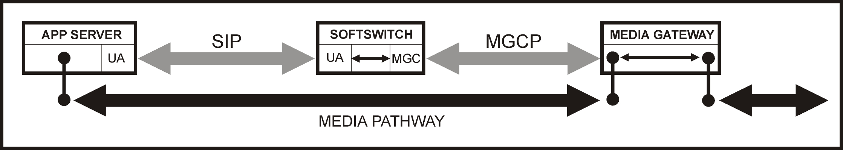
Figure 3
Message and Media Pathways for SIP-TSI

2.2.3.1 Message Passing Methodology for Extensions
Figure 3 depicts the message and media pathways utilized by the SIP-TSI method. It is shown to derive a generalized message-passing mechanism for mid-session control messages. The box on the left represents an application server (APP SERVER) and its User Agent (UA). This UA is the source of both SIP requests and mid-session control requests detailed in section 2.2.3.2 below. The vertical stick with balls represents an IP media pathway endpoint accessible through the IP bearer channel network. The SOFTSWITCH is shown to include a UA and a media gateway controller (MGC). The arrow between the UA and MGC indicates ongoing interactions internal to the SOFTSWITCH; the UA utilizes the MGC to realize requests from the APP SERVER and the MG responses to those requests are passed back to the APP SERVER UA from the SOFTSWITCH UA. The MG is shown with two media pathway endpoints. The endpoint to the left represents an IP endpoint for a media pathway between the application server bearer channel interface and the MG. The endpoint to the right represents a PSTN endpoint for a media pathway between the MG and a PSTN endpoint (not shown). Using MEGACO terminology, these “endpoints” in the media gateway would be called “terminations.” Signaling and control pathways are shown in gray whereas media pathways are shown in black. Directional arrows show the movement of media or signaling/control information, respectively.
Mid-session control messages defined for SIP-TSI operate using semantics essentially identical to any other SIP Request; however the request and response messages are passed between UAs using the SIP INFO Method; a mid-session control protocol is in essence tunneled through the existing SIP signaling pathway using the INFO Method. Each session control request is transmitted to the SOFTSWITCH UA from the APP SERVER UA, and the SOFTSWITCH UA responds with a session control response message using the same mechanism (as opposed to a 200 “OK” Response used for SIP requests). The model generalizes to communication between any two users in a multi-party call. In any case, a media pathway between two logical network endpoints typically refers to two discreet media streams – one in each direction. The SIP-TSI method requires applications to unambiguously identify a media stream to or from a particular user in a call. By referencing a user as an argument to a session control request, the User Agent Server receiving the request may unambiguously infer a particular media stream from the context of the operation. For example, a request to collect DTMF digits from a user will obviate that the digits are to be collected from the media stream transmitted from that user rather than to that user. SIP contains all information necessary to ascertain detailed media stream information from Session Description Protocol. With respect to describing the message-passing semantics for session control messages, a generalized form is presented below:

Message: <Request> <Call-ID> <User> [ <Argument List> ]

Where: Request is a specific session control message.

Call-ID is the SIP field used to identify the call to which Request is targeted.

User identifies network endpoint within the call specified by Call-ID, usually expressed as “user@host”; refers to the transmitting or receiving media stream in the media pathway, depending upon context.

Argument List is a variable or optional set of parameters related to the particular Request.

2.2.3.2 Telephony Service Interface Extensions
It is beyond the scope of this document to include the complete SIP-TSI session control message set and details related to specific call flows. Instead, this section provides an inventory of supported logical requests along with a short description of parameters. The following inventory represents a minimum representative feature set that may be expanded in future revisions:

- CollectDTMF – This request is used by the application to initiate the collection of DTMF digits from a particular user in a call according to one or more specified digit maps. Beyond collecting digit sequences, it may also be used to enable or disable ongoing single digit collection for a user such that every DTMF digit entered by that user generates a message sent back to the application. DTMF digit input may be collected individually for any number of users in the same call.

- GenerateDTMF - This request is used by the application to generate a DTMF tone or sequence of tones on a voice pathway to particular user in a call. The duration of individual tones may also be specified. DTMF digit input may be generated individually for any number of users in the same call.

- EnableToneDetection - This request is used by the application to initiate the detection of zero or more specified tones on a voice pathway from a particular user in a call. Tone detection is based on a list of tone flags, thus tone detection may be enabled or disabled for a “tone profile”. Tones that may be detected include facsimile tones, call-waiting, ringback, off-hook warning, busy, or even flash hook (which is actually an event).

- GenerateTone - This request is used by the application to initiate the generation of a specified tone on a voice pathway to particular user in a call. Parameters are supported for specifying tone duration, repetition, and timeout.

- NoiseCancelEnable - This request is used by the application to enable or disable a specified noise cancellation algorithm on voice pathway from a particular user in a call. The main use of this feature is to improve signal quality prior to speech detection performed on the application server. Parameters are supported for specifying the selection of noise cancellation algorithm to be used.

- VoiceDetectEnable - This request is used by the application to request that voice onset and offset detection are enabled or disabled for a voice pathway from a particular user in a call. The main use of this feature is to determine the onset of speech to support voice-activated menu “barge-in” or to determine the offset of speech when recording spoken input.

3.0 References
[1] Handley M, Schulzrinne H, Schooler E, Rosenberg J (March 1999) RFC 2543 on SIP: Session Initiation Protocol. Internet Engineering Task Force.

[2] Morgan B, Nadkarni V, Camarillo G, Mayer S, Vemuri A, Zimmerer E (October 1999) Internet Draft on SIP Best Current Practice for Telephony Interworking. Internet Engineering Task Force.

[3] Study Group 8 of the ITU-T (June 1998) Recommendation T.38: Procedures for Real-Time Group 3 Facsimile Communication Over IP Networks. International Telecommunications Union.

[4] Donavan, Steve (October 1999) Internet Draft on The SIP INFO Method. Internet Engineering Task Force.

[5] Schulzrinne H, Rosenberg J (June 1999) Internet Draft on SIP Call Control Services. Internet Engineering Task Force.

[6] Sparks R, Cunningham C, Johnston A, Donovan S, Summers K (October 1999) Internet Draft on SIP Telephony Service Examples With Call Flows. Internet Engineering Task Force.

[7] Handley M, Jacobson V (April 1998) RFC 2327 on SDP: Session Description Protocol. Internet Engineering Task Force.

[8] Schulzrinne H, Petrack S (December 1999) Internet Draft on RTP Payload for DTMF Digits, Telephony Tones and Telephony Signals. Internet Engineering Task Force.

[9] Choudhuri T, Haun C, Sollee P, Orton S, Whynot S (1999) Internet Draft on SIP INFO Method for DTMF Digit Transport and Collection. Internet Engineering Task Force.

