Emergency Services Problem Statement
Tom Taylor
Nortel Networks Cable Solutions
15 February 2005

1. What Is The Immediate Problem?
Interworking between the PacketCable network and the PSTN, where operator services are provided on the PSTN, requires appropriate signalling to achieve the following requirements:
- Enforcement of terminating hold, meaning that the caller should not be able to send or receive new calls until the operator releases the call, and whenever the caller is off-hook, there should be a voice path between the caller and the operator.
- Signalling to the operator when a terminating-held party has either gone on-hook or placed the call on hold at the caller's end.
- Allowing the operator to alert the caller on a terminating-held call, regardless of the caller's hook state. When the caller is off-hook, alerting consists of ROH tone played out for a few seconds.
- Providing the same feedback to the emergency services operator that the operator would receive in dealing with a caller calling from a PSTN line.

The first three requirements are described in section 2.6.11 of the NENA Generic E9-1-1 Requirements Technical Information Document [1]. The fourth is a "would be nice" requirement that applies to emergency service operators operating out of legacy Public Service Answering Points (PSAPs) connected only to the PSTN.

Note that the IETF view (as reflected in draft-schulzrinne-sipping-emergency-arch-02 [3]) is that terminating hold is not a requirement worth mentioning because in the general case it cannot be met. More on this below.

2. Analysis
Making the problem more abstract and general increases the chances that the IETF will be willing to help with any necessary protocol development. The question is: what aspects of the preceding problem statement are uniquely dependent on the PacketCable architecture? To pursue this point further, we consider a succession of increasingly more difficult scenarios, as follows:
- single Call Agent controlling both line and trunk gateways;
- general PacketCable architecture: Call Agent controlling line gateway, MGC controlling trunk gateway;
- NGN architecture: SIP endpoint calling through a service provider's Call Agent to an emergency operator;
- SIP endpoint calling an emergency operator without going through a telephony service provider's network.

Scenarios 2-4 are contained in Figure 1. Figure 1 also shows the possibility of an IP-enabled PSAP accessible through the internet. This variation makes the MGC and gateway unnecessary, but should not change the signalling that has to happen in the IP network. It does require more capabilities in the PSAP, to perform the functions that would otherwise fall to the MGC.

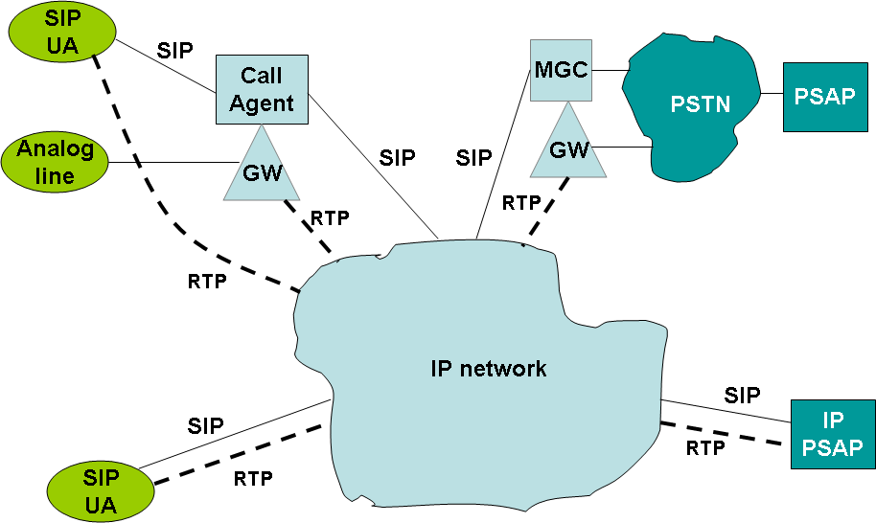

Figure 1: Possibilities for connection of emergency calls

Figure 1 makes a point to which we will return when we attempt to draw conclusions from our analysis. The MGC or IP-PSAP cannot count on support of specific features at the calling end unless they are indicated in the initial INVITE or determined through negotiation. This is a first requirement on the SIP signalling needed to meet the basic requirements stated above.

2.1 Scenario 1: Single Call Agent Controlling Line and Trunk Gateways
By assumption this scenario has no signalling requirements in the SIP network. It does require that the Call Agent understand and enforce the concept of terminating hold. To meet the "nice to have" requirement on emergency operator experience, it is also desirable that the Call Agent should provide audible ringback of a particular kind to the operator simultaneously with alerting to the subscriber on operator ring back. This can be done either from the line-side or from the trunk-side media gateway. PacketCable
specifications currently require the MTA to be able to implement this, but MTA
certification so far has not included a test of that capability.

There are one or two questions that should be resolved regarding the meaning of terminating hold. T1.628a-2001 [2] basically says that for a non-ISDN line the network should refuse to disconnect the operator call until the operator releases it. This suggests at a minimum that the Call Agent should ignore any flash signals from the MTA, preventing the caller from putting the call on hold and establishing another call. This consideration also applies to Scenario 2.

In Scenario 1, it is clear that the Call Agent is responsible for keeping the call up on the PSTN side even if the caller goes on-hook.

2.2 Scenario 2: Call Agent Controlling Line Gateway, Communicating Through SIP Network To MGC or IP-PSAP
In this scenario, the Call Agent still has to understand and enforce terminating hold. However, SIP-associated signalling is now required as follows:
- from the MGC/IP-PSAP to the Call Agent to indicate that terminating hold is in effect;
- from the Call Agent to the MGC/IP-PSAP to indicate that the caller has gone on-hook;
- from the Call Agent to the MGC/IP-PSAP to indicate that the caller has gone back off-hook;
- from the MGC/IP-PSAP to the Call Agent to request alerting of the caller when the latter is on-hook;
- (possibly) from the MGC/IP-PSAP to the Call Agent to request playout of ROH tone for off-hook alerting of the caller;
- (possibly) from the MGC/IP-PSAP to the Call Agent to describe the audible ringback tone to be sent back to the operator during operator ring back.

2.2.1 Indication of Terminating Hold
Signalling of terminating hold comes laden with serious security implications: it must not be possible for an unauthorized party to impose terminating hold on a caller. This is an end-to-end authentication and authorization issue, between the Call Agent and the MGC/IP-PSAP. Assuming that these requirements are resolved by standard means, this item requires an indication to be carried in the SIP header. T1.628a-2001 [2] indicates that terminating hold is invoked in the ACM. Assuming that indication of terminating hold happens within the initial session set up by the caller, the SIP analogue to this is that the indication should be present in provisional responses from the MGC/IP-PSAP. Since there is no guarantee that these will be received by the Call Agent (barring use of PRACK), the indication must also be present in the 200 OK.

2.2.2 Indication of On-Hook/Off-Hook
On-hook/off-hook signalling can be handled in at least two ways, and the architecture warrants discussion. The key decision is whether the session between the Call Agent and the MGC/IP-PSAP (or MGC) remains established when the caller has gone on-hook. The advantage of leaving this session in place is that the MGC/IP-PSAP can release the connection naturally by sending a BYE when it is appropriate. The disadvantage is that some other method of signalling has to be found to request on-hook operator ring back and to signal the caller's hook state. The latter can be done using SUBSCRIBE/NOTIFY, but there is no natural way to request on-hook operator ring back in this case. The potential information flows for this approach are shown in Figure 2.

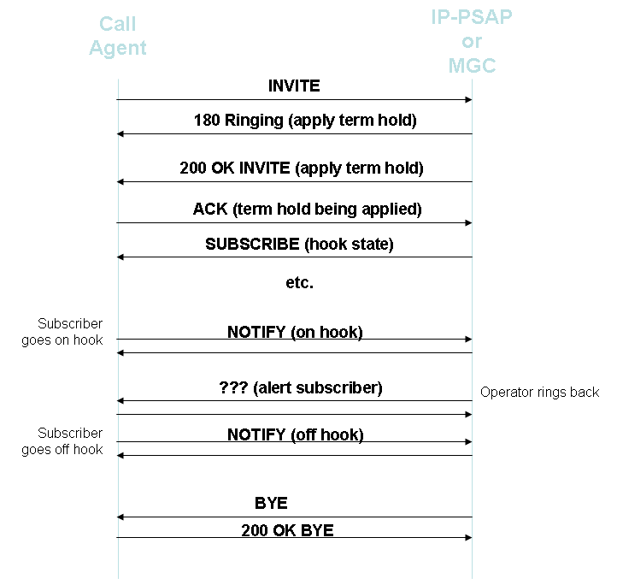

Figure 2: Session Startup, On/Off Hook Notification, and Operator Ring Back With Initial Session Retained

The alternative approach is for the session between the Call Agent and the MGC/IP-PSAP to be terminated with a BYE when the caller goes on-hook. In this approach, the MGC/IP-PSAP is responsible for keeping the call up on the operator side. Both ends are responsible for keeping a voice path reserved beteen the Call Agent and the MGC/IP-PSAP. The Call Agent is responsible for keeping a voice path reserved in the access network. The advantage of this approach is that signalling of caller hook state is natural, and signalling of operator ring back to an on-hook caller is also natural: a new INVITE from the operator end. The disadvantage is that some means has to be found to let the Call Agent know that all resources associated with the call can be released if the caller is on-hook when the operator releases the call.

One possibility is that terminating hold is set up by sending a reverse INVITE from the MGC/IP-PSAP when the original call is first received. There is an obvious signalling requirement to correlate this control session with the original one, while indicating that it is implementing terminating hold. The call and the media resources associated with it would not be released until the reverse session was released at the operator end. Possibly these resources would be parked with the control session while the caller is on-hook, but this is a mere formalism for extraordinary behaviour required in any event. [It may be possible to reuse SIP signalling designed for conferencing to set up and maintain this back-session, but that hasn't been thought through.]

Figure 3 shows the information flows that would result with this approach, for the same sequence as in Figure 2. In Figure 3, messages for the control session are shown in black, those for other sessions in green.

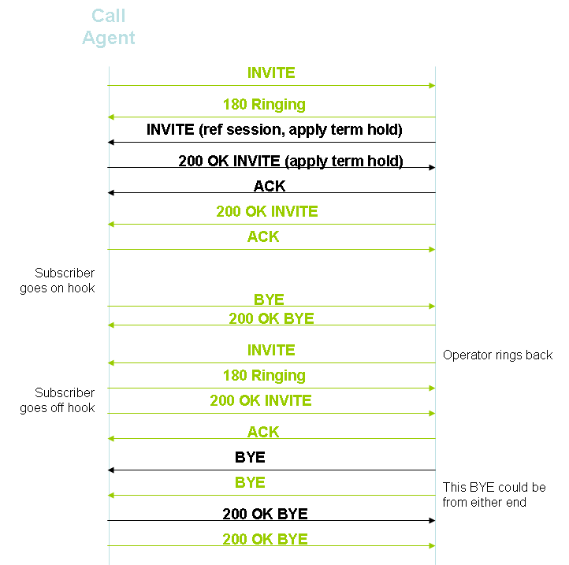

Figure 3: Session Startup, On/Off Hook Notification, and Operator Ring Back Using Reverse Control Session

2.2.3 Off-Hook Operator Ring Back
Off-hook alerting is most naturally achieved by injecting ROH tone into the media stream at the trunking gateway or IP-PSAP. The alternative is to request a media server to do the job. Either of these will work regardless of the outcome of the discussion in the previous section. In the particular conditions of Scenario 2, a third alternative is to have the MTA do the job, but this will not work for Scenarios 3 and 4.

2.2.4 Specifying Audible Ringback
Audible ringback during on-hook alerting could be sent from the MTA, but this seems cumbersome. Again, in Scenarios 3 and 4 it would not work. Moreover, in the off-hook alerting case generating audible ringback at the MTA is out of the question if the ROH tone is being applied at the trunking gateway or IP-PSAP. One concludes that audible ringback to the operator should always be generated at the trunking gateway or IP-PSAP.

2.3 Scenario 3: SIP terminal calling through NGN to MGC/IP-PSAP
This scenario differs from the previous one in that the user interface at the subscriber terminal is not controlled by the network. The consequences of that have already been reflected in the discussion of Scenario 2.

As far as call signalling is concerned, it is assumed that SIP-level interface to the caller is a B2BUA. In effect, this means that the same degree of control over the caller exists as in Scenario 2. Thus no cooperation is required from the subscriber terminal to enforce terminating hold.

Regardless of which of the two approaches discussed in section 2.2.2 is used in the service provider's network, signalling between the subscriber terminal and the Call Agent will reflect normal SIP usage. In particular, subscriber on-hook will be indicated by a BYE from the subscriber terminal, and off-hook by a new INVITE. For sessions subsequent to the initial one, the Call Agent will be responsible for ensuring that the media path signalled to the subscriber terminal makes use of the resources already reserved for the call. There are potential issues here if the subscriber terminal signals a new media endpoint when initiating a new session.

2.4 Scenario 4: SIP terminal calling directly to the MGC/IP-PSAP
Scenario 4 goes the next step beyond Scenario 3; call signalling as well as the user interface are autonomous to the subscriber terminal. Either one postulates cooperation from the user's terminal (a brittle proposition) or the MGC/IP-PSAP retains contact with the user on a best-effort basis.

In the best-effort case, user on-hook is signalled by a BYE. Operator ring back is signalled by an INVITE when the user has gone on-hook, but there is now a risk that the INVITE will find the subscriber busy on another call. If the INVITE goes through, the access network resources to support the media path may or may not be available.

3. Conclusions
- Analysis of the way to provide terminating hold capability requires that all of the scenarios inherent in Figure 1 be examined.
- Terminating hold can only be enforced if all call signalling at the calling end is under the control of service provider equipment (the Call Agent).
- Terminating hold requires service knowledge at the IP-PSAP or MGC and at the Call Agent.
- Terminating hold requires extensions to existing SIP capabilities. These can be detailed once the broad signalling strategy is agreed.
- The amount of extension to SIP can probably be reduced by using the approach of Figure 3 rather than the approach of Figure 2.
- Regardless of the approach taken for other capabilities, off-hook alerting through application of ROH tone is best done at the trunking gateway or IP-PSAP. This is also true of audible ringback to the operator for either on-hook or off-hook alerting. The required capabilities may not currently be implemented in trunking gateways in the field.

4. References

1. "NENA Generic E9-1-1 Requirements Technical Information Document", National Emergency Number Association (NENA) VoIP E9-1-1 Requirements Working
Group, Issue 1, July 23, 2004.

2. T1.628a-2001, "ECS - Connection and Ring Back Addendum", ANSI T1S1.7, 2002. "ECS" stands for "Emergency Calling Service".

3. H. Schulzrinne and B. Rosen, "Emergency Services for Internet Telephony Systems", draft-schulzrinne-sipping-emergency-arch-02.txt, Work in Progress, Internet Engineering Task Force, 18 October 2004.

