GIS background:

Two main different types of digital mapping:

- GIS-Geographical Information Systems-“smart maps”
  - Attribute data tied to map features
  - Projected, lat/long tied to map features
  - Example: ESRI map data or MapInfo map data

Note: It is possible to have GIS map data with no database tied to it. However, the ability to add them is there.

- Graphic maps-
  - No lat/long information
  - No database tied to individual map features
  - Unable to do analysis
  - Example: AutoCad

Note: It is possible to have “graphic” maps that have lat/long information (projected) but no database or capability to do an analysis

Also, I have included a .ppt that may be of value.

- For wireless, there is presumably a database that records the service areas for PSAPs (and ESZ, but we’ll ignore this for now) as a polygon, with long-lat line segments. How precisely is this information kept?

In GIS map data there are two different sets of information that can be kept “accurate”. The first is the positional accuracy the second is the attribute accuracy.

Positional accuracy in this scenario would be the boundary of each emergency service zone. The positional precision of this map data will vary from county to county. Since ESZs are imaginary features on the earth they can not be physically surveyed. However, if the individual zones are geographically referenced to a physical land features, such as road, parcel, water feature, townships etc. the ESZs can be created by referencing these features.

Typically, we build our ESZs based on hard copy maps provided by the county. Most counties will have existing or create hard copy maps by getting like agencies together and manually determining the boundaries of each responder. Keeping in mind, if already enhanced, that these zones must correspond with the MSAG. Further, with Phase 2 911 up and running, the accuracy of the individual zones in areas that there is no structure/wireline 911 call has become an issue in determining the actual positional accuracy of a zone. For example, if I am a farmer in the middle of the 160 acre field and I dial 911 from my cell phone, the ESZ can be determined by the lat/long. In the past the zone maybe arbitrarily cut across a township ignoring the positional accuracy where there was no structure.

Attribute accuracy relates to the data tied to each map feature. A county may have a perfectly position-ally developed ESZ map layer, yet there may be no attribute data or incorrect attribute data tied to the zones.

Getting back to the question, “How precisely is this information kept?” this will vary from one county to the next on what processes they have in place to verify existing data and for maintaining changes (annexations, general responder changes, etc.)

- Are there tens, hundreds, thousands of line segments?

If the zones are a polygon, there are no line segments, just polygons. Line segments do not cover area. We frequently run into potential customers that have existing ESZs that are line segments. These must be converted into polygons in order to cover a geographic area.

The number of polygons or zones will vary greatly from one county to the next, there may be 15 or there may be 415. Generally the number of zones is a direct correlation to population. However, it also has to do with the responder break down. Some are broken down by only fire, law and ambulance, others have first responders, primary, secondary, mutual responders, etc.

3. I realize that this will vary greatly by jurisdiction, but some indication of the order of magnitude likely to be encountered would be helpful. (If the county boundary is the middle of some meandering river, this boundary could be quite irregular if every turn of the river is represented.

In GIS this is typically not an issue. There are tools in most GIS software programs that allow for “cookie-cutting” out a feature by overlaying one over the other. See example below where municipal boundaries are defined by a lake.

Below is an example ESZ layer for an example county.
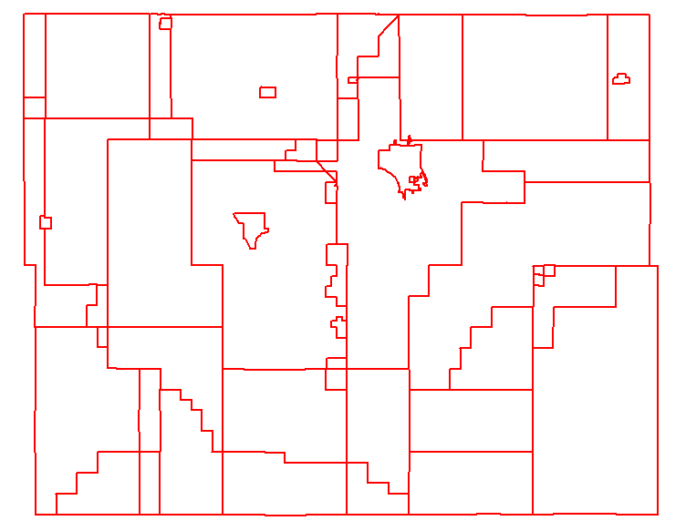
Polygons, not lines
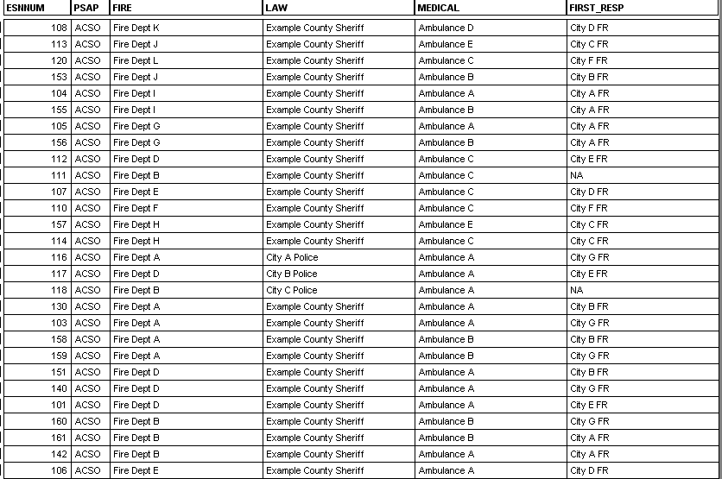
Example database tied to each polygon.

Normally each responder category would have the specific name of the agency.

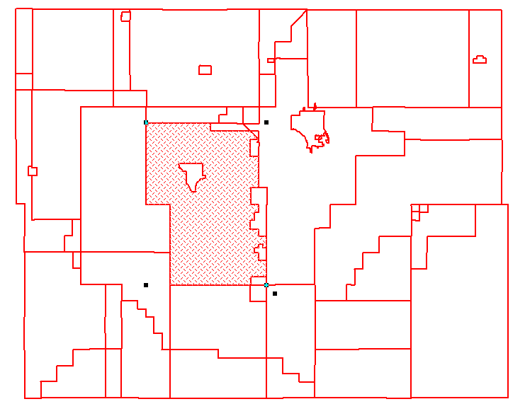
Selected polygon, shows coverage area.

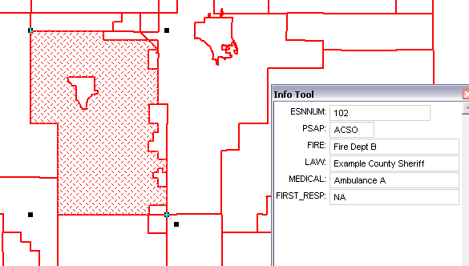
Map feature information tied to the selected area

