COMS W4701x: Artificial Intelligence
MIDTERM EXAM
October 29th, 2007

DIRECTIONS

This exam is closed book and closed notes. It consists of three parts. Each part is labeled with the amount of time you should expect to spend on it. If you are spending too much time, skip it and go on to the next section, coming back if you have time.

The first part is multiple choice. The second part is problem solving. The third part is short answer.

Important: Answer Part I by circling answers on the test sheets and turn in the test itself. Answer Part II using a separate blue book for each problem. Answer Part III on the test itself. In other words, you should be handing in the test and at least four blue books.

Part I - Multiple Choice. 20 points total. 15 minutes.

Circle the one answer that best answers the question.

1. The effectiveness of alpha-beta pruning depends on
a. the implementation of mini-max search
b. the order in which successors are examined
c. whether α is greater than β
d. beam search

b

2. Which of the following search algorithms uses an initial complete-state formulation?
a. depth first c. A*
b. hill climbing d. greedy search

b

3. A search algorithm is optimal if it
a. always finds the solution with the shortest path
b. always finds a solution if there is one
c. finds all possible solutions
d. never finds a solution

a
4. Which of the following techniques is not useful for escaping or avoiding local maxima?

a. Stochastic hill climbing
b. Local beam search
c. Simulated annealing
d. Gradient descent

d

5. Depth first search treats the open list like a
a. Queue, placing all successors on the right end
b. Stack, placing all successors on the left end
c. Sorted list, sorting open after adding successors to the list
d. Sorted list, sorting open first and then adding successors to the left end

b

6. A probabilistic proposition is equivalent to
a. all atomic events for which it is either true or false
b. the conjunction of all atomic events for which it is true
c. the disjunction of all atomic events for which it is true
d. the intersection of the probabilities of its atomic events

c
7. Given a choice between moves A and B in the following tree, which would mini-max choose (assuming MAX is to move at the root)?
a. A
b.Ba
50
50
49
200
A
B
50
2
51
90

8. Quiescence search

a. is used during online search to distinguish the best exploratory direction
b. is used during game playing to decide among opening moves
c. is used during game playing to extend search depth for game states with instability
d. is used during game playing to extend search depth at the end game only

c

9. Which of the following search methods combines a breadth-first and depth-first approach?

a. greedy search
b. best-first search
c. A* search
d. iterative deepening

d

10. An evaluation function is used in game playing to
a. estimate the expected utility of the game from a given position
b. compute the winner of the game based on number of pieces left
c. compute the utility of a terminal leaf in a game tree
d. compute the next moves returned by the successor function

a

Part II. Problem Solving. 65 points. 50 minutes.
There are four problems in this section. Use a separate blue book for each problem.

- [20 points] Constraint Satisfaction. Consider the Sudoku puzzle shown below. The object of this puzzle is to fill in each of the blank squares with a digit from 1 to 9 so that no digit is repeated in its 3X3 grid, in its row, or in its column.

Suppose you are using constraint satisfaction propagation to solve Sudoku puzzles like the one shown below..

A. (3 points) What would the variables in this problem be?

The variables would be the blank entries in the puzzle and can take on values from 1-9. (Note that I didn’t explicitly ask for the latter, so don’t penalize them on this).

B. (5 points) What would the constraints on the variables be? You can describe this in words without drawing the constraint graph.

The constraints are that the value of a variable cannot be equal to the value of any other variable in the row, of any other variable in its column, and of any other variable in its grid. So that makes for
8+6+6 = 20 constraints. Give 2 pt for noting the equality check, 2 pt for noting that it must hold between row, column, and grid, and 1 pt for noting number of constraints.

C. (12 points) There are 3 heuristics that are used in constraint satisfaction:
- Minimum Remaining Values heuristic
- Most Constraining Variable (also known as degree heuristic)
- Least Constraining Value

Give a 1 line definition for each of these and show how they would apply for the first 3 steps of solving the puzzle using CSP. In particular, show how MRV influences which variable would be solved next, whether the MCV would apply in this case and how the LCV comes into play.

Hint: You only need to look in one 3X3 grid.

   | 2 | 1
   | 5 | 7
  6 | 9
  9 | 3
  7
  8
  9
  6
  8 |  | 9
   |  | 2
  1
  1
  3
  5
   | 9 | 4
   | 4 | 2
   | 6
  8 | 1

Definitions:

MRV: Will choose the variable that has the fewest legal values left.
MCV: If there is more than one variable which both have the fewest number of values left, MCV can be used as a tie breaker. It will choose the variable that places the most constraints on the remaining variables. Since all variables participate in the same number of constraints, MCV often will not come into play. However, it could come into play if one of the tied variables has fewer filled slots in its column, row and grid than the other one. In that case, it will result in more constraints.
LCV: Will choose a value for the selected variable that least constrains the values of other variables. LCV could come into play by picking a value that doesn’t cause the number fo remaining values in other variables in the same column, row or grid to shrink to zero.

n this example, the variables in the upper-left 3x3 grid appears to have the fewest remaining values since this grid has the most values filled in. So from here on, we restrict discussion to this grid.
The remaining values for each of the variables are 3, 4, and 8 based on constraints from the grid. However, V(3,3) cannot be assigned 8 or 3 since an 8 exists in its row and a 3 exists in its column, so the number of legal values are 1. Similarly, V(1,1) cannot be a 3 since a 3 already occurs in its row, so the number of legal values are 2. In summary, we have:
V(3,3) = {4}
V(1,1) = {4,8}
V(2,1) = {3,4,8}
So using just MRV, we see that the variables are assigned values in order as follows.
Assign V(3,3) = 4
V(1,1) = {8}
V(2,1) = {3,8}
Assign V(1,1) = 8
V(2,1) = {3}
Assign V(2,1) = 3
Therefore, MCV and LCV don't come into play here. However, to illustrate their use, we can consider a relaxation of the problem. Say V(8,3), which is currently assigned to 3, was unassigned. In this case, we have a tie between V(1,1) and V(3,3). We need to consider MCV by checking the number of empty cells in the row, column and 3x3 block for each variable.
V(3,3) = {3,4} (involved in 13 constraints)
V(1,1) = {4,8} (involved in 8 constraints)
V(2,1) = {3,4,8} (involved in 11 constraints)
If we use MCV, we would choose to fill V(3,3) first. Now, V(3,3) can take on values 3 or 4, but if 4 is chosen then there will be just one remaining value for V(1,1) and that is 8. If 3 is chosen, then V(1,1) can be either 4 or 8. Thus, the LCV for V(3,3) is 3 since it leaves the most flexibility for future assignments.
NOTE: Although the example Sudoku grid implies that the MRV must be in the top-left grid (i.e the most populated grid) and is therefore variable V(3,3), two other MRVs can be found outside of this grid. In addition to V(3,3), V(1,8) and V(9,9) also have just one legal value each.
V(3,3) = {4} (involved in 12 constraints)
V(1,8) = {5} (involved in 10 constraints)
V(9,9) = {3} (involved in 9 constraints)
So if the entire Sudoku puzzle is considered, the order of variables filled in using MRV (with MCV as a tiebreaker) is:
V(3,3) = 4
V(1,8) = 5
V(9,9) = 3
V(1,1) = 8
V(2,1) = 3
However, this was not required to be shown.

2 pt for each definition. (6 total)
2 pt for showing whether and how each definition would be used in soduku in this puzzle (6 total)

- [10 points] Bayesian Networks

It’s flu season and you’re sick. But is it the flu or is that terrible MRSA infection that you’ve heard about on the news? You decide to use Bayesian networks to determine the cause of your symptoms.

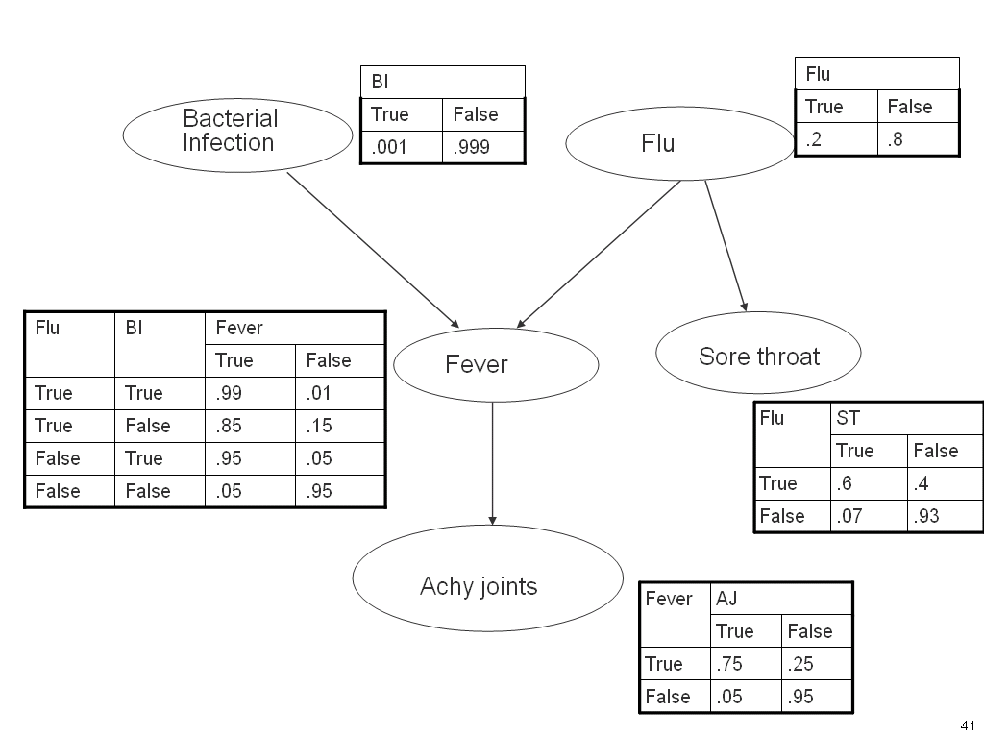

a. Show the computation required to determine the probability that you have the flu and no bacterial infection given that you have a sore throat, no achy joints, and a fever P(Flu, ST, , ¬AJ, Fever, ,¬BI).

P(¬AJ|Fever)*P(Fever|¬BI, Flu)*P(Flu)*P(¬BI)*P(ST|Flu)
=.25*.85*.2*.999*.6

4 pt, 2 for the general formula and 2 for filling in the numbers properly.

b. Is achy joints independent of flu given fever?
Yes, because the path is not d-connected. Fever blocks AJ from Flu
3 pt
c. Is flu independent of bacterial infection given fever?

No. We have a converging path here and by our definition if a converging path has either an internal node or a descendent that are evidence nodes, then the path is d-connecting. If the path is d-connecting that the two end points of the path are conditionally dependent.

3 pt

3. Machine Learning [20 points]

 | User Action | Author | Thread | Length
1 | skips | known | new | long
2 | reads | unknown | new | short
3 | skips | unknown | Follow-up | long
4 | skips | known | Follow-up | long
5 | reads | known | new | short
6 | skips | known | Follow-up | long
7 | skips | unknown | Follow-up | short
8 | reads | unknown | new | short
9 | skips | known | Follow-up | long
10 | skips | known | new | long
11 | skips | unknown | Follow-up | short
12 | skips | known | new | long
13 | reads | known | Follow-up | short
14 | reads | known | new | short
15 | reads | known | new | short
16 | reads | known | Follow-up | short
17 | reads | known | new | short
18 | reads | unknown | new | short
Counts | 9 skips  9 reads | 12 known  6 unknown | 10 new  8 Follow-up | 7 long  11 short

The data set above was gathered by a web-based agent that observed a user deciding whether to skip or read a newsgroup article depending on whether the author was known or not, whether the article started a new thread or was a follow-up message, and the length of the article.

- (15 pts) Based on the above data, list the attributes in order of decreasing information gain(i.e. the first attribute listed has the highest information gain and would therefore become the root of a decision tree created by an decision tree learning system). You do not need to show any calculations but you should mention the formula and you can show your work.
Attributes in order of decreasing information gain: Length, thread, order

They should show that the values of each attribute split the training instances into sets. They should mention the need to measure entropy in sub-set. A perfectly split set has an entropy of 1, a set that is entirely uniform as an entropy of 0. Other splits will have values in between. 0 and 1. The formula for information gain measures entropy of the initial set minus the sum of the entropies of each subset.

In this example, they should show the following subsets:

For author: entropy is 1 for each subset:

Value = unknown

Reads: 3 instances
Skips: 3 instances

Value = known

Skips: 6 instances
Reads: 6 instances

For thread, entropy >0, < 1

Value = new

Reads: 7 instances
Skips: 3 instances

For length, entropy for one subset = 0 and for the other close to 0.

Value = short

Reads: 9 instances
Skips: 2 instances

Value -= long

Skips: 7 instances
Reads: 0 instances
B. (5 pts) Assume now that the decision tree learner selects the first attribute in the list that you created in part 1 as the root node of the tree. To continue building the tree, the decision tree learner would be called recursively to build the rest of the tree. List the training instances that would be included in the next recursive call associated with each branch of the root node.

In the next recursive call, for Length = short the training instances would be: 2, 5, 7, 8, 11, 13, 14, 15, 16, 17, 18

For length = long, the training instances would be: 1, 3, 4, 6, 9, 10, 12

4.[15 points] Search.

Consider the search space below, where S is the start node and G1 and G2 are goal nodes. Arcs are labeled with the value of a cost function; the number gives the cost of traversing the arc. Above each node is the value of a heuristic function; the number gives the estimate of the distance to the goal. Assume that uninformed search algorithms always choose the left branch first when there is a choice. Assume that the algorithms do not keep track of and recognize repeated states.

A. (10 points) For each of the search strategies greedy and iterative deepening

(1) indicate which goal state is reached first (if any) and
(2) list in order, all the states that are removed from the OPEN list.

B. (5 points) Would the h function in this graph lead to an admissible search? Explain your answer.

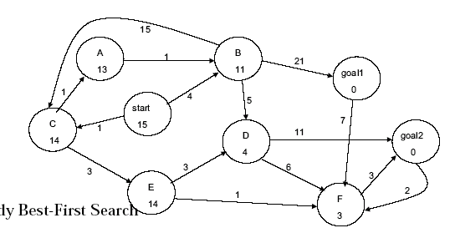

Greedy: Start, B, Goal 1. goal 1 is reached first.
Iterative deepening: Start, C, B, Start, C, A, E, B, C,D ,Goal1. Goal1 is reached first.

5 pt each for above (2 pt for goal, 3 pt for path)

b. No, it is not admissible. There is at least one case where the estimate inside the node is greater than the sum of the costs on the remaining path. For example, E has a heuristic estimate of 14, but if we go to goal2 via F, the cost is actually 4.

5 pt

Part III. 15 points. 10 minutes.
Short Answer. Answer 3 out of the following 5 problems. Use no more than 2 sentences for each question. Each question is worth 5 points. You may put your answer on the test sheet or in a separate blue book.

1. What is the Turing test?
The turing test is a test designed such that questions can be posed to both a computer and human. If we can’t tell the difference between the answers given by the human and by the computer, then we know that the computer is as intelligent as the human. This test is intended as a way to determine when a computer program has intelligence equal to that of a human.

2. We saw two heuristics for solving the 8 puzzle, manhattan distance and number of tiles misplaced. Are these heuristics admissible? Why? Which one is better than the other and why?
Both of these are admissible heuristics because each one underestimates the distance to the goal. Since manhattan distance is always larger than number of tiles misplaced, it is a better estimate. It will always be closer to the actual distance.

- Choose one technique that is used to avoid local maxima in hill-climbing and in 2 sentences or less, describe the general principle by which it works.
Simulated annealing could be used. Or stochastic hill-climbing. For either of these, the principle is to introduce randomness into the algorithm. As opposed to always taking the steepest ascent, the algorithm may either randomly choose an ascent (in stochastic hill climbing) or may choose less than the steepest more often in the beginning and with decreasing probability as the search goes on.

Beam search is another possibility. In this case, multiple branches are expanded (but not all as in breadth first search). For example, if k= 3, then 3 branches from each state will be expanded. In this case, we have less likelihood of getting stuck in a maxima.

4. What is the time/space tradeoff between depth-first and breadth-first search?
Depth-first uses less space but takes more time. Breadth first uses more space since all branches are expanded at each step and they all must be saved in memory. However, it will find the optimal solution more quickly. Could give formulas for space and time.

5. In the machine translation paper, we saw how hill climbing could be used to search the space of possible translations of a sentence. Describe the problem formulation that was used, including the initial state and an example of what the successor function did.

The initial state is a gloss of the translation, using simple word look up in a dictionary. At each step in hill climbing, an edit is made to the translation and the edit that most increases the score of the resulting translation is selected. To compute the score of the translated sentence, a language model is used. This is the evaluation function.

