COMS W4701y: Artificial Intelligence
MIDTERM EXAM
March 11, 2004

DIRECTIONS

This exam is closed book and closed notes. It consists of three parts. Each part is labeled with the amount of time you should expect to spend on it. If you are spending too much time, skip it and go on to the next section, coming back if you have time.

The first part is multiple choice. The second part is short answer and problem solving. The third part is an essay question.

Important: Answer Part I by circling answers on the test sheets and turn in the test itself. Answer Part II and Part III in separate blue books. In other words, you should be handing in the test and at least two blue books.

Part I - Multiple Choice. 20 points total. 15 minutes.

Circle the one answer that best answers the question.

1. Which of the following search algorithms is not heuristic search?
a. greedy search b. iterative deepening
c. A* d. beam search

2. In which of the following search algorithms is it possible to confuse a local maximum with a global maximum?
a. depth first b. A*
b. hill climbing d. greedy search

3. Which of the following search algorithms is not optimal? (assuming that step costs are identical)
a. depth-first b. uniform cost
c. breadth-first d. iterative deepening

4. A semantic network

a. is a graph-based representation where nodes represent concepts and arcs represent relations
b. is a graph-based representation where nodes represent relations and arcs represent concepts
c. represents an entity as a set of slots and associated values
d. is a subset of first-order logic

5. An ontology

a. represents an entity as a set of slots and associated values
b. is a subset of first-order logic
c. is an inference mechanism
d. provides a vocabulary for expressing knowledge

6. An inference procedure

a. is a declarative knowledge representation
b. provides rules for deriving new facts from existing facts
c. is a proof
d. is a type of inheritance

7. An inference method is sound if it

a. can derive any sentence that is entailed
b. only derives entailed sentences
c. is efficient in both time and space
d. is not NP-complete

8. An inference method is complete if it

a. can derive any sentence that is entailed
b. only derives entailed sentences
c. is efficient in both time and space
d. is not NP-complete

9. A zero-sum game is one in which

a. the feature weights in an evaluation function must sum to zero.
b. the points in any one player's hand must sum to zero.
c. if one player wins, the other necessarily loses.
d. two players may team up to beat a third.

10. Which of the following statements about a frame-based representation is not true?

- A frame can represent a specific entity or a general concept
b. A frame can only represent specific objects at specific points in time
c. Frames are implicitly associated with other frames because the value of a slot can be another frame
d. A frame-based representation can be implemented using object oriented programming

Part II. Problem Solving. 65 points. 45 minutes.

- [10 points] Show alpha-beta cutoffs in the following game tree.

MIN
MAX
4
10
8
7
3
1
14
8
2
2
8
10
2

- [20 points] Solve the cryptarithmetic problem below by hand, using backtracking, forward checking, and the minimum remaining values and the least-constraining-value heuristics. Show your work, indicating where forward checking and each of the heuristics comes into play.

PIN
+ PIN
KNOT

3. [20 points] Resolution Search.

Knowledge Base:

Either (I have a sweet tooth and I like chocolate) or (I like chocolate and I like cake)

Rules:

If I like cake, then I also like Danish.
If I like Danish, that implies I have a sweet tooth.
If I have a sweet tooth and I like chocolate, then I am a chocoholic.

Goal: I am a chocoholic

A. Convert these sentences to propositional logic.

B. Put the resulting sentences into Conjunctive Normal Form using applicable conversions from the table below.

C. Using proof by refutation and resolution as the single inference rule, show the resolution proof that proves or disproves the goal.

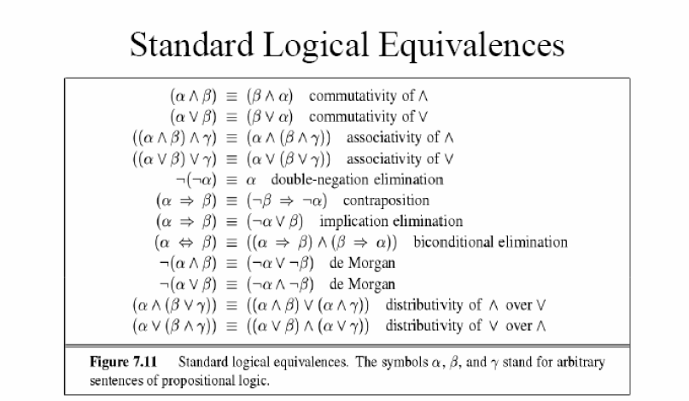
4. [15 points] Consider the search space below, where S is the start node and G1 and G2 are goal nodes. Arcs are labeled with the value of a cost function; the number gives the cost of traversing the arc. Nodes are labeled with the value of a heuristic function; the number gives the estimate of the distance to the goal. Assume that uninformed search algorithms always choose the left branch first when there is a choice.

For each of the following search strategies, indicate 1. which goal state is reached first (if any) and 2. list in order, all the states that are popped off the OPEN list.

Depth-first

Iterative Deepening

Breadth-first

Greedy

A*

`
S
5
C3
G₂₀
D1
B
1
F
6

A2
2
1
1
1
5
2
5
7
9
8

1
4
G₁
₀
3

Part III. Essay. 15 points. 15 minutes.

Games are interesting for artificial intelligence because they are hard. Chess, for example, has a branching factor of 35, with a typical game containing some 10 ³⁵ nodes. Many search problems have a similar problem. In these types of game and search problems, a program must make some type of decision even when the optimal decision cannot be found.

a. Heuristics are one way for either a game playing program or search to arrive at a good decision. Provide an argument why heuristic functions (or evaluation functions) are a form of intelligent behavior, drawing on at least two different definitions of artificial intelligence. Give two examples in your argument of why this is the case.

b. Describe one other technique that either game playing programs, search or constraint satisfaction use in addition to heuristics to help make good decisions in reasonable time.

