COMS W4701y: Artificial Intelligence
FINAL EXAM
December 21st, 2004

Name:
UNI:

DIRECTIONS

This exam is closed book, closed notes, closed laptop, closed calculator and closed cell phone. It consists of three parts. Each part is labeled with the amount of time you should expect to spend on it. If you are spending too much time, skip it and go on to the next section, coming back if you have time. Point value of individual questions also bears on amount of time.

The first part is multiple choice. The second part is short answer. The third part is problem solving and it includes one essay.

Note: longer problem and essay are last two questions. Save enough time for the end.

Important: Answer Part I by circling answers on the test sheets and turn in the test itself. Answer Part II on the test sheet itself. Use a separate test booklet for each question in Part III.

Part I – Multiple-choice questions. 16 points total. 15 minutes.

Circle the one answer that best answers the question.

1. Given a choice between moves A and B in the following tree, which would minimax choose (assuming MAX is to move at the root)?
50
50
50
50
49
200
A
B
a. A b. B

2. The results of exhaustive backward-chaining (to find all solutions) are independent of the search order
a. T b. F

3. Every partial-order plan with no open conditions and no possible threats has a linearization that is a correct solution
a. T b. F

4. Which of the following statements is not true of Bayesian learning?

a. Prior knowledge can be combined with observed data to determine hypotheses
b. They can accommodate hypotheses that make probabilistic predictions
c. It is computationally feasible to estimate the required probabilities by counting in training data
d. New instances can be classified by combining the predictions of multiple hypotheses, weighted by their probabilities

5. You are given a vocabulary with three propositions, A,B and C. How many models are there for the sentence (A⇔B) V B?

a. 6 b. 8
c. 3 d. 2

6. Planning and constraint satisfaction are alike in that they both

a. are more efficient than A* search
b. allow for the use of domain-independent heuristics that exploit structure
c. can be used for game playing as well as problem solving
d. are a good algorithmic fit for solving crossword puzzles

7. An ontology

a. provides a vocabulary for expressing knowledge
b. uses frames for hierarchical inferencing
c. is more promiscuous than perspicacious
d. represents relations, objects and properties

8. Local search, such as hill-climbing,

a. operates using many current states
b. uses more memory than depth-first search
c. is not suited for pure optimatization problems
d. does not retain the paths followed by search
Part II. Short Answer. 24 points total. 45 minutes total.

- [2 points] Assume an evaluation function for chess that simply counts material (number of black pieces versus number of white pieces left on the board). Which of the following two boards is not quiescent and why? How would quiescent search help? (4 sentences total).

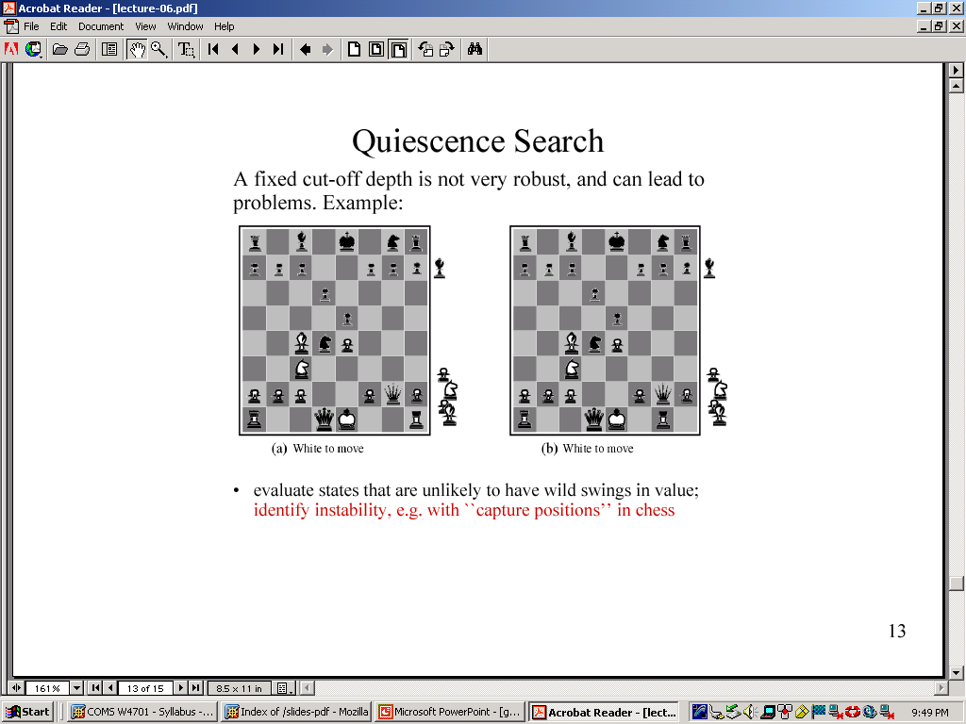

- [2 points]. Assume that a king can move one square in any direction on a chessboard (8 directions in all). Is Manhattan Distance an admissible heuristic for determining a move from A to B? Explain why or why not (2 sentences).

- [4 points] Translate each of the following English sentences into the language of standard first-order logic, including quantifiers. Use the predicates French(x), Australian(x), Wine(x), >, and the functions Price(x) and Quality(x)
  - All French wines cost more than all Australian wines.
  - The best Australian wine is better than some French wines.

- [4 points] Using First Order Logic, write axioms describing the predicates GreatGrandmother, Cousin. Use only the predicates Mother(x) and Father (x) in your definitions.

- [8 points] You are writing a Strips-style planner to get you from the entrance of an airport to the gate of the plane you want to board. Show the plans you would need in the Strips formalism for the following four actions: check-in, pass-security, board-plane, and go. Assume that the plan go will take you from one point to the next.

- [4 points] Answer this question for either the natural language problem or the vision problem (not both):
  - Vision: You are writing a supervised learning program to identify the handwritten digits 1-9. What would your training material be? What features might your program use?
  - Natural language: You are writing a supervised learning program to translate from French to English. What would your training material be? What features might your program use?

Part
III. Problem solving. 60 points total. 1 hour 45 min.
1. [12 points] Bayesian Networks
Consider the following Bayesian Network, where variables H,G,R, and J are all Boolean-valued:
P(H=true) = 0.1 0.20.20.2
H | P(G=true | H)
T | .4
F | .8

G

H

R

H | G | P(R =true | H, G)
false | false | 0.2
false | true | 0.9
true | false | 0.3
true | true | 0.8
 |  |  |  | R | P(J=true | R)
 |  |  |  | false | 0.2
 |  |  |  | true | 0.7

J

You are given the simple belief network above with Boolean variables, H=Hardworking, G=Good Grades, R = excellent Recommendation, J = landed a good Job. For each problem below, show your work.

- Which, if any, of the following are asserted by the network structure (ignoring the CPTs for now)?
[Note: any subset of these may be correct]
    - P(H,G) = P(H)P(G)
    - P(J|R,H) = P(J|R)
    - P(J) ≠ P(J|H)

- Calculate the value of P(H,G,¬R,¬J). It is sufficient to show how you would calculate it without actually doing the arithmetic.
- Suppose we want to add the variable C = HasTheRightConnections to the network; describe, with justifications, all the changes you would make to the network.

2. [10 points] Resolution Theorem Proving

Use proof by refutation and application of the resolution rule to show whether or not the following goals can be proved.

a. First-Order Logic: Prove that there is always a number greater than another number given the axiom that a number is less than its successor:
KB: ∀t (t < t+1) (A number is less than its successor)
Goal: ∀x∃y (x < y) (A number is always greater than another number)
- Propositional Logic: Use the table shown below to do conversions.
KB: (¬A-> ¬E)
(E⇔(A∧D))
Goal: (D->E)

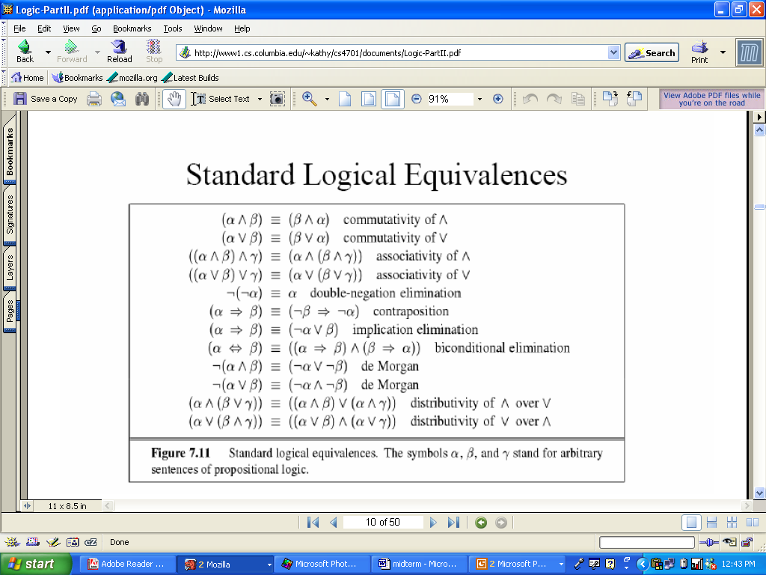
3. Learning from Observations (8 points)

Ms Apple I. Podd is a Columbia University Computer Science major who listens to music almost everywhere she goes. She often has homework due and many of them involve programming. We’ve sampled her choice of music genre over several points in time.

TimeOfDay | HomeworkDue? | Programming? | MusicType
Morning | Yes | No | Classical
Morning | No | No | Pop
Morning | No | Yes | Classical
Morning | Yes | No | Classical
Afternoon | Yes | Yes | Pop
Afternoon | No | No | Pop
Evening | No | Yes | Pop
Evening | Yes | Yes | Classical

Naive Bayes is a machine learning method based on probabilities. The formula below can be used to compute the most probable target category given a new instance. Suppose a friend of yours observes Ms. Podd in the morning. She has homework due and it does not involve programming. Use the formula to show what type of music Naïve Bayes will predict she is listening to.
V_{NB} = argmax P(v_{j})∏_{i}P(a_{i}|v_{j)}
v_{j}εV

4. [20 points] Search and heuristics.

You are being hired by Roomba to improve the search algorithm that their robotic vacuum cleaner uses. Your program is given the size of the room, which you can represent as an NXM matrix. There are 8 possible moves: up, down, left, right or along the diagonal (upper-left, lower-left, upper-right, lower-right). Assume the vacuum cleaner is always on. You are also given as input the position of obstacles in the matrix. An obstacle can occupy any number of cells and there may be any number of obstacles in the room. Your input can be represented as:

- Room size: n,m (dimensions of the matrix)
- Obstacle positions: a binary matrix of size nxm where non-zero positions indicate location of the obstacles.

Assume that Roomba can explore as much of the space as it wants to before making a move (i.e., it can plan out its path before taking a step, contrary to the real-world situation and thus, online search is not needed), but that it can only “see” obstacles as it hits them when planning a path. The successor function will indicate whether a space in the matrix is occupied by an obstacle when Roomba attempts to move to that space. Assume your program also has memory; it records which tiles it has already visited.

Your goal in writing the program that searches the space is to vacuum the same tile as few times as possible. You decide to use a greedy search.

      - How would you define greedy in the context of this problem? (2 sentences).
      - Define the state space for this problem.
      - What will the successor function return? Show pseudo-code for the function.
      - Roomba could have several possible strategies for moving. Keeping in mind your goal (hit the same tile as few times as possible) and the fact that you are implementing a greedy search, choose two strategies that you might attempt to model and in one sentence each justify your choice.
      - Describe a heuristic function that you might use to implement the strategies you favor. Show pseudo-code.

5. [10 points] Essay.
Consider the following quote from the philosopher Searle (Minds, Brains and Programs, 1980):
”What psychological and philosophical significance should we attach to recent efforts at computer simulations of human cognitive capacities? In answering this question, I find it useful to distinguish what I will call "strong" AI from "weak" or "cautious" AI (artificial intelligence). According to weak AI, the principal value of the computer in the study of the mind is that it gives us a very powerful tool. For example, it enables us to formulate and test hypotheses in a more rigorous and precise fashion. But according to strong AI, the computer is not merely a tool in the study of the mind; rather, the appropriately programmed computer really is a mind, in the sense that computers given the right programs can be literally said to understand and have other cognitive states.”
Choose one of the following applications that we discussed in class:
  - Chess playing programs, such as IBM Deep Blue
  - Crossword puzzle solver
  - KDD 2002 Cup winner: which journal paper will be most popular (i.e., how many downloads will it have in the next 2 months from the web site?)
A. These applications either use features as part of their evaluation functions (IBM Deep Blue), features for their heuristics (crossword solver) or learn features that can make the best predictions (KDD 2002 machine learning program). For the application that you chose, first identify two features that it uses. Then in one page, show how it can be classified as weak AI. How does it enable the formulation and testing of hypotheses? Use the two features you chose as an example.

B. For the application that you selected, do you think that the computer really is a mind? Does the program model human behavior in solving the same problem? Why or why not?

