Project 1: Organisms II

Group 2
Andrew McDaniel (awm2001@columbia.edu)
Chris Murphy (cdm6@columbia.edu)
James Rishe (jlr2002@columbia.edu)

September 29, 2004

Introduction

This project focused on the design and development of an “organism” that could survive and prosper in an environment in which it had very limited knowledge of its surroundings. Organisms live in a two-dimensional world, the size of which they do not know, and food grows in this world at a rate also unknown to the organisms. In this world, other organisms of the same or of different species live and compete for food. Organisms can move to get food, but moving costs energy, and the organism will die if it runs out. Organisms might reproduce as well, but overpopulation could lead to overconsumption of food and eventual extinction. The goal of the organism is to maximize the total energy of the species by using different strategies of finding food, reproducing, moving, and communicating with other organisms.

This project required teams to implement an organism and then would test it under various conditions. Some environments would be “lush” (high amounts of food) and some would be “harsh” (low rates of appearance of food). Some would be single-species (only one species in the environment) and some would be multi-player (two or more species competing).

This document starts off by explaining our initial thoughts about this problem, based on our findings from previous efforts and discussions in class. It then lists some of the approaches and strategies that we considered, before discussing the two that we ultimately decided to implement. Finally, this report summarizes our results in the various “tournaments” that were run, and finishes with some closing thoughts and ideas on how we could have improved.

Background and Initial Findings

This project is identical to one that was used in this class in Fall 2003. We read the project reports from Groups 1, 3, 4, 5, and 7 from Fall 2003, mostly focusing on that of Group 1, whose ideas were most similar to the ones we discussed independently (i.e., before seeing their report). Based on our analysis and discussion of these findings, we came to the following conclusions:

- Most groups observed that they performed well in one situation (e.g., a single-species environment) and poorly in another (e.g., a multiple-player environment). We decided that it would be preferable to tune our organisms for a specific situation, choosing the single-species environment as our focus.

- Farming seemed to have had limited success when the farm was more than 2x2, even with various approaches like the Queen or Onion Farming. It seemed that communication, coordination, and overall “return on investment” were all preventative factors that most groups encountered. We decided that we would attempt farming, but that we would have a small farm, likely to be just a single grid space (described as the “diamond farm” by Group 1 in Fall 2003).

- Attempts to estimate p (chance that food appears) and q (chance that existing food doubles) typically took a long time and were not useful in determining strategy. Our initial idea was that this was not an effective way to approach this problem, and the findings of last year’s groups support that. We did, however, understand the importance of having different strategies in lush and harsh conditions.

- The act of communicating with other organisms took up a lot of consideration from many of the groups, some of whom went so far as to introduce encryption mechanisms to prevent “enemy” organisms from reading signals. In every case, this was determined to be unnecessary overhead. As discussed in class, the worries of an enemy getting information regarding food and strategy seem to be unfounded; therefore, it was very unlikely that we would be implementing any sort of complex communication or “spoofing” mechanism.

- Evolution over time seemed to have been the key to success for many groups. That is, organisms have one type of “role” for the first few moves of their lives, and then they “evolve” into other roles. Most importantly, the rates of reproduction and movement would need to be adjusted as the game went on, and would have to consider the game conditions and the organism’s immediate surrounding environment. In particular, we liked the “hunter/farmer” approach of Group 1 from last year, but also recognized the strength of the “black plague” organism as well.

- Many groups complained in their reports that the competition conditions (especially the values of p and q) were harsher than they originally expected and planned for. Group 1 from last year discussed this in detail, and we will carry over their strategy of being conservative.

- Like Group 1, we discussed the “dumb army” strategy, and independently came to the same conclusions: that the army would be hard to coordinate, and that the army (or “wall” discussed in this year’s class) had little purpose except for harassing opposing species. However, we thought we could build on the idea of having an army by implementing a “flocking” strategy, as described below.

As we discussed these concepts (and others) in class and with our peers, we also started to work with further ideas. Among the most important were the following:

- A combination of “conservative” and “aggressive” strategies would assist in the survival of the species, especially in multi-player games or under “harsh” conditions, when food is typically scarce. Organisms that were too conservative (i.e., they do not move much) would die out quickly under scarce food conditions because there would not be much food near them. On the other hand, organisms that were too aggressive (i.e., they constantly move) might waste energy looking for food.

- The first rounds of multi-player games were a very unique situation in which organisms would typically be spread out and food would be plentiful (relative to the rest of the game). However, after a certain number of rounds, the organisms would start to become intermixed, and the resulting high population would cause the amount of food to drop sharply. Successful multi-player organisms would be those that could survive this drop-off of food and persist under harsh competitive conditions.

- A typical cause of extinction (or, at least, massive population loss) would be when organisms would starve because of being “clustered” together. That is, when organisms (even of the same species) all gathered together in packs, the ones on the inside would be unable to get food and would ultimately die. It seemed that successful organisms, under any circumstances, would be those that spread out from each other and allowed other organisms sufficient room to gather food.

Strategies and Concepts

After our research and discussions, we came up with two major strategies that we would try to implement in our organisms. Although one of them never made it past the conceptual design stage, we felt that both were strong conceivable models for approaching this problem.

Flocking

The main goal of flocking was to allow large groups of organisms to move as a group and find food without a lot of overhead. The inspiration for this idea grew out of the class discussion about moving as a single wall (the aforementioned “dumb army”) across the board. In our private discussion, we realized that implementing a coordinated move would take an extremely long time to set up and it would become very difficult to synchronize movements so that they moved as a solid wall.

However, the possible advantages seemed interesting. First of all, by moving as a “sweeping” group, we guessed that the species as a whole would be more likely to find as much food as possible. This tied into our initial thinking that eating as much food as possible would be better than saving it, because then that energy would be locked into our species’ total, and is thus made unavailable to competing players.

Flocking worked by encoding a few pieces of information into the external state information: a species identifier, a movement direction indicator, and a relative age qualifier. When an organism encountered another of the same species, it would first check to see whether that organism had seen any food nearby. If not, then it would look at neighboring organisms that were qualified as “older” than itself. If it saw one, it would change its direction of movement to that of the older organism, essentially “following” it. Otherwise, it would move in a single direction, with increasing likelihood of changing direction for each step it took in the same compass direction.

During each move, each organism also made a random roll to decide whether it would reproduce. The probability of an organism reproducing is governed by the equation:

$$p_{s}=1−(α−β(r/M))$$

where α and β are constants [ 0 < α, β < 1] defined in the player code, r is the current amount of energy, and M is the maximum amount an organism can contain. This reproduction scheme isn’t related to the flocking concept, but was another experiment we tried in attempting to govern the reproductive behavior on the organism beyond a simple “cutoff” point.
The main advantage to flocking was that it did allow the organism to become very strong in the early stages of the game, and reproduce very quickly as well as gobble up a considerable portion of the food on the board. The behavior seemed to work best on boards that were very large (over 2500 total squares) and relatively high values of p and q. Another advantage is that it often succeeded for a while in trapping opponents who were less aggressive.

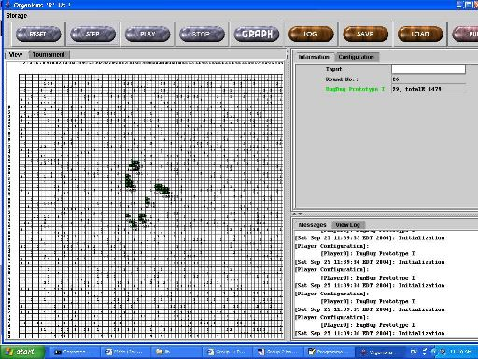
Figure 1. After 26 moves, three small flocks have formed. They “follow the leader” in search of food.

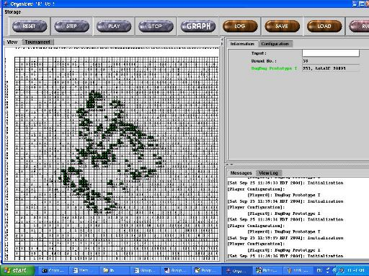
Figure 2. After 58 moves, each flock has expanded greatly. They start to spread out to the point where they are combining, forming a “ripple effect”.

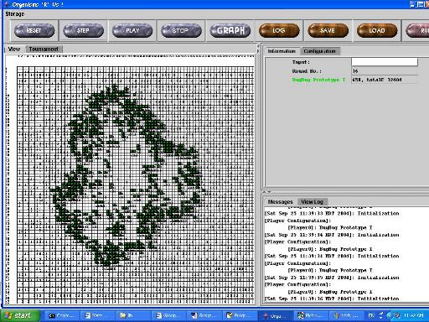
Figure 3. After 76 moves, a complete ring has been formed, and the flocks start to move out in all directions in search of more food. Most of the food inside the ring has been consumed.

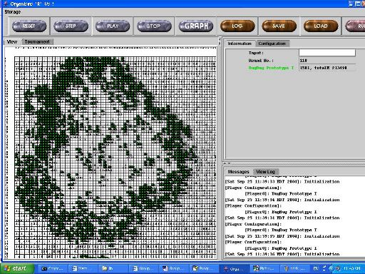
Figure 4. After 110 moves, organisms on the inside of the ring have started to “clean up” and consume any food that is left inside.

Unfortunately, the flocking strategy that we prototyped could not survive in the long-term. In class we talked a bit about the two “epochs” of the game cycle. The player did very well in the first epoch, multiplying rapidly and swarming the board. However, we had hoped that even if a majority of them died, the initial huge population would provide a competitive advantage for the survivors by preventing the opponents from getting strong. This did not happen, and the player did not have a strategy for the late game, and as a consequence quickly expended its energy and died off. Also, the strategy of flocking is based on moving as much as possible. However, this results in expending too much energy in most settings, and essentially makes the organism too aggressive about finding food, contributing to quick extinction of the population in the second epoch of the game.

Areas for future development
Though we decided not to pursue the flocking idea past this initial conceptual design, we are convinced that it could be developed into an effective strategy, and urge future development teams to consider it as part of their approach. However, the following considerations would need to be taken:

- First, that it is critical to have two game strategies for the different phases or epochs of the game. This is because the conditions and strategy are drastically different in the two phases, and any well-designed organism is going to have to adapt for this change, or at the very least be specialized for the second phase versus the first. Flocking handles the first phase very well, but a second phase would need to be incorporated into the organism.

- Second, it is quite difficult to ‘tune’ the reproduction rates of the organism. We tried to do this online with the probability function, but it still required quite a few offline adjustments of equation constants before the organism could reliably survive even the first few rounds. Future efforts to develop this strategy would need to perform more offline testing to determine these rates.

- Lastly, the excessive amount of movement inherent to flocking isn’t necessarily a strong strategy under sparse food conditions. Moving a lot only wastes energy, and a well-designed organism is most likely going to move relatively little in comparison to our flocking player. Any team who decides to develop flocking more would need to consider situations in which the amount of food is low, and tailor flocking to handle those situations more gracefully.

Farming (Diamond Farm)

The idea of farming is based on the concept that a group of organisms could protect a number of squares in the hopes that food would appear and/or grow there. The organisms could then profit from this food growth because they would not have to expend much energy in obtaining the food.

Although it was explored heavily in the Fall 2003 project, the concept of farming became widely discredited amongst this year’s class, as groups began to feel that the tradeoff (of staying in one place versus moving to find food) was not worthwhile. However, we decided to stay with farming for the following reasons:

- Farming could conceivably maximize energy in single-species settings that are considered to be “lush” (high frequency of food appearing and growing). This is because the farmers could conserve energy by letting the food come to them.

- Farming could be used as a protective mechanism in multi-player settings or “harsh” environments. The reason is that the farm could act as a blockade to other organisms’ strategies and protect a food source. This is admittedly more of a side effect than part of the initial strategy, however.

- Farming might be useful in combination with another strategy, such as hunting or even flocking as described above. It would allow our species to have some “conservative” members (the farmers) and some “aggressive” ones (the hunters).

- The basic concepts and structures of a “farm” could, in the future, be further developed into things like a lattice network or a “checkerboard” (this concept was evaluated by Group 1 of last year’s class, but eventually disregarded; more investigation might reveal a simpler solution for solving the problems they encountered). These “super-farms” would be more complex in implementation but could give the organisms more space to grow food and provide a more secure environment for “nurturing” the organisms.

As discussed above, we agreed with the findings last year and the oft-expressed opinions this year that anything bigger than a 2x2 farm would be difficult to implement and would likely have low yield (because of the costs associated with creating and maintaining the farm).

However, we subscribed to the belief that a “diamond farm”, in which four organisms blocked off one square of food, would be a useful strategy. We arrived at this idea independently of our research into last year’s work, but did later learn that some groups (notably Group 1) implemented a similar technique. The diamond farm could potentially reap the benefits of farming as described above, but also would require few organisms, little coordination, and less space, and there would be less likelihood of interference from other species’ organisms.

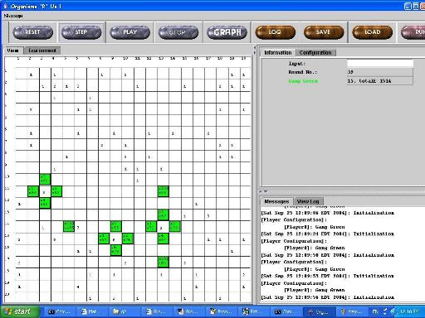
Figure 5. Three diamond farms protecting food sources. The organisms not in the farms are looking for food so that they can start their own.

In choosing this strategy for our implementation, we fully understood that we were limiting our likelihood of success to very specific conditions: when food was abundant, and when there was plenty of room for expansion on the board. This meant that we probably would not fare well in multi-species environments, and we accepted that, based on our belief that we could build very strong organisms for those particular conditions.

Implementation

We developed two implementations of the diamond-farm approach: Gang Green and Emerald Miners. The basic concept behind each is similar, but each tried to add important new features to the idea of farming.

Group2Player2: Gang Green

The “Gang Green” organism is designed to act in one of two roles: hunter or farmer.

The hunting strategy is fairly straightforward: keep looking for food until you have enough energy to either reproduce or start a farm. In hunter mode, if the energy level is high enough, the organism prefers to farm instead of reproducing (and creating another hunter). Changing the order of this preference tended to have very little impact on Gang Green’s performance in our offline testing.

The farming strategy was based on the “diamond farm” concept described above, with some additional features. Most importantly, a farmer will look for food not only in the farm (i.e., the square surrounded by the farmers), but also in the squares adjacent to it (outside the farm). Though this occasionally would leave the farm open to intruders, in most environments this was not a serious risk, and it gave the farmer three additional possible food sources. Another additional feature is that farmers in this strategy would also reproduce and create a new hunter if their energy level were high enough.

One last feature about Gang Green farmers is that they would leave the farm if their energy level were dangerously low or if the farm was not producing enough food. The farmers would observe the surroundings for at least 10 turns. After that, they could estimate how much food was appearing on the board (by measuring the ratio of how much food exists to how many squares have been observed). Based on this, the farmer can estimate how many turns it would take to go find food if it left the farm. If the farmer’s energy level is below that amount, then it would leave the farm and try to find food on its own. The formula for determining the energy level at which to leave the farm is

M – [(turns * 5 * v) / (food * 3)] + v

where “M” is the maximum amount of energy per organism, “turns” is the number of turns the organism has been observing for, “v” is the amount of energy used per move, and “food” is the amount of food the organism has observed. The number 5 comes from the fact that an organism observes 5 spaces per turn, and the 3 comes from the number of new spaces the organism could observe on each move. If the organism has observed no food at all after 10 turns, then it leaves the farm.

By adding an element of “hunting” to the basic idea of “farming”, we felt that Gang Green had an advantage over pure farmer implementations.

The following provides a high-level description of how Gang Green works. The very first organism starts out as a hunter, and then each one follows this algorithm:

If it’s a hunter:
- If there is food in an adjacent spot, go grab it
- If you have enough energy, start a farm
- If there’s not enough energy for starting a farm, reproduce if you have enough energy
- Otherwise, keep hunting in the same direction that you were currently going

If it’s a farmer:
- See if you have enough energy to create a new hunter and reproduce if you do
- Look for food, first in the farm and then in a surrounding square
  - If you found food in the farm, see if the other farmers are still there; if not, leave the farm and hunt
  - If you found food in a nearby square, move back into place in the farm after you’ve eaten
- If there’s no food around and you’re low on energy, then leave the farm and hunt

Rules for hunting:
- If you remember seeing food on your last turn, move back to that spot and see if the food is still there
- If there’s food on a nearby square, move onto it
- If there’s another organism in the way, move away from it
- Otherwise, keep going in the same direction

Rules for setting up a farm:
- First, reproduce to the west
  - That child reproduces to the south
    - That grandchild moves east
- Then, reproduce to the east
- Finally, move north into the place in the farm
- If any of these moves are blocked, then wait

Rules for reproducing:
- If there’s food nearby, reproduce onto it
- If there’s another organism in the way, reproduce away from it
- Once you've found a spot to reproduce on, change direction according to the same rules

Gang Green is a fairly simple implementation of the logic, in that it does not have many requirements in the way of communication or environmental analysis (though some estimation is present and is explained below). Communication is mostly from parent to child, especially in regards to setting up farms.

Configuration
We did extensive testing of configuration for Gang Green. The organism had four major configuration parameters, three of which were tested off-line, with the remaining one determined during the organism’s lifecycle. These four are huntReproduceFactor, farmReproduceFactor, startFarmFactor, and leaveFarmLimit.

When an organism is hunting, it divides the maximum amount of energy (M) by huntReproduceFactor. If that organism’s energy is above that value, then it will reproduce. The huntReproduceFactor was set to a low value (1.5), which means that the organism would need to have a fairly high amount of energy (around 334 units by default) in order to reproduce while hunting. This number was set to be high because we wanted organisms to be able to continue moving around looking for enough food to farm. Setting that value to be at a lower energy level might cause too much reproduction and not enough energy to start a farm.

Once an organism is farming, it uses the farmReproduceFactor to determine whether or not it should reproduce and create a new hunter. This value is set to 4 also, so that a farmer will reproduce at about 125 units (by default). However, off-line studies showed that this variable had little impact on performance. That is likely to be because when the board is crowded, the organism might not be able to even reproduce at all, so a few dozen units here or there make no difference.

The startFarmFactor is used to determine the level of energy at which a hunter should start a farm. Off-line tests demonstrated that this value had the biggest impact on performance, especially in single-species environments. We needed that number to be high (we set it to 4) so that organisms would start farms even at relatively low energy levels (125 units by default), assuming there was enough room to do so. Because farming was inherent to our strategy, we felt that it would be okay for an organism to start a farm even at a somewhat low energy level, despite the toll it would take on that organism.

We tested Gang Green with various changes to its configuration, but only the value of startFarmFactor seemed to make any difference.

huntReproduceFactor | startFarmFactor | number of organisms | total energy | average
1.5 | 1.5 | 99 | 23087 | 233.202
1.5 | 2 | 201 | 74295 | 369.6269
1.5 | 3 | 224 | 92044 | 410.9107
1.5 | 4 | 235 | 101360 | 431.3191
2 | 1.5 | 68 | 10689 | 157.1912
2 | 2 | 172 | 51585 | 299.9128
2 | 3 | 228 | 97737 | 428.6711
2 | 4 | 211 | 89686 | 425.0521
3 | 1.5 | 52 | 5771 | 110.9808
3 | 2 | 72 | 7539 | 104.7083
3 | 3 | 225 | 92171 | 409.6489
3 | 4 | 204 | 84596 | 414.6863
4 | 1.5 | 47 | 4426 | 94.17021
4 | 2 | 60 | 6979 | 116.3167
4 | 3 | 224 | 93020 | 415.2679
4 | 4 | 224 | 95338 | 425.6161

These tests were run under “default” conditions but show that having a high value of startFarmFactor (meaning that organisms would have more of a tendency to start farms) had the greatest impact.

The last (and probably most important) configuration is leaveFarmLimit. This is the energy level at which an organism should leave the farm. The calculation of this value is described in the previous section. It is calculated online, and will vary according to game conditions. The organism uses it to determine how many steps it would need to take in order to find food.

Finally, as a side note, the calculation of leaveFarmLimit (using the formula described above) is also used while hunting. If a hunter realizes that there are sparse food conditions, it will slow down its movements in an attempt to let more food grow/appear, and hopefully the hunter can get some food without moving too far. This was something we experimented with towards the end of the project, as it appeared that our organisms were dying under harsh conditions due to too much movement. However, further analysis of this would be required to improve Gang Green.

Analysis of Gang Green
As a “farmer”, Gang Green was conceived and designed to do well in a single-species environment. The two main reasons for this should be quite clear by now:

- Farming as a strategy in general only works well when there is little competition for food, because organisms are very conservative and tend to stay in the same place. They typically maintain low energy levels in the early stages of the game (before the farms start returning food). Therefore, if other species are taking the food, farming will have little use.

- Because effective farming requires a lot of space to spread out, a multi-player environment would crowd the board and farming organisms would (a) be able to set up farms and (b) get trapped easily and would ultimately starve.

Despite attempts to make Gang Green more robust and to handle competitive environments more, we decided that we would stay true to the initial concept of “farming” and tune it for the single-species environment.

Gang Green thrived under single-species conditions, especially when food was plentiful. Here are some sample results from its solo test runs.

board size | P | q | v | u | number of organisms | total energy | average energy per organism | board coverage
15 x 20 | 0.01 | 0.02 | 10 | 100 | 219 | 92936 | 424.3653 | 0.73
30 x 30 | 0.01 | 0.02 | 10 | 100 | 677 | 283343 | 418.5273 | 0.752222
40 x 40 | 0.01 | 0.02 | 10 | 100 | 1180 | 495842 | 420.2051 | 0.7375
50 x 50 | 0.01 | 0.02 | 10 | 100 | 1900 | 798023 | 420.0121 | 0.76
100 x 100 | 0.01 | 0.02 | 10 | 100 | 7035 | 2630287 | 373.8859 | 0.7035

Notice how the average energy per organism is typically within “u” units of the maximum (500). This means that each organism has so much energy that it cannot eat anymore (because eating would put it over the maximum). We feel that this is as much as could be hoped for under these situations. We also feel that the board coverage of approximately 75% is an ideal number for sustaining multiple farms.

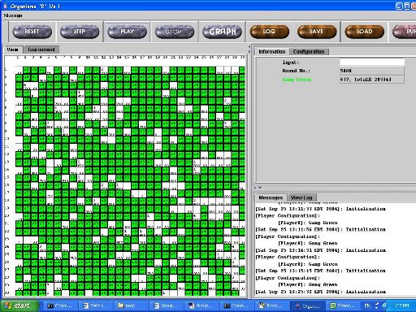
Figure 6. Gang Green after 5000 moves in lush conditions. Even the organisms that are “trapped” have high energy levels because of the amount of food they are sitting on.

When food was scarce and the game environment was very large, Gang Green still survived, though obviously with less impressive results. Its hunter/farmer nature allowed it to be conservative when there was little food (but still room to spread out, unlike in the mult-player game), or to gather and horde the food it found some. Though extinction did occur in some cases (like when the first organism was unlucky enough to be in a very sparse area), once some food was found, Gang Green was able to survive most of the time. Here are some typical results:

board size | p | q | v | u | number of organisms | total energy | average energy per organism | board coverage
300 | 0.01 | 0.001 | 10 | 100 | 69 | 5964 | 86.43478 | 0.23
900 | 0.05 | 0.01 | 10 | 100 | 95 | 9186 | 96.69474 | 0.105556
900 | 0.001 | 0.01 | 10 | 100 | 83 | 6293 | 75.81928 | 0.092222
900 | 0.001 | 0.001 | 10 | 100 | 52 | 7164 | 137.7692 | 0.057778

Group2Player3: Emerald Miners

Developed to take advantage of the benefits of farming with an eye towards player evolution, Emerald Miners is designed to occur in three varieties: scouts, colonists, and sentinels. Each is assigned a role at birth. The scouts and colonists are assigned to one of the four cardinal directions of the farm – N, S, E, W – and the sentinels belong to the four diagonal directions: NW, NE, SE, SW.

Scouts
Scouts are similar to “hunters” as described in Gang Green, but with more intelligence in how they look for food. The very first organism spends the first two turns splitting into four scouts, one for each direction. A scout travels in a pattern that favors its assigned direction. A scout on an empty square will always move towards food that is in an unoccupied square. A north scout, for instance, will move north if it sees food to the north, and if there is no food, it will check west, east, and then lastly south, the opposite from its natural direction. If no open squares with food are nearby, it checks in the same order for a space to move and then moves there. In this way, it may be diverted from a straight path, but its movement follows a trend in one of the four directions. They are designed to balance each other’s movement. For example, the north scout checks west before east, and the south scout checks east before west, and similarly for the east and west scouts.

Scouts follow this logic while moving:
- If a scout at any point is sitting on a single piece of food, we check its energy level e and reproduce under the following situation:

M/2 <= e <= 4M/5

Where M is the maximum allowable energy level. In this case, the scout will create a new scout whose natural direction is the opposite of its own. We chose this value as the one at which Emerald Miners should reproduce in order to conserve energy when energy is low (below M/2), and to start farms when energy is very high.

- If a scout is at any point sitting on more than one piece of food or has energy greater than 4M/5, it becomes a colonist. Unlike Gang Green, which preferred to set up farms (even at low energy levels), Emerald Miners will only do so when the energy level is high.

- If a scout at any point encounters a colonist at the center of a colony, it tries to move away, either onto food, or onto an empty space, regardless of its own energy or the presence of food in its current square. This is done to avoid disrupting a colony.

Colonists
When a scout becomes a colonist, it starts in the center state. It checks to see how many other organisms are nearby and if it is fewer than three, it creates new colonists until there are three. It then looks for an empty space and if it finds one, it changes its external state based on the direction of the empty space, waits one turn, and then moves to the outside of the colony.

All colonists are born as outer colonists, and are given information telling them where they were born in relation to the center of the farm. An outer colonist checks the state of the center of the colony every turn, and if discovers that a center colonist is signaling that it is next, it waits 23 turns and then tries to go to the center of the colony. It then becomes a center colonist, and communicates important state information with the other colonists.

Colonists act according to the following rules:
- If a colonist's energy is greater than 2M/5, it creates a sentinel in a clockwise direction with respect to the center of the colony. For example, a west colonist creates a sentinel to its north and a north colonist creates a sentinel to the east.

- If a colonist finds that it has not entered the center for more than 110 rounds, it reverts to a scout. A north colonist becomes a north scout, etc.

With this system, even if a colonist dies, it can be regenerated by the next colonist to enter the center of the colony. A colony can fall apart for one reason or another, but the colonists, after a while, will resume looking for food if they have been waiting too long for a signal to move to the center.

Sentinel
A sentinel is created as a small barrier against other organisms in an attempt to block them from disrupting the colony. A sentinel sits on one space for 25 rounds and then evaluates how many members of the same species it has seen recently. If it has seen fewer than eight in the last three rounds, it will become a scout with the same direction as the colonist that made it (a west colonist makes a northwest sentinel, which becomes a west scout). If it has seen eight or more friends in the last three rounds, it stays put and waits for that condition to change, in an attempt to avoid interfering with farms.

Communication
One of the advantages of Emerald Miners over the basic “farming” strategy is that it incorporated a more sophisticated method of recognizing organisms of the same species, and of communicating important farming information to them.

The first organism randomly chooses a 5-bit number as its ID. This ID is recomputed every term by the following formula:

new_ID = (ID + 3) mod 32

This way, it cycles one at a time through all numbers 0-32. These five bits are shown at all times as the upper five bits of each organism's external state and are passed on from parent to child. The latter three bits are used for communication beween a colony's center and the outer colonists, and scouts that might come along and need to avoid the colony.
The purpose of the ID is not to prevent other species from trying to fool Emerald Miners (we figured everyone would make a better use of their external states or just not bother trying to fool other organisms). Rather, the dynamic ID is set up mainly to lower the likelihood of an accidental, coincidental miscommunication from another species. Even if another species tried to copy Emerald Miners' states, it would only create a marginal effect compared to the effect created simply by its presence.

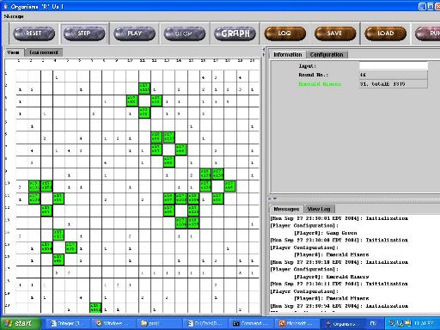
Figure 7. The Emerald Miners have started to form six farms. Sentinels are on the “shoulders” of the farms.

Analysis of Emerald Miners
Like Gang Green, Emerald Miners (true to its “farmer” roots) was known to only do well in lush, open environments. During its development, we immediately learned that securing a food source to sit in the middle of a colony was very difficult, because by the time all the colonists are born, the creator of the colony has usually eaten all the food. We tried making a requirement that the space have four or more units of food, but usually (especially in a competitive environment), the likelihood of finding that much food was slim. We lowered the requirement to two units of food, which we figured would be low enough but still give the founder of the colony enough energy to recuperate after spawning three children.

We also realized that having colonists continually going in and out of the center did not allow any food to grow, so we played with different waiting periods for the colonists to go to the center after getting the signal, and we settled on 22, which would be enough time for at least one unit of food to sprout in most conditions.

The sentinels were created as a measure based on the observation that most other species would envelop the colonies and stop them from functioning. The sentinels did help to some degree and were a novel method of introducing new offspring into the environment, but the organisms were still not sufficiently competitive against other species. Further development of Emerald Miners would need to strengthen the sentinels and make them more protective of the farm.

Tournament Results

Multi-species Environments

Only one of our players (Emerald Miners) was submitted for the multi-player tournaments. Its results were, as expected, not very strong. We knew to expect low results because, as has been discussed previously, the farming strategy requires much food and much space; the tournament was designed to provide neither of those. Emerald Miners’ strategy focuses more on staying still than on moving around seeking food, and as a result, it collected less total food than other species and had less fuel to reproduce. Once a faster growing species overwhelmed Emerald Miners, it had no chance of survival.

Though Emerald Miners tended not to survive the full 5000 rounds of the multi-species environments, it lasted the longest when the board was big (100x100) and when food was copious (p=0.02 and q=0.2). In those settings, it lasted an average of 3855 rounds, which was longer than all but one of the players that ultimately went extinct. Though this is admittedly nothing to cheer about, it did match our analysis of the organism and demonstrates that farming could be useful under the right conditions.

Single-species Environments

Gang Green fared very well relative to other species in the single-species tournament, having the highest number of remaining organisms in two of the simulations. In fact, no other organism won more single-species games. These results were as expected, because farming is an effective strategy when the farmer organism is not restricted and constrained by other strategies.

game number | board size | v | p | q | number | rank | energy | rank
1 | 50 x 50 | 10 | 0.005 | 0.01 | 298.34 | 17 | 27577.0 | 19
2 | 40 x 40 | 2 | 0.008 | 0.002 | 674.62 | 9 | 99069.0 | 13
3 | 40 x 40 | 10 | 0.005 | 0.002 | 144.59 | 18 | 10912.2 | 19
4 | 75 x 75 | 10 | 0.002 | 0 | 0 | 18 | 0 | 18
5 | 25 x 25 | 10 | 0.01 | 0.02 | 444.68 | 1 | 176051.8 | 1
6 | 50 x 50 | 10 | 0.01 | 0.02 | 1778.33 | 1 | 728841.8 | 1
7 | 50 x 50 | 10 | 0.005 | 0 | 223.74 | 18 | 16991.5 | 19

We think it is worth noting that Gang Green won game #6 by a huge margin, having far more than double the total energy of its nearest competitor.

Emerald Miners was also very successful in the single-player games, winning one game and finishing second (to its teammate, Gang Green) in another.

game number | board size | v | p | q | number | rank | energy | rank
1 | 50 x 50 | 10 | 0.005 | 0.01 | 999.55 | 1 | 192115.8 | 1
2 | 40 x 40 | 2 | 0.008 | 0.002 | 578.87 | 16 | 75430.9 | 18
3 | 40 x 40 | 10 | 0.005 | 0.002 | 287.85 | 16 | 25129.4 | 17
4 | 75 x 75 | 10 | 0.002 | 0 | 0 | 18 | 0 | 18
5 | 25 x 25 | 10 | 0.01 | 0.02 | 246.53 | 12 | 33484.2 | 15
6 | 50 x 50 | 10 | 0.01 | 0.02 | 1403.32 | 2 | 270583.8 | 3
7 | 50 x 50 | 10 | 0.005 | 0 | 433.63 | 16 | 37121.8 | 17

Not surprisingly, both Gang Green’s and Emerald Miners’ performances in the single-species environment were almost completely linked to the value of q. In an environment where q is high, food is likely to reproduce more, and farming will pay off because a food source is protected and ultimately is more likely to create more food to sustain the organisms. When q is low, then farming tends to be ineffective because any food that is found is not likely to grow, and so the four organisms guarding it are probably going to starve.

Conclusion and Lessons Learned

Areas for improvement
While we would consider this project successful for having reached the objectives described below, there certainly is room for improvement. Our admittedly poor showing in the multi-player tournament aside, the primary situation in which we could have improved was when food was scarce. Future implementations of our organisms should be a little more conservative when it comes to hunting for food, and perhaps a little smarter about how they calculate board crowding and the availability of food. This could be developed through the organisms’ observations, communication with other organisms, or a combination of both.

Another general problem that we never completely solved was that our organisms sometimes “choked” each other by surrounding them and thus blocking them from getting more food. The more successful teams in this year’s project tended to have implementations that allowed their organisms to spread out and not get clustered together. This was especially a problem for Gang Green; any further development would need to take this into consideration.

Accomplishments
Someone famous (and yet unidentified) said, “Do one thing and do it well”. That’s what we attempted to do in this project. It was theorized in class that the so-called “ultimate organism” would be one that could survive in any environment, and many other groups emphasized the importance of the multi-organism tournament as a matter of pride and of programming and algorithm superiority. And while we admit that we would like to have done better in the tournament for those reasons, we are quite satisfied with what we accomplished here. Not only did our organisms win three of the seven single-player games, we also achieved the following goals in this project:

- We improved a previous concept by taking the basic idea of farming and adding additional features that enhanced organisms’ performance. These features (like leaving the farm to get food, calculating the average distance to food, protective “sentinels”, and improved communication) could further be developed to make farming a strong part of a larger, more comprehensive strategy.

- We created a unique concept, “flocking”, that could be used in future development of this project. Though it ultimately was disregarded, we showed that it has potential to be successful under particular circumstances, and that there are still strategies to be explored and room for creativity in this project.

- We laid down the foundation for continued development of each idea through thorough documentation and testing of parameters and configurations. Even though farming is now in its second generation, we have shown that there are still ways and areas in which it can be better.

Based on having accomplished these three things, we feel that this was certainly a successful project.

Acknowledgements
- As mentioned frequently in this document, many of the ideas regarding hunting and farming (especially the diamond farm) came from Group 1 of last year’s project.

- Gang Green’s strategy for setting up the farm in a minimum number of steps was based on that of Mutant X from Group 7 of last year’s project.

- The references to “spreading out” as being a suggested area of improvement were based on the findings and contributions of Group 7 of this year’s project.

