Subway Information Domain

What is the domain about?

The system is designed to be used in a kiosk inside in a subway station to direct tourists and NYC residents to the correct train for their desired destination. The system will direct tourists from a preset origin location to anywhere else in New York. For the purposes of our project, we have chosen the 42nd Street Times Square station as our origin location. It specifies the first train that the user should take out of Times Square. It will not tell the user the connecting trains that he/she should take after the first train. Furthermore, the system can accept both cross streets (e.g. 79th street and Broadway) and named locations (the MoMA) as input for the destination. While the system assumes the user wants to take the next train out, the user can also specify a specific time that is later in the same day to query. The system posts a webform to HopStop (http://www.hopstop.com/ws/GetRoute) to look up real train directions from Times Square. Hopstop returns an XML file that the system can parse to get the answer to the user’s question.

What sorts of questions can be asked?

Since this is a spoken dialog system, it is designed to handle conversation-like questions. Figure 1 on the next page shows all the possible transitions that can be made in the spoken dialog system. We will explain the state machine below. We will then provide two examples of possible conversations with the SDS.

The system first greets the user and explains its purpose in the “Greeting” stage. It then prompts the user on whether he or she will be providing the destination as a cross street or place name. Depending on which option the user chooses the system would prompt a different message next. If cross street were chosen, the system would prompt the user for the exact cross street and then confirm after the user replies. If the system got the cross street wrong, it will break up the cross street into avenue and street and ask the user separately. Alternatively, if the user chose to provide a place name, the system will use a different set of grammar and listen for a landmark name (e.g. the Met) instead. Just like with the cross street, the system will prompt for confirmation. Once the system returns the train information, the system will ask the user if he/she wants train information for a different time of the day. If yes, the system will prompt for the time. The user has a choice of either saying an absolute time (e.g. 5 pm) or a future relative time (e.g. in 3 hours). The system again would prompt for confirmation and provide the results. The system would loop back and ask again if user states that the time is incorrect.
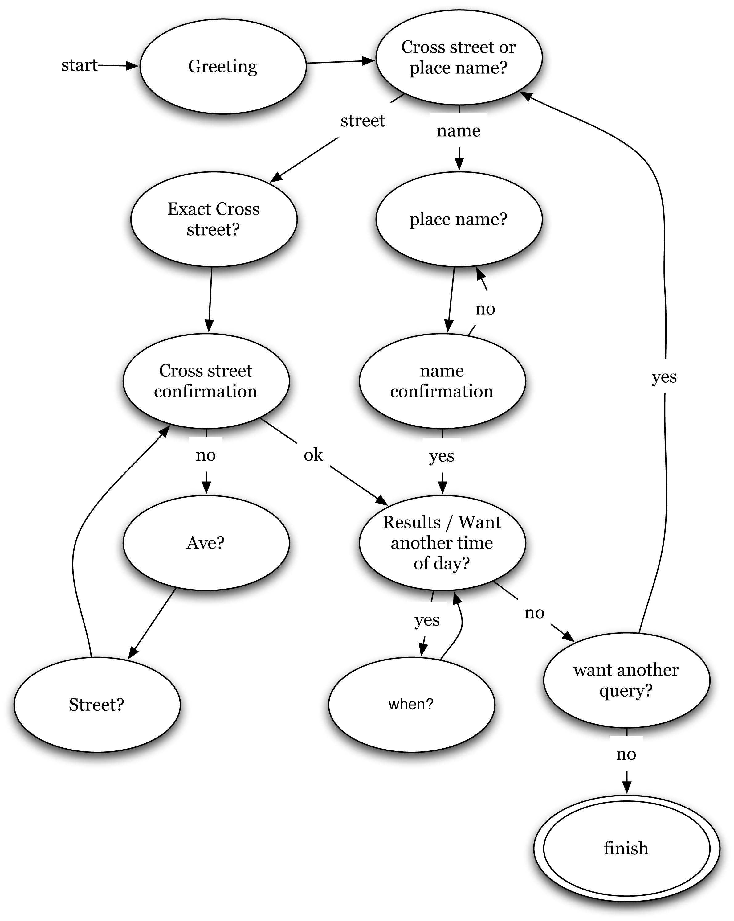
Figure 1: State Diagram

Example Dialog A:
System: Hi. This is the Times Square subway directions kiosk. If you want to go somewhere but don’t know which subway to take, you can ask me. Do you know the location by its cross street or place name?
User A: Cross street.
System: What’s the exact cross street?
User A: It’s 37th and Park Ave.
System: Just checking, did you say 37th and 1st Ave?
User A: No no, I said 37th and Park Ave.
System: Sorry, just checking again, you said 37th and 5th Ave? Is that correct?
User A: No no…I said 37th and Park Ave!
System: Alright, just give me the avenue?
User A: Park Avenue.
System: and the street?
User A: 37th street.
System: Great, 37th and Park Ave right?
User A: Yea…
System: The next train out to 37th and Park Ave is the S train.
System: Would you want to know about which train to take for a different time of the day?
User A: Yes
System: When?
User A: At 5 o’clock.
System: You said 6 o’clock right?
User A: No, I said 5 o’clock.
System: Oh you said 5 o’clock.
User A: Yea…
System: Great, the next train out to 37th and Park Ave at 5 o’clock is the S train.
System: Alright, would you like to make another query?
User: Nope, thanks.
System: Wonderful, have a great day at the MoMA!
Example Dialog B:
System: Hi. This is the Times Square subway directions kiosk. If you want to go somewhere but don’t know which subway to take, you can ask me. Do you know the location by its cross street or place name?
User B: Place name.
System: What’s the exact place name?
User B: The MoMA.
System: Great, you want to go to The Met?
User B: No. I said the MoMA.
System: Oh you said the MoMA. Is that correct?
User B: Yep.
System: The next train out to the MoMA is the V train.
System: Would you want to know about which train to take for a different time of the day?
User B: No. It’s OK.
System: Alright, would you like to make another query?
User: Nope, thanks.
System: Wonderful, have a great day at the MoMA!

Special features of the SDS
- Exact cross street prompts skips straight to asking for avenue and street separately.
  - If the ASR does not recognize what the user provided for the cross street, the state machine skip straight to asking for the avenue name and street separately.
- Exact cross street splits up for better accuracy
  - If a cross street is not recognized, either if a nonsensical phrase gets recognized or the user confirms the address is incorrect, the system will not ask for the cross street. Instead the system will ask just the avenue name, and then just the street name (separately), in order to better recognize the destination.
- Cross street and place name confirmation listens for possible correction
  - Even though the prompt does not ask explicitly for the user to repeat the destination and only asks for confirmation, the ASR still tries to listen for the cross street or place name in case user tries to correct system. The system would then skip asking for the cross street/place name and confirm with the new destination.
- Time is delayed until later.
  - Asking for the time (time is required by Hopstop) is delayed until later in the SDS. We are assuming that most users would want to know the next train out of Times Square at the time of kiosk use.
- System directs user to human after N failed attempts
  - System blames telephone company for errors (Easter egg). In a real system, SDS will redirect to human.
- Bids user farewell with their destination information
  - Adds personal touch to SDS. E.g. if user is going to the Met, the system will say “Wonderful, have a great day at the Met” as the final prompt.
Cross street destinations we support
14th <= Street number <= 116th
1st <= Avenue <= 12th
More specifically for named avenues, we support:
- Amsterdam
- Columbus
- Central Park West
- Lex/Lexington
- Park
- Madison

Named places we support
- The MoMA
- The Met
- The Whitney
- The Guggenheim
- Cooper Hewitt
- The Museum of Natural History
- Museum of Sex
- The Rubin Museum
- The Intrepid
- The Frick
- Columbia University
- Bryant Park
- Madison Square Park
- Grand Central
- Penn Station
- Empire State Building
- Columbus Circle
- Union Square

The area our system serves is chosen to provide enough coverage to demonstrate our SDS. We did not include streets below 14th street and above 116th street because streets are no longer in a convenient grid and it would have taken significantly longer to build a system to take care of those streets.

We have also fixed the origin to Times Square as the system is designed to reside in one location in a kiosk. Since our system queries the HopStop API, there is no reason why the system could not be augmented to take care of dynamic origin and final destinations.

