STEP BY STEP NAVIGATION W/ SCREENSHOTS

- Download Shareviz.jar and place in desired directory.
- Place the input files into the same folder as your jar (see below).

Linux
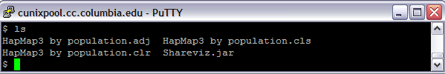
or
Windows (Eclipse)
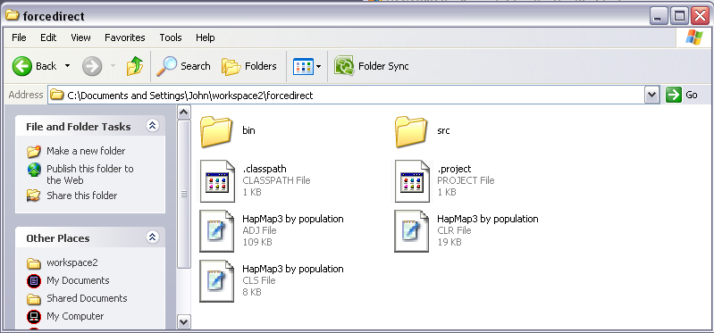
Linux

- Run the Jar: java -jar shareviz.jar
- Under Local Datasets, select the dataset that you loaded. In this case, all of the datasets were called “HapMap3 by population.*” so select that. Then click Load.
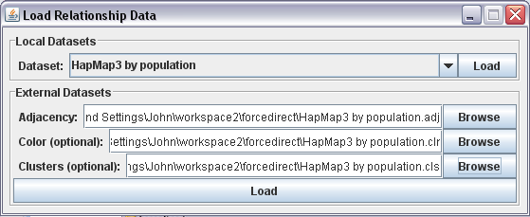
- The resulting interface should have you’re clusters (if you provided cluster) in a minimized energy fashion within each cluster. Then the clusters themselves should shift to a position that would minimize cluster to cluster interaction as well if you have links between clusters (see below).
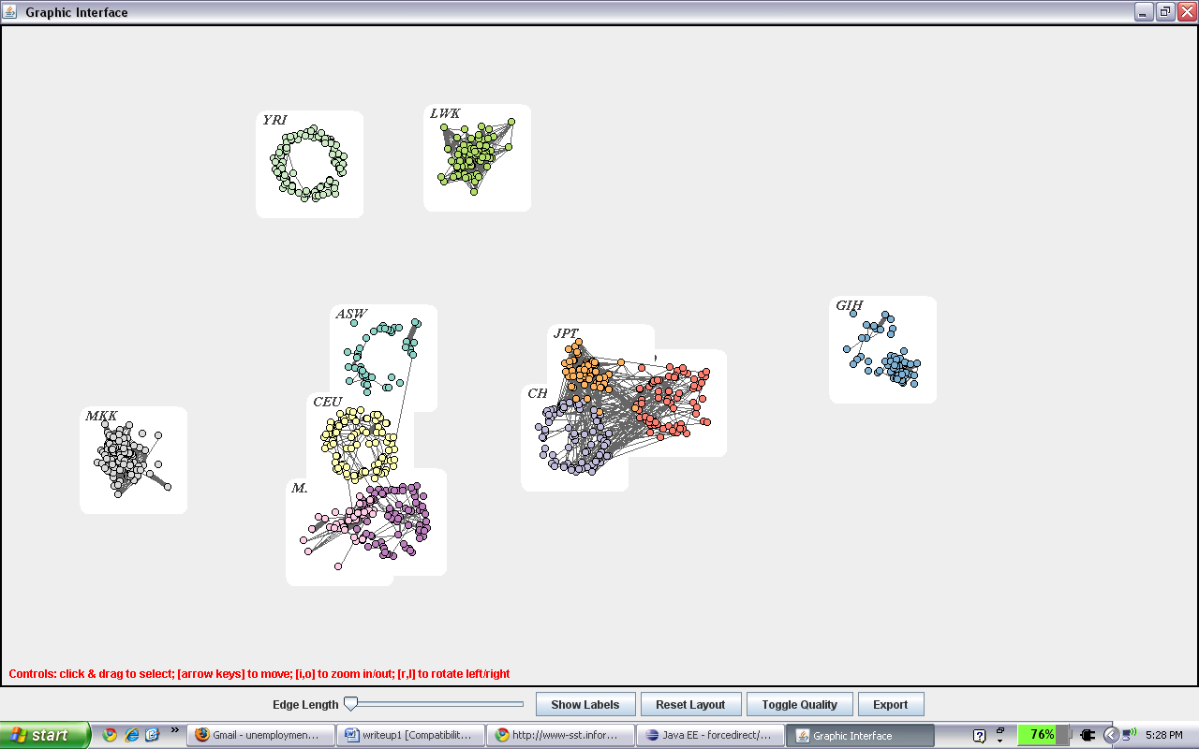
- [Feature 1] You can raise the minimum edge length that will appear by moving the slider up from the left to the right. Once the length is all the way up, no edges will appear. When it’s in near the right, only the thickest edges will appear (see below).
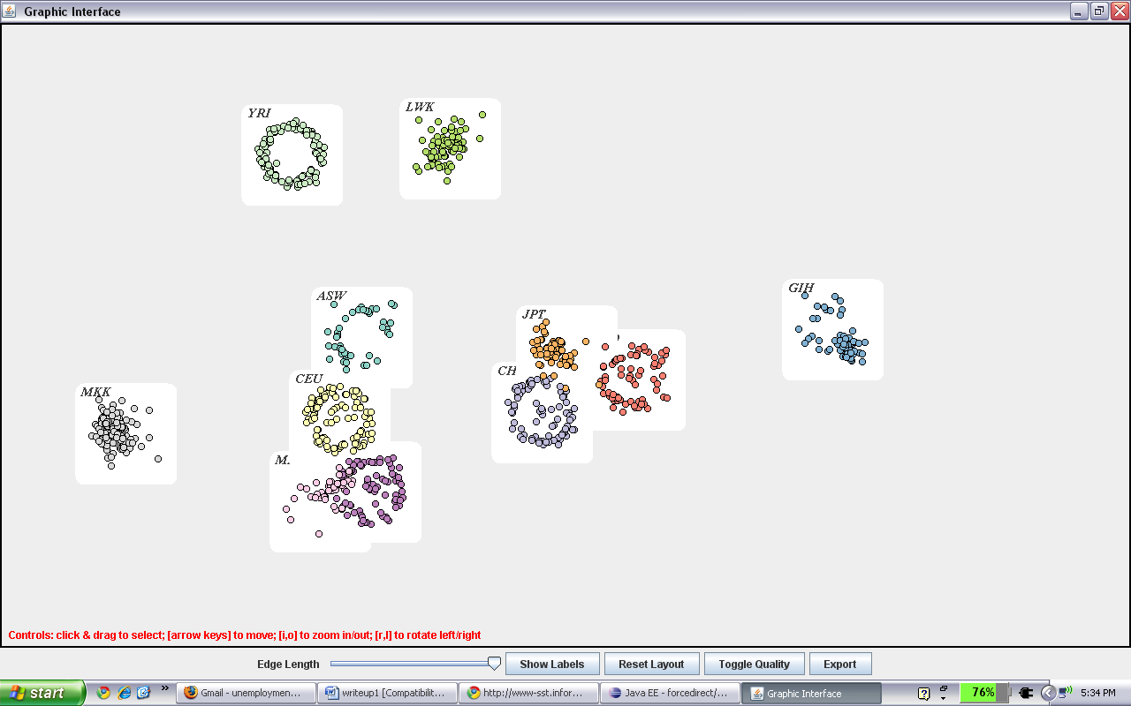
- [Feature 2] In order to zoom in, press “i” on the keyboard and “o” to zoom out (see zoomed in below).
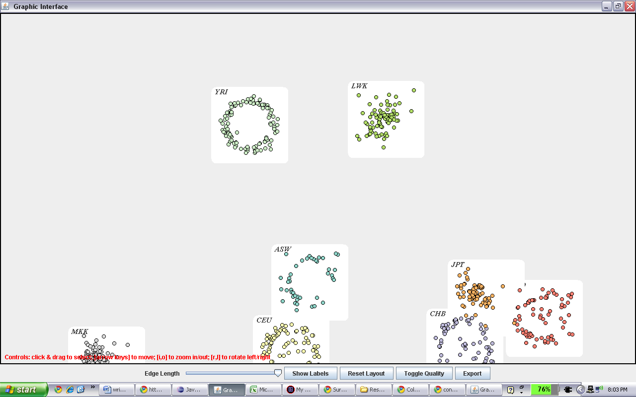
- [Feature 3] To rotate, press the keys “l” for rotate counterclockwise and “r” for rotate clockwise (see below rotated counterclockwise).
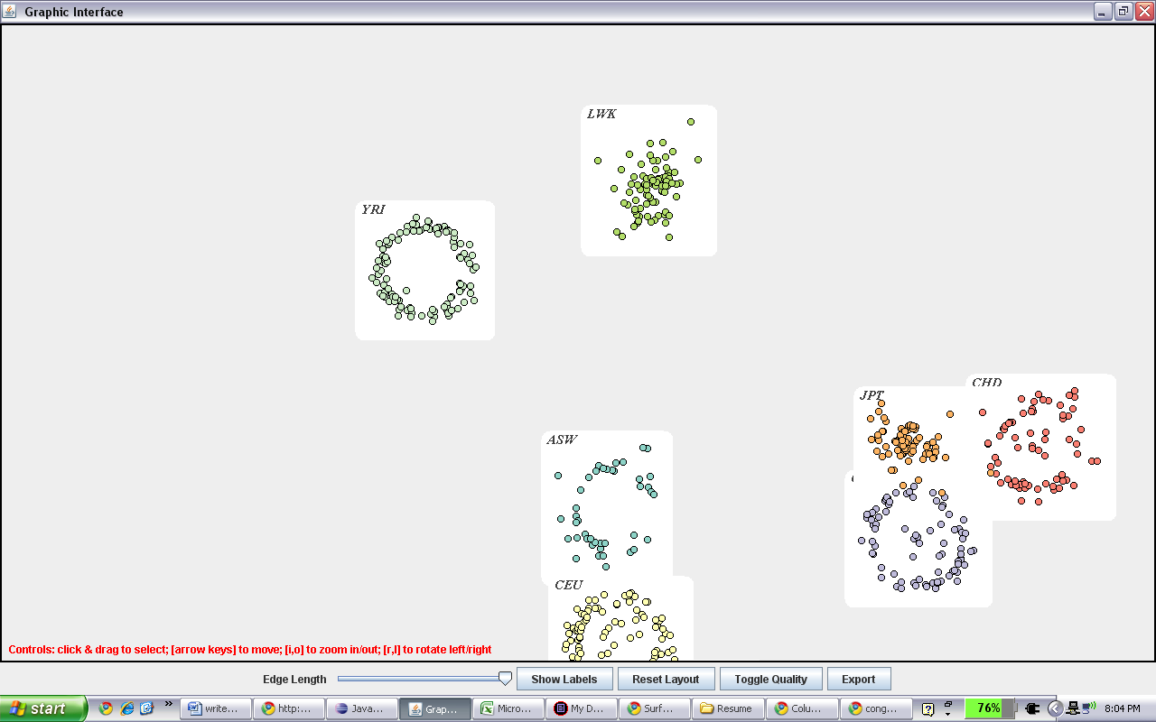
- [Feature 3] In order to move the picture up, down, left or right, use those respective keys on the keyboard.
- [Feature 4] To only zoom into or rotate a specific section, please take a mouse, click the top left corner of the selection, drag, and drop at the top right corner of the selection. Two red corners will appear marking the edges of your selection. Once in position, use the zoom in, out, rotate right, rotate left, move in any direction features freely only affecting that selection.
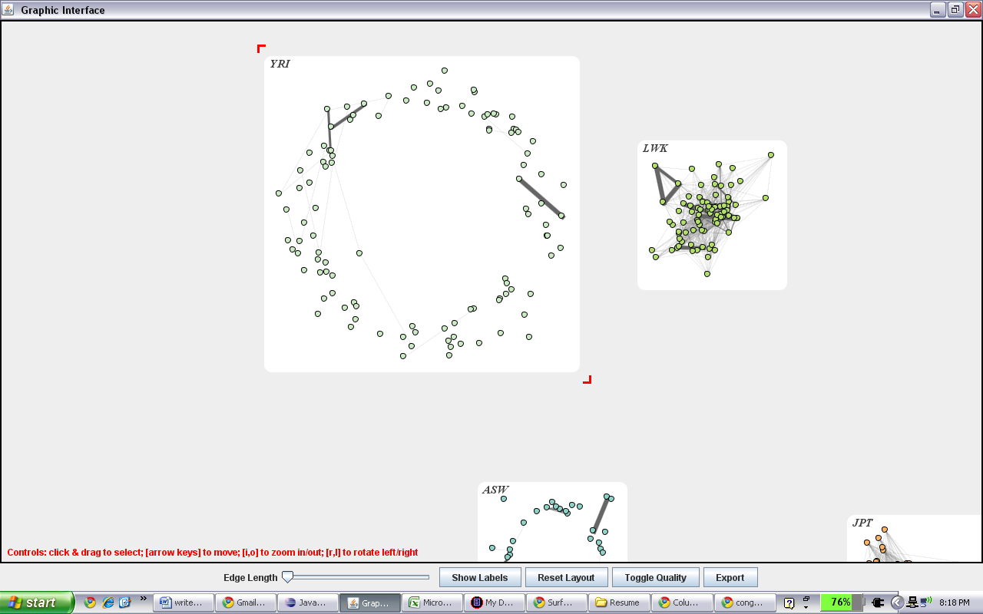
- [Feature 5] After playing with the picture, if you find that the layout must be resent, simply click reset layout and it will return to the original layout.
- [Feature 6] For a clearer picture, click toggle quality (see below)
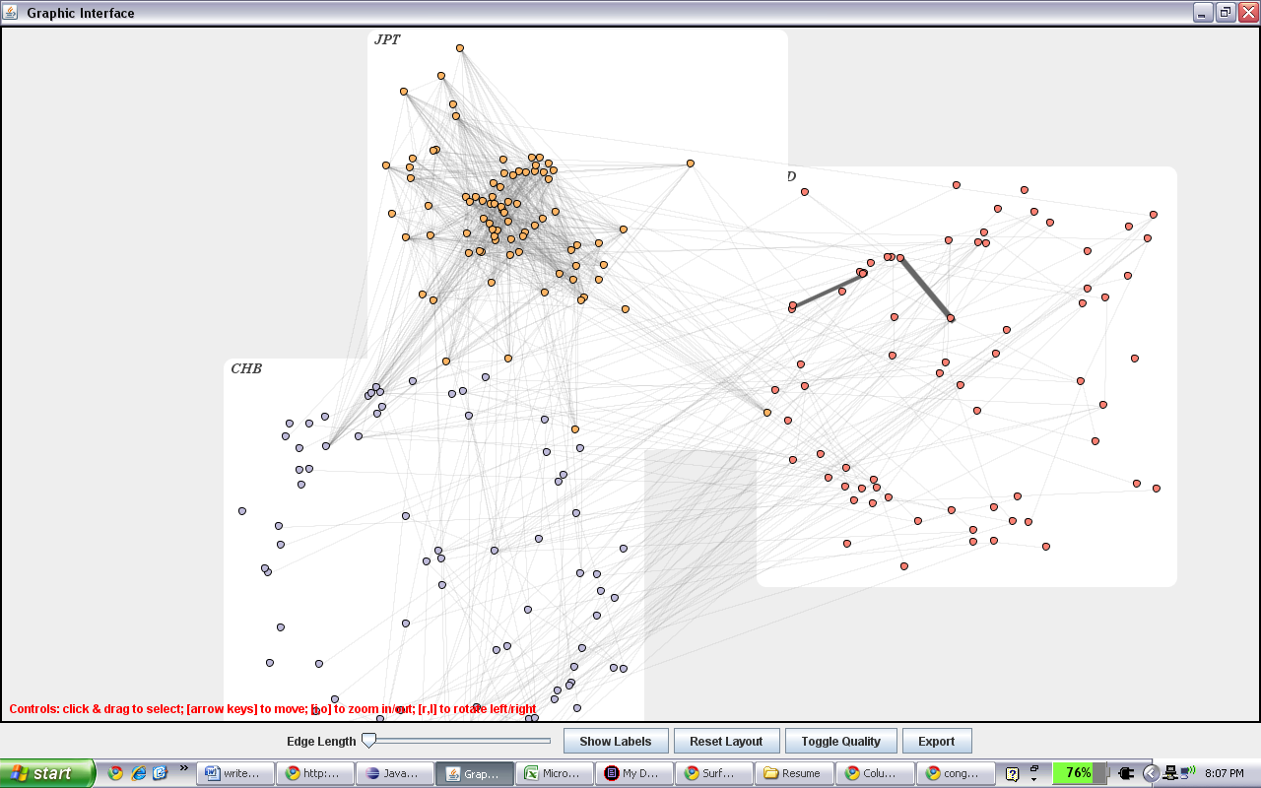
- [Feature 7] Feel free to export the picture as a png, simply click the export button, find a folder you’d like to save the file in, and in the address add a “\” + the name of the file. Then click the “save” button. For example, if you’re choosing to save in the C drive, you’re box should say “C:\saved”. Then just go to that place after you’ve clicked and see your picture there. The program will automatically also save a copy in the source folder with the name saved.png (see below).
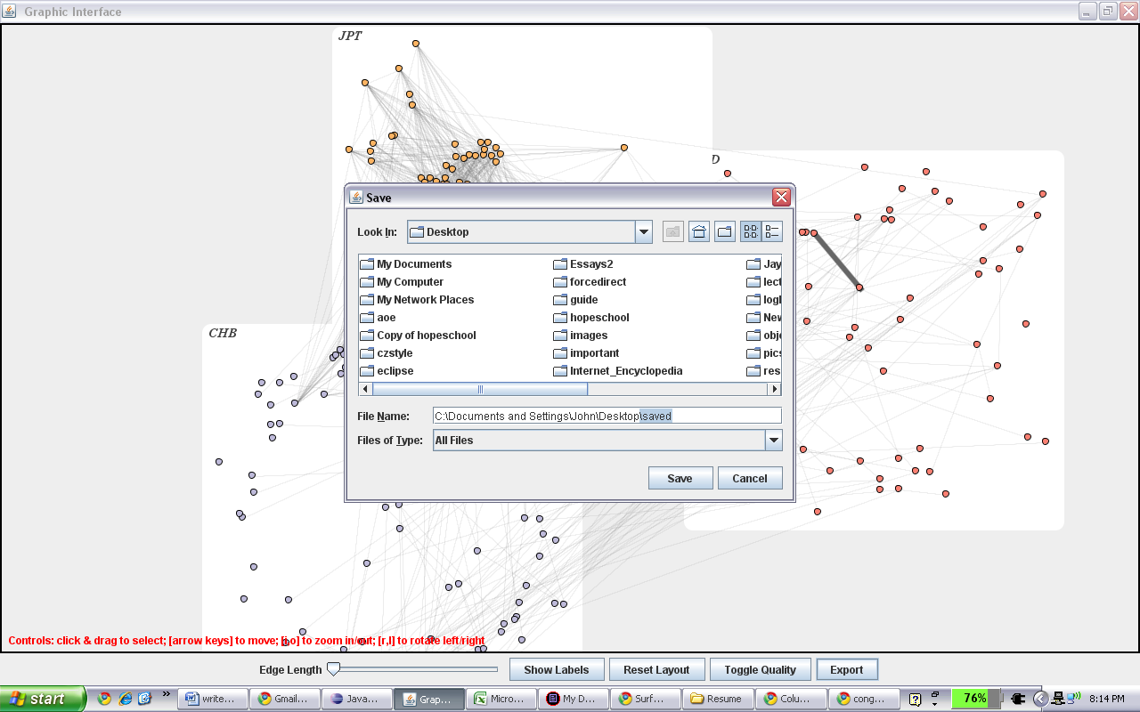
- [Feature 8] Clicking on a single node will also allow on the top right to appear a table, listing the properties of that single node.
