Implementation of Permission Based Sending (PBS) in Network Simulator 2 (NS-2)
Aniruddha Niranjan
Columbia University, Dept. of Computer Science
an2345@columbia.edu

ABSTRACT
The main objective of this project is to implement Permission Based Sending (PBS) on Network Simulator 2 (NS-2). The PBS Network Signaling Layer Protocol (NSLP) is implemented on the General Internet Signaling Transport (GIST) Network Transport Layer Protocol (NTLP).

INTRODUCTION

Overview of PBS
The primary aim of the PBS Network Signaling Layer Protocol (NSLP) is to prevent denial-of-service attacks and unauthorized traffic on the Internet [3]. It involves permission state setup to authorize flow of traffic between nodes, which is a proactive component. Also, after authorization the flow is monitored in order to detect and take action against attacks. This is the reactive component of the protocol.
The permission state setup and maintenance is done via the explicit handshake mechanism using the PBS QUERY and PBS PERMISSION messages. These messages are sent on-path.
The authentication of traffic between PBS nodes is achieved through the installation and maintenance of permission states. The query message requests the permission. In response to the query messages, permission messages are sent back along the same route. This message is used for permission state setup and maintenance on the routers. Also, the sender of the permission message sets up the proper state information as well.
Further, PBS is a soft-state protocol. The state that has been setup throughout a particular route will last only for a specific amount of time. Within this time, the node that requests permission must send a refresh query message to maintain that state. Otherwise, the state will be removed and the permission states will have to be re-established.

PBS Detection Algorithm (PDA)
The PDA makes use of the PBS signaling messages to ensure that only traffic for which permission states have been installed on the PBS networking entities pass through the network. The sender of traffic includes in its signaling message the amount of data that it has sent so far and this is verified by the PBS routers as well as the receiver. The PBS query message is used as the signaling message for this purpose and is sent at regular intervals of time after the establishment of the permission states.

An attack is detected when the amount of data that the sender claims to have sent does not match the amount of data that the receiver or an intermediate router has received. Other possible attacks are complete or selective dropping of packets by a malicious router on the path from the sender to the receiver. When these types of attacks are detected, the nodes either change the cryptography algorithm used or change the path of the traffic flow.

Overview of Network Simulator-2

NS-2 is an object-oriented and event-driven simulator [4]. It consists of C++ core methods and uses Tcl and Object Tcl shell as interface allowing the input file (simulation script) to describe the model to simulate.

Users can define arbitrary network topologies composed of nodes, routers, links and shared media. A rich set of protocol objects can then be attached to nodes, usually as agents. The simulator suite also includes a graphical visualizer called network animator (NAM) that enables the users to get more insight into their simulation by visualizing packet trace data.

User’s View of NS-2
As shown in Figure 1, in a simplified user’s view, NS is an object-oriented Tcl (OTcl) script interpreter that has a simulation event scheduler and network component object libraries, and network setup (plumbing) module libraries (actually, plumbing modules are implemented as member functions of the base simulator object). In other words, to use NS, you program in the OTcl script language.
To setup and run a simulation network, a user should write an OTcl script that initiates an event scheduler, sets up the network topology using the network objects and the plumbing functions in the library, and tells traffic sources when to start and stop transmitting packets through the event scheduler. The term "plumbing" is used for a network setup, because setting up a network is plumbing possible data paths among network objects by setting the "neighbor" pointer of an object to the address of an appropriate object. When a user wants to make a new network object, he or she can easily make an object either by writing a new object or by making a compound object from the object library, and plumb the data path through the object. This may sound like complicated job, but the plumbing OTcl modules actually make the job very easy. The power of NS comes from this plumbing.

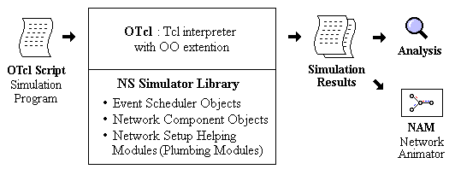
Fig 1. Simplified User’s View of NS-2
Another major component of NS beside network objects is the event scheduler. An event in NS is a packet ID that is unique for a packet with scheduled time and the pointer to an object that handles the event. In NS, an event scheduler keeps track of simulation time and fires all the events in the event queue scheduled for the current time by invoking appropriate network components, which usually are the ones who issued the events, and let them do the appropriate action associated with packet pointed by the event. Network components communicate with one another by passing packets, however this does not consume actual simulation time.
All the network components that need to spend some simulation time handling a packet (i.e., need a delay) use the event scheduler by issuing an event for the packet and waiting for the event to be fired to itself before doing further action handling the packet. For example, a network switch component that simulates a switch with 20 microseconds of switching delay issues an event for a packet to be switched to the scheduler as an event 20 microseconds later. The scheduler after 20 microseconds dequeues the event and fires it to the switch component, which then passes the packet to an appropriate output link component. Another use of an event scheduler is timer. For example, TCP needs a timer to keep track of a packet transmission time out for retransmission (transmission of a packet with the same TCP packet number but different NS packet ID). Timers use event schedulers in a similar manner that delay does. The only difference is that a timer measures a time value associated with a packet and does an appropriate action related to that packet after a certain time, and does not simulate a delay.

IMPLEMENTATION OF PBS ON NS-2

Architecture
The architecture is divided into the interactions between GIST module [5] and PBS NSLP and the components of the PBS NSLP module.

GIST and PBS Interaction
The PBS NSLP module makes use of the transport services of GIST to carry messages along the signaling path. The Query messages are sent from a PBS Sender to a PBS Receiver through a set of PBS Routers along the path. Also the GIST module parses the packets and delivers them to the appropriate NSLP upon reception at any node.
The interfaces for the interaction between GIST and PBS NSLP modules are as follows.
When a PBS related scripting command is given in a Tcl script, the command() function in Gist.cc file of the GIST NTLP module is called in order to determine the actions that need to be taken. The commands given in a script are passed to the command() function in the form of the character array argc. Firstly, the first member of this array is compared with the word “pbs” to detect commands in the script related to PBS.
The syntax of PBS commands are as explained in section 2.3 of this report. The third argument of a PBS command in the Tcl script is either “query” or “data”. If it is the former, then the variable PbsType_ is initialized to PBS_MESSAGETYPE_QUERY within the command() function. The volume that is requested by the sender is argc[4] and requested_volume is initialized to this. Also, data_volume is set to zero for the query messages. The sendPbs() function of the Pbs class is called to pass the packet details to the module that handles initialization of the parameters necessary for PBS operation. In response to this PBS Query message, PBS Permission message will be sent back by the target of the query message.
The other part of the transfer of control from the NTLP to the NSLP is when a packet arrives from a lower layer in the network protocol stack to the GIST NTLP. The NTLP maintains a finite state machine (FSM) of its own. As seen in the file gistFsm.cc, the getSignalingAppID() is used to extract the identifier for the NSLP to which the packet belongs and the appropriate handleRecvMessage() function is called.
Similarly when the NSLP has to send a message to the NTLP, control must be transferred in the opposite direction. In this case the functions instances of the GIST FSM’s are created in the main module defined in the file Pbs.cc. Then the appropriate events in the GIST FSM are triggered from the PBS module so as to enable this transfer of control.
Figure 2 shows the interface called in either directions for the flow control transfer between GIST and PBS. The PBS NSLP runs on top of the GIST NTLP. The functions for flow transfer used are mentioned alongside the direction of the flow transfer.
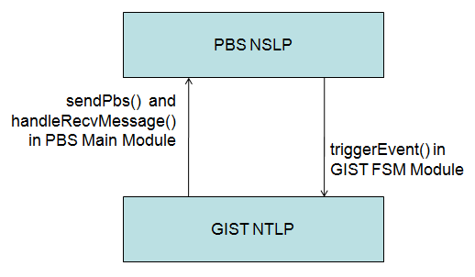
Fig 2. Interaction between GIST NTLP and PBS NSLP

PBS ARCHITECTURE
The different components of the PBS module implementation are shown in figure 3.
In the following subsection the descriptions of the functions implemented in the different files of the PBS module to carry out different tasks in the operation of the PBS protocol.
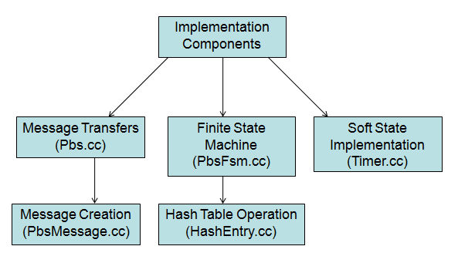
Fig 3. Components in the implementation of PBS module

Details of PBS Code

Main PBS NSLP Module – Pbs.cc
The constructor of the Pbs class takes the local address of the node and the gist object associated with the node as arguments. The attributes needed are initialized such as the local address, the destination address and the gist object attached to the current pbs object. The major functions are as described in the following parts.

sendPbs() Function [lines 46 - 90]
As described in the previous section, the sendPbs() section is the interface that transfers control from the GIST module of ns-2 to the PBS module. A variable of the type PbsFsmData is created and its values are initialized. For the PBS operation, the important fields that are initialized are the requested volume if the packet is a query, data volume if the packet is a data packet. Variables of the PbsQspec and Traffic are initialized. These functions are required to put the query fields into the message buffer that is the actual NSLP data that is used as the argument in the SendMessage() function later. The message->getBuffer() function call fetches the buffer which contains the fields such as requested volume, sent volume and if necessary data volume. Also, the message->getLength() function gives the length of the NSLP data in bytes. Finally, the triggerEvent function in the data->fsm object is called with the event EV_TG_QUERY and the PbsFsmData object data as arguments.

handleRecvMessage() Function [lines 94 - 300]
The handleRecvMessage() function is called from the GIST module whenever a packet is received from the lower layers. Its function is to identify the type of the packet, extract the necessary fields and pass the control to the appropriate component of the finite state machine module of PBS. The memcpy() function is an important part of the code of this module. Its purpose here is to extract a specific part of a character stream and assign this data to a specified variable. It takes three arguments – the address where the extracted data needs to be stored, the starting address of the required data and the length of the data.
Firstly, the type of the packet that has been received is stored in the nslpType variable in order to invoke the required part of the FSM. If the nslpType is a PBS query message, the fields requested volume and sent volume need to be extracted. Also, the data volume field is extracted and stored. Before invoking the FSM, all these fields are stored in the data->pbs_ object for further analysis. Next, we check if the current node is the intended receiver of the query or a router along the path to the final receiver. If the destination address is not the local address of the node, then the current node is a router. In this case a PBS FSM with the PBSROUTER identifier is created. Other information such as the message routing information (mri) and nslp_data fields are also set. Alternatively, if the destination address of the packet and local address of the node are equal, the packet is received at the intended receiver. Again, the fields that are set are similar to that in case of the router, except that a new FSM with the PBSRECEIVER identifier is created.
If the local address of the node matches the source address, then the permission message has been received at the sender of the corresponding query. Here, the allowed_volume as well the solution fields of the permission message are extracted using the memcpy() function.
In the case of a permission message being received at a router on the way to the sender, the router needs to install the permission state and forward to the message to the next node in the route. Again, the allowed_volume and solution fields are extracted and entered in the corresponding fields of the data->pbs_ objects. The routing information is stored in the data->mri object for future use. At the end of the handleRecvMessage() function, the data->fsm->triggerEvent() function is called with the event type and the PbsFsmData object data as arguments.

sendMessage() Function [lines 304 - 386]
The sendMessage() function is called whenever any message needs to be transmitted. It in turn calls the GIST NTLP functions necessary for transmitting the message over the network.

FSM Implementation – PbsFsm.cc
The setState() function takes the a value of the enumerated data type States defined in the header file PbsFsm.h as an argument and sets the state of the current FSM to the argument that was passed. Further, an approporiate status message is printed. The getState() function returns the state that a particular FSM is currently in. The finite state machine is implemented through the following functions:

Functions for PBS Query Transmission
The idle_tg_query() function (lines 243 - 275) is called when at any node, a query message is to be sent. It takes as argument the event identifier in the variable event and the arguments passed to it in args. Firstly, the args object is cast into an object of the type PbsFsmData which is defined in the header file PbsFsmData.h. Next, the tg_query function is called with the arguments event and args.
Similar to the previous function, tg_query() function takes the event and args variables as arguments. A cast is performed and the variable data of type PbsFsmData stores the contents of args. Next, the routing information is set for the correct path on which the message must be sent. The variable pc_mri of type msg_routing_info_path_coupled_t is declared and initialized to 0 using the memset function. Further the different attributes of the routing information variable is set such as – routing method, IP version, source and destination addresses and the direction of message transfer (upstream or downstream). Finally, a status message is printed and the SendMessage() function from the Pbs class is used to send the query. The arguments that the SendMessage() function uses is explained under the description of the Pbs.cc program file.

Functions for PBS Query Reception
The idle__rx_query() function (lines 71 - 81) just invokes the process_query() function (lines 83 - 214). In the process_query() function, a switch case is performed on the value of the data->nodepos element so that different processing actions can be taken depending on whether the PBS query message was received at a router or a receiver. When a PBS router receives a query message, its task is to parse the query message and forward it to the next node in the routing path, which may be the intended receiver of the query or another router. Again, the SendPermission() message of the Pbs class is used. The actions taken are again printed out on the screen.
If the datav field in data->pbs_ object takes a non-zero value, then the current packet received is a data packet. So, the hash table is referred to check whether the state has been setup for the transmission of data packets. For this, the GetHash() function is used with the parameters being the fields of the flow identifier. If the GetHash() function returns a NULL value, then the current packet is not forwarded to the next node in the path. A message is output to indicate the lack of state setup.
If the GetHash() function does returns a valid pointer to an entry in the hash table, then the state has been setup for the flow to which the current packet belongs. So, the values of the received_volume field in data->pbs_ is updated and checked if it exceeds the allowed volume for the permission state that has been setup. If the data volume sent so far is within the limits of the state, then the packets are forwarded and the hash entry is updated for this flow. The ModifyHash() function is used for this purpose. Otherwise, the packet is dropped and the state is removed from the hash table.
The packet arrival at a receiver is represented by the nodepos variable taking the enumerated value PBSRECEIVER. When the intended receiver gets the query message, it performs the necessary checks to determine whether the required permission can be granted to the PBS sender. Using the entries it has in its local hash table, the PBS receiver checks if there already exists an entry for the corresponding flow-id i.e. the 5-tuple. The function GetHash() in the file event_packet_hash_entry.h is used. If an entry does not exist, then a new entry is created in the hash table using the PutinHash() function. If an entry already exists, then the receiver knows that the query message being processed is a refresh query message sent in order to keep the soft-state alive. A permission message is sent back to the sender of the query using the SendMessage() function.
If the datav field in data->pbs_ object is greater than 0, the receiver treats the packet as a data packet of size datav. The hash entry corresponding to this flow is fetched using the GetHash() function. The received volume on the receiver side is recomputed and checked if it’s lesser than the allowed volume. If so, then the hash entries are updated with the recomputed value of received volume. If the received volume exceeds the allowed volume, then the corresponding hash entry is removed from the table by using the RemoveHash() function. Also, a permission message is sent back to the sender of the data packet with the allowed_volume field set to 0. The send_permission() function (lines 216 - 241) is used for this purpose.

Functions for PBS Permission Reception
The function responsible for this activity is inst__rx_permission() (lines 277 - 373). When the event occurred is the reception of a PBS PERMISSION message, the node is either a router or the sender of the QUERY message that resulted in the creation of this permission message. Routing information is initialized again, in the form of the object pc_mri. Also, the argument args is cast to PbsFsmData in order to access the fields that were set in the handleRecvMessage() in the Pbs.cc file.
If the PERMISSION message is received at a router, then the state is installed for the flow indicated in the message, if it is already not installed. If the result of the call to GetHash() function is NULL, the state is not installed yet. So, the state is installed using the PutinHash() function and the fields in the PERMISSION message are printed. Also, the SendMessage() function is called to forward the PERMISSION message to the next node in the route. If the state is already installed for this flow, then this message was generated in response to a soft-state refresh query message sent by a PBS SENDER. An appropriate status message is received and the message is forwarded to the next node in the route.

Hash Table Operation
In the operation of PBS, the permission states are stored in the form of hash entries at the PBS routers and receivers. A hash entry consists of the two tuple {<key>, <value>}. In the header file, the five tuple {source address, destination address, protocol number, source port, destination port} is declared. This will be used as the key while performing the hash operations. Next, the fields that will all be added as the data values into the hash table are initialized. These consist of the fields from the permission message and one extra entry for the amount of data sent corresponding to a particular flow.
In the constructor of the class, all the key as well as data value fields are initialized to 0. The operations that need to be performed on the hash tables are:
- Adding a hash entry
- Modifying a hash entry
- Deleting a hash entry
- Retrieving values stored in a hash entry
- Deleting all the entries in the hash table

The operations of the hash tables are implemented in the files event_packet_hash_entry.cc and event_packet_hash_entry.h. The fields in the ‘key’ and ‘value’ components of a hash entry are listed below.
Key: Source address
Destination address
Protocol number
Source port
Destination port

Value: Allowed volume
Sequence number of query message
Time to live
Refresh time
Public key
Solution
Authentication algorithm
Shared key
Authentication data

Function | Operation
GetHash() | Fetches a hash entry
ModifyHash() | Changes a hash entry
PutinHash() | Adds a hash entry
DeleteHash() | Removes a hash entry
ResetHash() | Removes all hash entries

GetHash() function [lines 11 - 30]
The GetHash() function takes the values for the five fields in the key as input. It declares a key[5] array and assigns these values one by one. Then the Tcl_FindHashEntry function is called with the address of the current table and the key initialized above. If a hash entry is found with the above key, a pointer is returned and this is stored a pointer entryPtr. This is returned to the function where the call to the GetHash() function was made. In case an entry is not found in the table, a null value will be returned to entryPtr, and an appropriate error message is printed.

ModifyHash() function [lines 32 - 99]
The ModifyHash() function takes the values for the five fields of the hash key as well as those for the entries in the <value> part of a hash entry. Again, a key[5] array is declared and initialized to contain the values of the tuple. Then a function call is made to Tcl_FindHashEntry to get a pointer to the hash entry in the table. Then, the entry that was just identified is deleted from the hash table. A new hash entry is created and a pointer initialized to it by making use of the Tcl_HashCreateEntry function. Finally, the key values as well as the data value fields are initialized in the hash entry that was just created.

PutinHash() function [lines 101 - 152]
Similar to the ModifyHash() function, PutinHash() takes the values of <key> as well as the <value> fields as its parameters. The operation of this routine is quite simple. The key[5] is initialized to store the 5-tuple. A call is made to the Tcl_CreateHashEntry function, which takes the table where the new entry is to be added. Then a pointer is returned to the new entry in the field. Using the new pointer hashPtr, the <key> as well as the <value> fields are initialized.

DeleteHash() function [lines 154 - 200]
The DeleteHash() function takes the values of the five <key> fields as the input arguments. The key[5] array is set up as before. A call is made to the Tcl_FindHashEntry() function with the table and the key as parameters. If the entryPtr variable which stores the value returned by this call has a null value, then a hash entry corresponding to this key was not found. Otherwise, the Tcl_DeleteHashEntry() function removes the entry making use of the entryPtr variable.

ResetHash() function [lines 203 - 216]
In the ResetHash() function, three different types of pointers of the following types are made use of – Event_Packet_Hash_Entry, Tcl_HashEntry, Tcl_HashSearch. The Tcl_FirstHashEntry takes the addresses of the hash table and the searchPtr and returns a pointer to the first entry to entryPtr. A while loop is setup in order to traverse all the entries in the hash table. The Tcl_HashValue takes the entryPtr as an argument and returns the hash entry into hashPtr. For deleting the hash entry, Tcl_DeleteHashEntry is called with the entryPtr as the argument. Also, hashPtr is deleted. Then the entryPtr is assigned the address of the next hash entry by making a call to the Tcl_NextHashEntry() function.

Soft State Implementation – Timer.cc
The files associated with the soft state implementation are Timer.h and Timer.cc. The soft-state module is called when the sender of a PBS QUERY message receives the corresponding PERMISSION message. The class SenderTimer extends the TimerHandler class provided by ns-2. It has two main an object of class Pbs and an expire() function [lines 90 - 96] that is used for the callback when the timer expires. The constructor takes the Pbs instance that called the schedule_after_s() function as the parameter.
The schedule_after_s() function [lines 65 - 76] is the function called for starting the soft-state timer by the PBS SENDER. It takes the same arguments that are necessary for sending a new PBS QUERY that will serve as the refresh message in the soft-state operation. After the sched(s) call is made, the timer will last for s seconds in simulation time. After the timer counts down the expire() function will be called. The parameters that were passed to the schedule_after_s() function are used. The sendPbs() function is called with this parameters with the t_ object of the SenderTimer class.

Message Creation – PbsMessage.cc
The PbsMessage.cc file basically contains management functions at the time of creating a message to be sent out by a node. It has constructors for creating messages as well as functions for deleting and rebuilding messages.

Tcl Scripting
In this section, we see the major steps taken to create a Tcl script for the purpose of simulating the operation of PBS.
The first step is to create a simulator object with the command set ns [new Simulator]. Then we open files for collecting simulation trace data as well as data required for the network animator. The trace-all and the namtrace-all commands are used to collect trace data and animator data respectively.
The next major step is the creation of nodes, the agents for different protocols associated with these nodes and finally the topologies that define how the nodes are connected. The steps below along with code snippets show the way that different nodes are created for a simple simulation.
- The creation of a node is done via the set n0 [$ns node] command.
- Optionally we can set colors to the nodes so that they are identifiable during the animations.
- The next step is creating and attaching transport protocol agents to the nodes. Suppose we want to attach a TCP agent to a node. The following code snippet shows the different commands to accomplish this task:
set tcp0 [new Agent/TCP/SimpleTcp]
$ns attach-agent $n0 $tcp0
$tcp0 listen
set app0 [new Application/TcpApp/GistTcpApp $tcp0]
- Further, we want to attach the GIST NTLP agent to the transport layer agents associated with the nodes. This is necessary as the PBS NSLP makes use of the services offered by the GIST NTLP. In other words PBS runs over GIST. The steps needed for creation and attachment of an NTLP is as follows:
set gist0 [new Application/Gist]
$gist0 attachAgent $udp0
$app0 setapp $gist0

- The final step before defining the topologies is to attach the PBS NSLP agent over the NTLP agent associated with a node. The command that accomplishes this is $gist0 pbs-install.

- Finally we move to setting up links between the nodes. Suppose two nodes n1 and n2 have been created. The commands that create links between these two are as follows:
$ns duplex-link $n1 $n2 1Mb 100ms DropTail
$ns duplex-link-op $n1 $n2 orient right
It is a duplex-link with a total capacity of 1Megabit/s and the time taken to traverse this link will be 100 milliseconds. Also, if the queue associated with link is full, the packets at the tail will be dropped (as specified by DropTail). Further, for animation purposes, the orientation of the link from n1 to n2 will be from left to right.
So, we have created nodes and setup links. Suppose we want to send a PBS query from node n1 to node n4. The command which does this action is $ns at 1.0 "$gist1 pbs query n4 40". This command specifies that a PBS QUERY message will be sent from node n1 to n4 at time 1.0 with a requested volume of 40. We can also specify the data volume to be sent using a command such as $ns at 10.0 "$gist1 pbs data n4 30". The command syntax is identical except that the argument data specifies data packet instead of PBS QUERY packet.
At the end of all the simulation activities, the standard finish{} procedure of a Tcl script is called. Inside this, we flush the trace of the simulator object and close the simulation trace and animator trace objects. Finally, the exec nam command is used, along with the animator trace data file, to run the network animator.

PBS SIMULATION

Installation of the PBS Module
The steps to be followed for the installation of the PBS module on ns-2 are as follows:
- Download and install ns-2.29.3.
- Extract and install the NSIS patch.
- Extract the NSIS folder present inside the PBS module and replace the ns-2.29/nsis folder with this.
- Modify Makefile in ns-2.29 folder (ns-allinone/ns2.29) similar in nature to the one provided with the module. This replaces the QoS related lines with the PBS related lines
- Compile the code with the 'make' command.
- Put the ‘nam’ executable provided into the ns-2.29 folder and add the current working directory to the PATH variable.
- Run the scripts with ./ns pbs-example.tcl command.

Simulation Output

Command Line Output
On the command line, a textual description of the transfer of messages is provided. First, the exchange of the GIST messages in the form of a three-way handshake is shown. This is followed by the actual transfer of PBS Query message from the Sender to the next PBS node in the path towards the PBS Receiver. At each point the values in the fields of the PBS Query message are printed out.
The set of three GIST messages are transferred between pairs of PBS nodes whenever the PBS Query message is first transmitted between them. When the Query message reaches the destination the permission state is setup and this is shown on the command line as well. Then the PBS Permission message is sent back along the reversed path that was taken by the PBS Query message. Whenever the routers receiver the permission message, they print out the contents and setup the permission state for that flow.
Later on, when the refresh query message is sent from the PBS Sender to the PBS Receiver, the events are shown on the command line as well. Apart from the actual PBS refresh query, the sending of GIST refresh messages will also be displayed.

Trace Files
The trace files are the most common way of recording the events that occur in a simulation. The format for the trace file is defined within the simulator. They contain a list of all the individual packets that arrive, depart or are dropped at a link or node. The packet details are written into the file when the corresponding events occur in the simulations. The packet detail entries begin with an event abbreviation symbol which is one of the following:

Symbol | Event
r | Receive
d | Drop
e | Error
+ | Enqueue
- | Dequeue

Following this there are packet details containing properties of the packet. The different attributes that are recorded are:
- Time
- Source Node
- Destination Node
- Packet Name
- Packet Size
- Flags
- Flow ID
- Source Address
- Source Port
- Destination Address
- Destination Port
- Sequence Number
- Unique Packet ID
The trace files are used for the purpose of analyzing the simulations in terms of different parameters such as delay and throughput. Other scripts such as shell or PERL scripts can be written to extract attributes of required packets to obtain patterns or total and average measurements of the attributes.

Hash Tables Records
In the operation of the PBS NSLP, the states are installed at PBS routers and PBS receivers. Hash tables are used for this purpose. The installation and modification operations performed on the hash tables at different nodes are recorded into a file. This file contains primarily the node at which the operation is being performed, the nature of the operation, the flow identifier for the state and the values of the different state attributes.

Network Animator
Network Animator (NAM) is a tool used for visualizing the different events in the simulations. The ‘.nam’ files, that are generated along with the trace files, have information in a format that can be read by NAM. The information includes nodes, links and packet traces. Upon startup the NAM console window is popped up and the simulation is generally paused at time 0. The user can edit topologies before or during the animations, if required. Figure 4 below shows the Network Animator window with annotations.

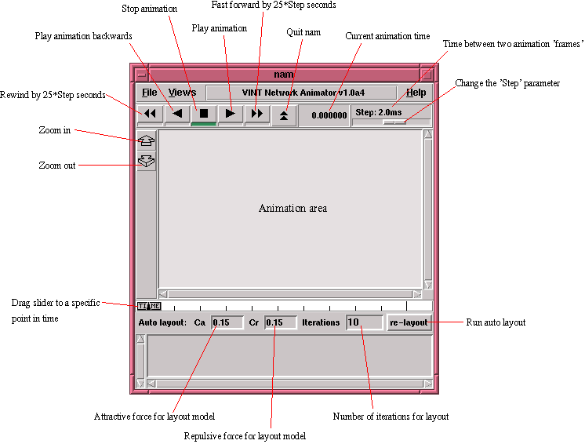
Fig 4. A Sample Animator Screen
The final screenshot of figure 7 shows the layout for a simulation of the PBS protocol having 10 routers in between the sender node 1 and receiver node 12.

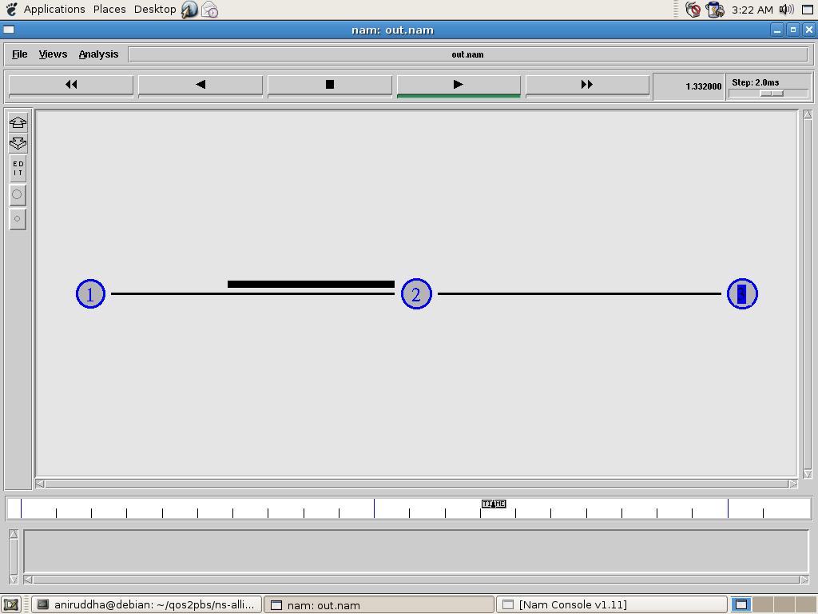

Fig 5. PBS Query message from node 1 to node 2

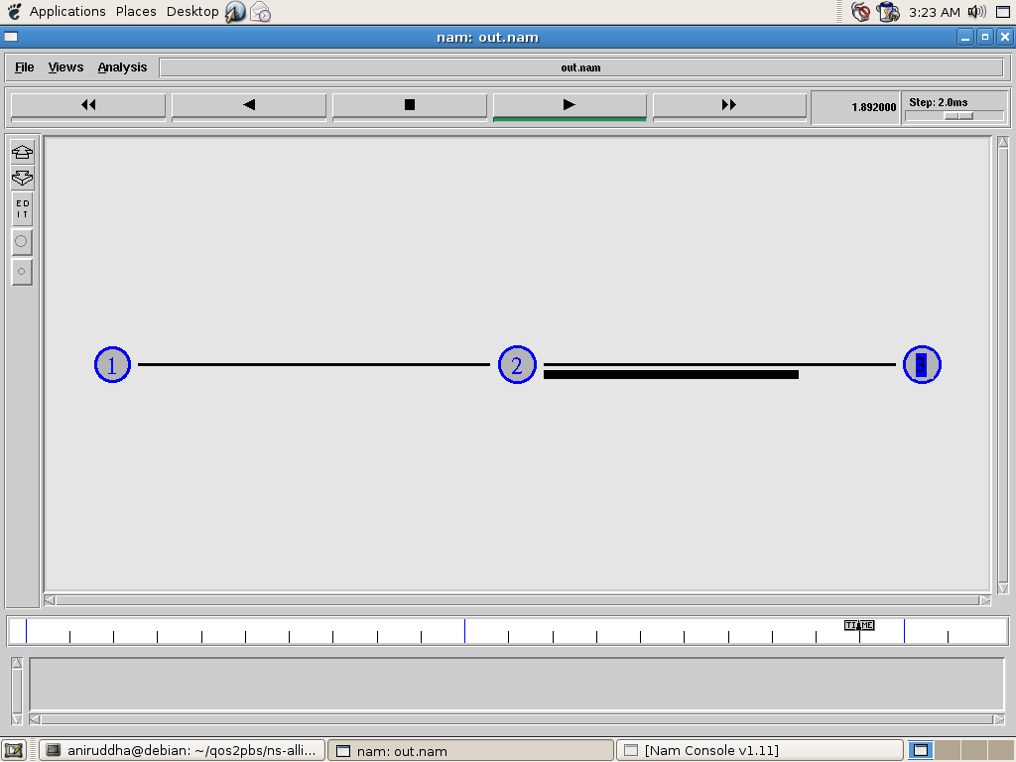

Fig 6. PBS Permission message from node 3 to node 2

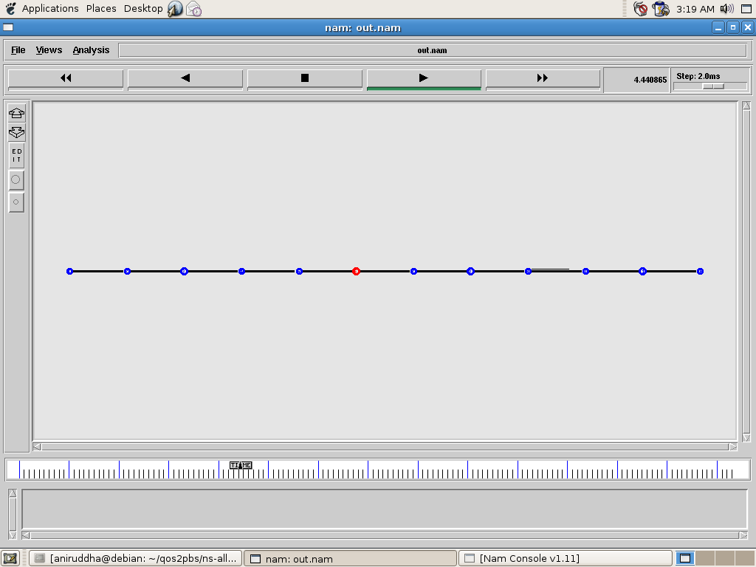

Fig 7. Scenario with 10 routers between sender and receiver
For the PBS NSLP, some sample animator screenshots are presented below. Firstly, the screenshots for the simplest simulation with one sender, router and receiver is shown. A PBS query message going from node 1 to node 2 is shown in the first screenshot in figure 5. In the next screenshot shown in figure 6, the PBS permission message from node 3 being sent to node 2 is shown.

REFERENCES
- R. Hancock, G. Karagiannis, J. Loughley, S. Van den Bosch; Next Steps in Signaling (NSIS): Framework; RFC 4080. June 2005.
- H. Schulzrinne, R. Hancock; GIST: General Internet Signaling Protocol, Internet Draft; June 2008.
- S. Hong, H. Schulzrinne; PBS NSLP: Network Traffic Authorization, Internet Draft; Oct 2008.
- The Network Simulator 2 (ns-2) Manual, http://isi.edu/nsnam/ns/ns-documentation.html
- Yu Ke, Zhang Lin, Fang Xinqiu, Liao Peizhan, Li Xin, Wang Binbin, Yu Taoran, Zhou Chonglv, Wen Xinghua; Communication Network Lab of BUPT SIE, China; Feb 2007

