Interest-based Music Sharing Application on Android Platform

Siqi Yan Suman Srinivasan Henning Schulzrinne
Columbia University Columbia University Columbia University
1214 Amsterdam Avenue 1214 Amsterdam Avenue 1214 Amsterdam Avenue
New York, USA 10027 New York, USA 10027 New York, USA 10027
sy2349@columbia.edu sumans@columbia.edu hgs@cs.columbia.edu

ABSTRACT
With android system taking off during the last three years and more android devices entering the market, people began to realize the lack of a sophisticated music sharing solution on Android platform. We developed this application to help people easily share music with friends and expand music library on their android devices, user can add friends using their facebook account and share music with friends in three different ways.
1. INTRODUCTION
Since its initial release on October 2008, Android mobile operating system is getting more popularity every day. In second and third quarter of 2010 Android system has claim number one market share in all smartphones sold in the U.S. With more and more people start to use Android smartphones and tablets, they need an application to let them easily share music with their friends, so that they can expand their music library, our music share application does just that. With built in facebook connectivity, users can easily add friends to their friends list; equipped with three different music sharing functionalities, the application let users easily share with just a few clicks; and the powerful interest-based sharing functionality allow users to get their favorite songs without explicitly knowing what they want.
2. RELATED WORK
The original idea and functional scope of this application came from the earlier work of [5], the iShare application that provides an interest-based music sharing solution on iOS operating system. Our application expand the functionalities of iShare on Facebook connectivity, new sharing functions including push and pull, and new interest extraction procedure that takes artist and album into account. Also the architecture of our file sharing function is extended from the earlier work of [4], which provides us insight about TCP/IP socket programming.
3. SYSTEM IMPLEMENTATION
In this Chapter we will introduce how we implement the music-share system. First we shall briefly go through the UI design and explain the functionalities associated with each UI elements; then we will iteratively examine the design patterns and underlying technologies for each section of the system.
3.1 System UI Overview
As can be seen from the screenshots, we use tab views to organize the main interface of the application. There are four tabs under the tab view: Share tab, which contains the main sharing functionalities; Music tab, which lists all songs currently in the music library; Friends tab, which lists all the friends of the user and their IP addresses; and finally Facebook tab, which allows user to log in to their facebook account and publish their current IP to the music share group, and update their friends’ IP address.
3.2 Friends list management
In this application we use both Facebook tab and Friends tab to manage user’s friends list. There are two ways to add a new friend to the friends list: automatically and manually. This section will cover both approaches in detail.
3.2.1 Automatically discover friends
The most convenient way to add new friends to the friends list is automatically adding friend. This functionality is achieved by using the Facebook Android SDK, allowing user to sign in to their facebook account and retrieve friends’ information from the facebook event.
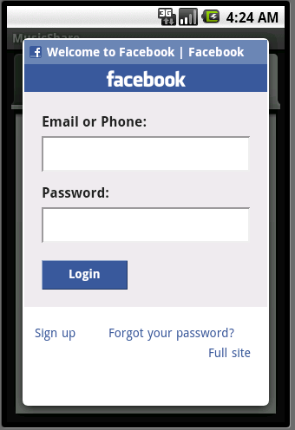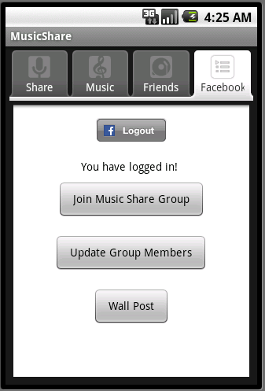
Figure 1: (a) Facebook login interface; (b)Facebook friends discovery interface

Specifically, we user OAuth 2.0 for login authentication, and use Facebook Graph API and old REST API to register event and extract other users’ information. User can also do wall post on this page.
3.2.2 Manually add friend
Another way of adding new friends to the friends list is to do it manually.
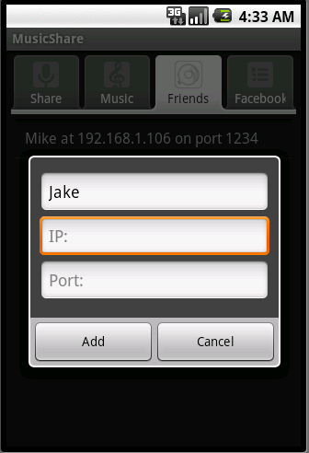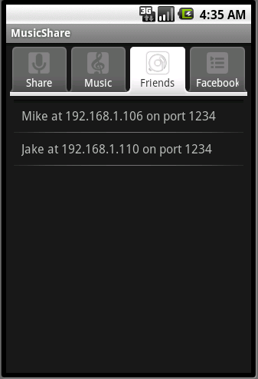
Figure 2: (a)Manually add friends interface; (b)Friends list

Specifically, user can navigate to the friends tab, press menu, and select "Add" function, then system will prompt user to provide friend name, IP address and port information.
3.3 Music interest definition
One of the most powerful functionalities of our system is interest-based music sharing, and it is achieved by first determine current user's music interest. We take three factors into account when calculating interest: Artist, Album and Genre.
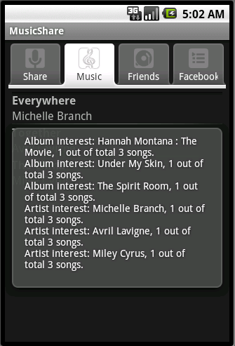
Figure 3. Music interest extraction

We use managed cursor of the external content provider to retrieve song information, including artist, album and genre, and based on the percentage and absolute number of each attribute, decide the music interest of current user and use it for interest-based sharing.
3.4 Music sharing functionalities
In this section we will be covering three music sharing techniques supported by our application: push, pull, and interest-based sharing. Each of these functionalities has its particular advantages and together provides the user powerful and flexible solution to share music with their friends.
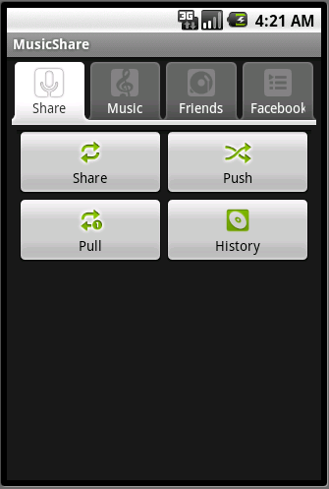
Figure 4. Sharing functions interface
3.4.1 Push music
One of the functions for user to share music with each other is the push function. Push is the most controllable sharing function provided by our system, since it allow user to select both songs to share and one particular friend to share songs with, so that user can determine the details of the sharing process.
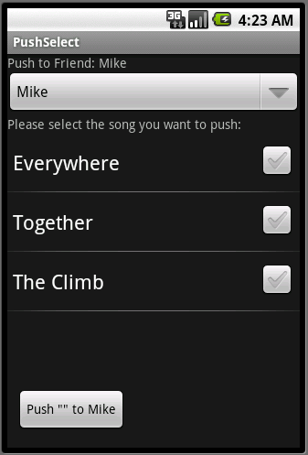
Figure 5. Push music interface

As seen in figure 5, use need to select target friend and songs to share, and click the push button. System will first send song list to the friend and get back the songs the friend doesn’t have yet in order to eliminate duplicates. After that the parties will begin the iterative file transferring process.
3.4.2 Pull music
Another way for user to share music is to use the pull function. Pull function is the most flexible sharing function in our system. User can input anything: song name, artist name, or music genre, and click pull, then the application will automatically iterate through the current friends list and issue request to retrieve relevant songs.
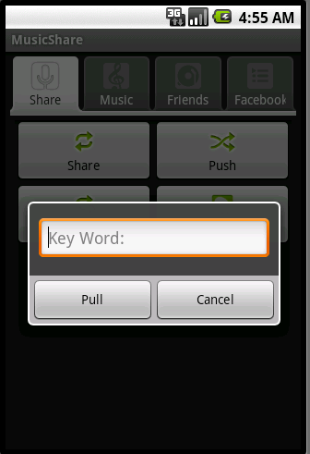
Figure 6. Pull music interface
3.4.3 Interest-based sharing of music
The most amazing feature of our application is interest-based music sharing function. It is also the most powerful sharing function since users can get the music they like without knowing any details about which songs to retrieve or how it works, all they need is one single click.

After the user selects a friend, the application will first send the current user’s music interests to his/her friend, and then get back the friend’s interests. Then applications will prepare a list of songs that both match the common interest and don’t exist in each other’s music library, and send it to the other party.
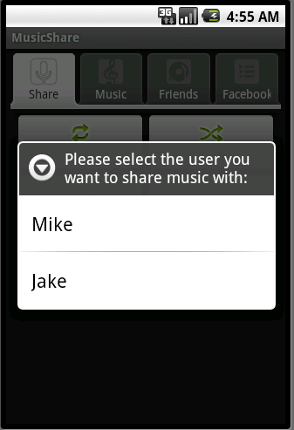
Figure 7. Interest-based Sharing interface
4. RESULTS
We have successfully test our application on Android 1.6, 2.1 and 2.2 devices. User need to have an existing Facebook account in order to login and use the automatically add friends function, and in order for the application to recognize a song for interest extraction it has to include artist and album information.
5. CONCLUSIONS AND FUTURE WORK
Our application provides a simple but powerful solution for android user to quickly find friends, and share music with them in various ways. One problem we still have to deal with is the work around the NAT that’s been widely deployed now days, since our current system can only work with global internet address. Another aspect in which we can significantly enhance the application is to add the multicast auto discovery functionality, so that user can automatically find each other under local opportunistic network.
6. ACKNOWLEDGEMENT
We are thankful for the Internet Real-Time Lab (IRT) providing the testing Android devices.
REFERENCES
[1] Facebook Android SDK https://github.com/facebook/facebook-android-sdk
[2] Android Developer’s Website http://developer.android.com/guide/index.html
[3] Facebook Graph API http://developers.facebook.com/docs/reference/api/
[4]. Ming Ge, Suman Srinivasan, Henning Schulzrinne. FileXChange: Drag-and-Drop File Sharing in Opportunistic Networks. ACM HotMobile 2010, February 1, 2010.
[5]. Xuekun Fu, Arezu Moghadam, Henning Schulzrinne. Interest-aware based Music Sharing in Opportunistic Networks. Unpublished report.
[6]. Android API reference http://developer.android.com/reference/packages.html
[7]. "Android DACP Remote Control"
http://dacp.jsharkey.org/.

