Query Times
- Query times grow exponentially in relation to number of polygons in database
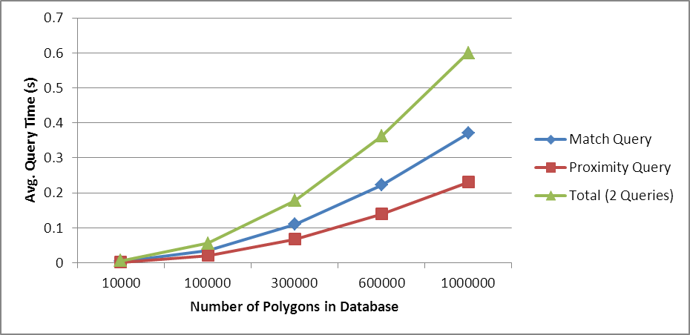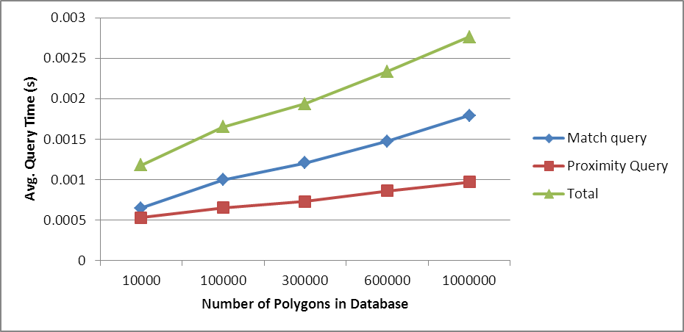
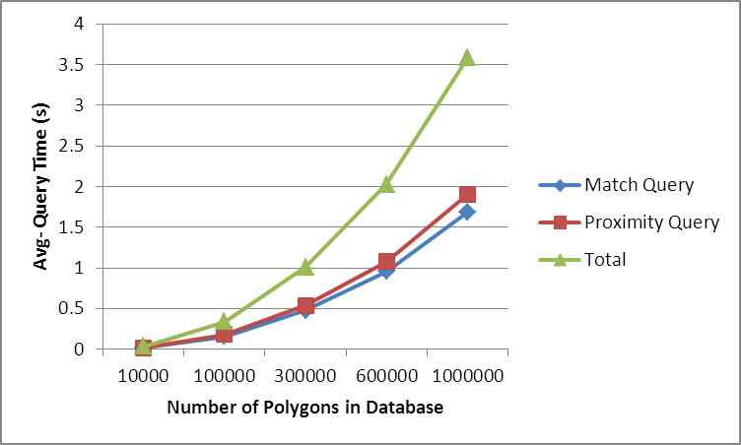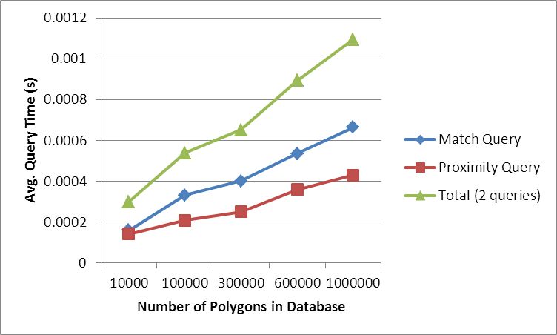
Figure 1. PostgreSQL non-indexed (upper left) and indexed (upper right) and MySQL non-indexed (lower left) and indexed (lower right) database query times with polygons of 8 edges
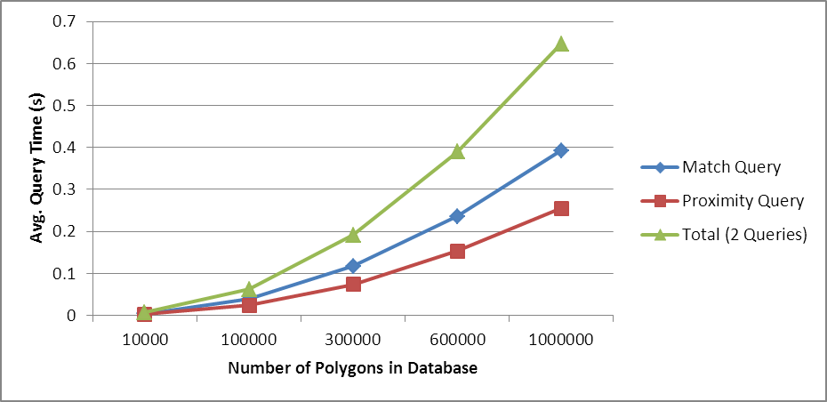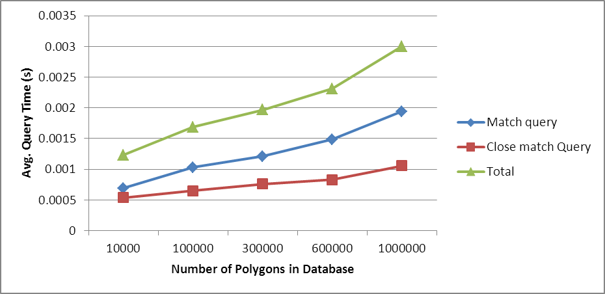
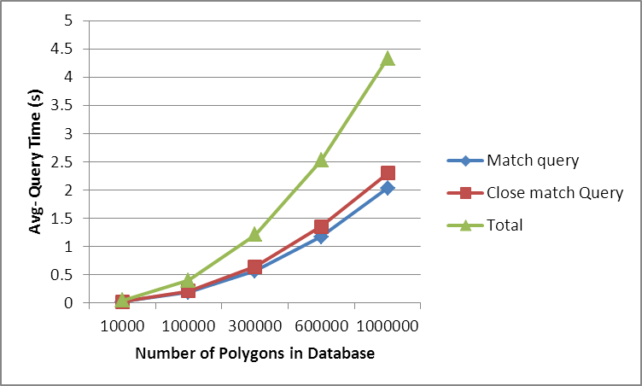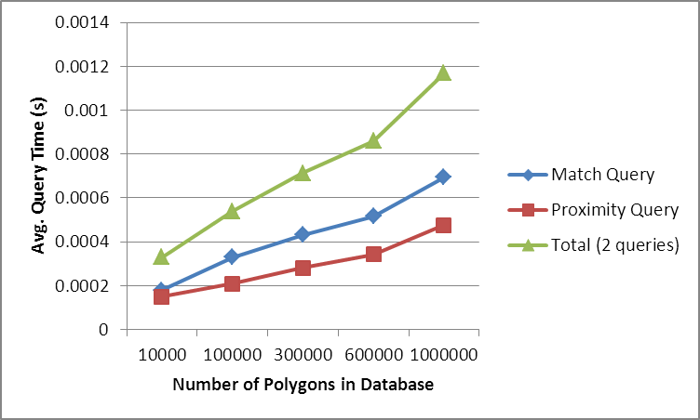
Figure 2 PostgreSQL non-indexed (upper left) and indexed (upper right) and MySQL non-indexed (lower left) and indexed (lower right) database query times with polygons of 13 edges

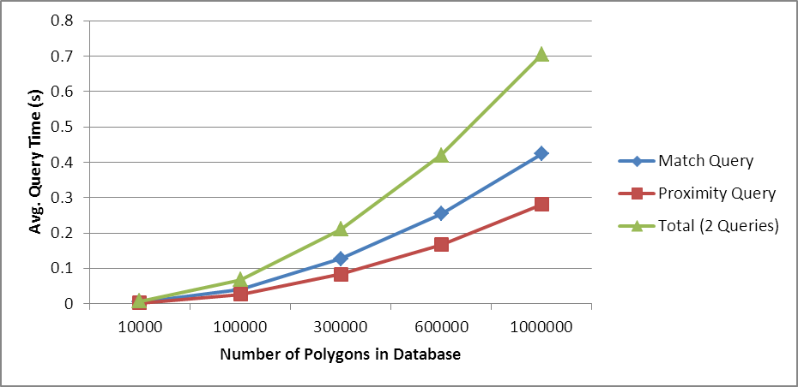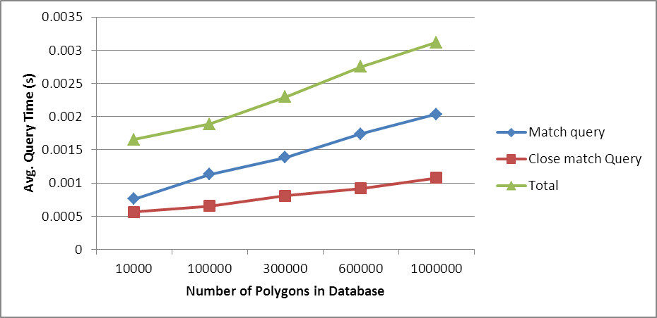
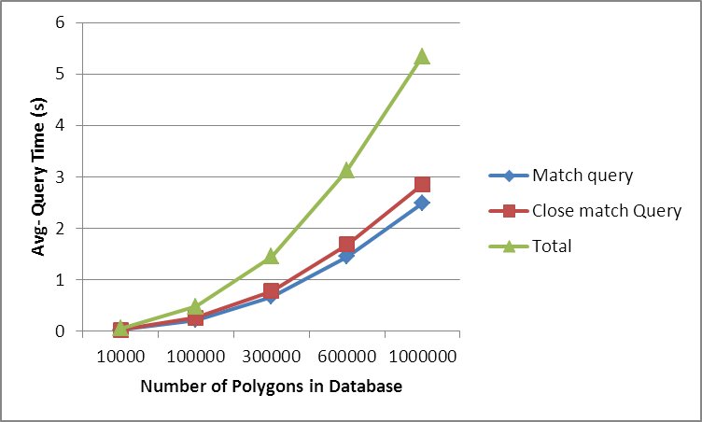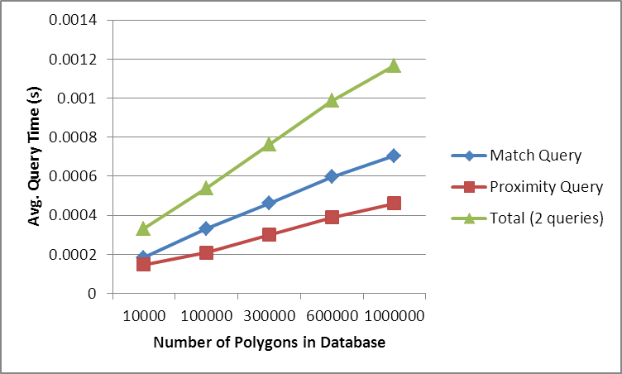
Figure 3. PostgreSQL non-indexed (upper left) and indexed (upper right) and MySQL non-indexed (lower left) and indexed (lower right) database query times with polygons of 20 edges
- With indexed MySQL, 20 edges polygons, and 1M polygons in the database the average query time increases significantly. Rerun is needed to see if this behavior re-occurs.

Polygon Size vs. Query Time
- Number of edges in polygons slightly affect the query times
  - With indexed postgreSQL, query time rises about 20% when the edge amount increases from 8 to 20
  - With MySQL the query times increase by about 10% with 300k polygons and up when comparing 8-edge and 20-edge polygons
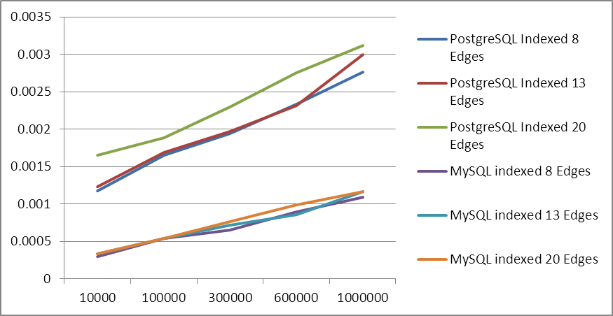
Figure 4. Impact of number of polygon edges on query time in indexed databases

Query Load
- Gives the upper bounds as the measured query time indicates only the delay of executing the queries, not the time taken by the data processing in the server. Persistent database connection is used.
- The load saturates with four simultaneous processes that are constantly executing the queries (both polygons including the location point and polygons near that)
- Measurement runs lasted 30 seconds and a query per hour gauge was calculated from that. Would queries/minute make more sense? All polygons are with 20 edges.
- In MySQL indexing improves the performance by more than 200 000% attaining 24 million queries per hour with 300k polygons in the database.
- In PostgreSQL the performance difference between indexed and non-indexed is not that big than with MySQL but is in the order or 14000%.
- Indexed MySQL performs significantly better than PostgreSQL by providing, for example, with 300k polygons 16M more queries per hour. However, the near match query is not executed exactly the same way with PostgreSQL and MySQL, but this does not explain the difference. Near match (distance within) query takes less time in PostgreSQL than the exact match query (point within the polygon). The exact match query solely takes about three-fold time with PostgreSQL when compared to MySQL.
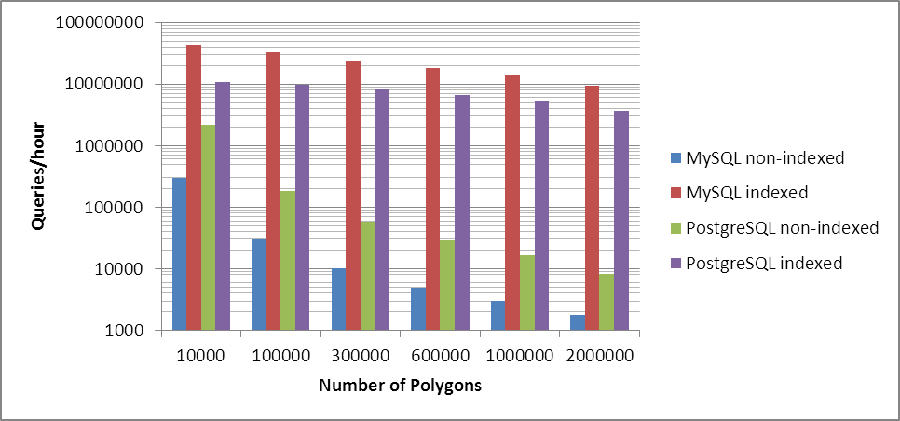
Figure 5. Query load.
- According to http://www.ctia.org/consumer_info/index.cfm/AID/10323 there was 331.6M wireless subscriber connections at the end of 2011 in the USA. If expected that they all were connected simultaneously, this would mean that each subscriber can make 73 queries per hour when using indexed MySQL and a database with 300k polygons. Of course, the usage should not be restricted only to subscriber usage. One additional scenario could be the use of coverage area database for cognitive radio purposes also. This would allow, for example, base stations to query for coverage areas of particular frequency bands near its location for possible short-time frequency borrowing or white-space usage to improve the frequency usage.

Enhancing the Query Time through Regional Optimization
- Dividing the geographical area (e.g. country) in smaller areas (e.g states and counties in the USA)
- Three types of optimization are measured (USA used as an example):
  - Instead of database table including only “CELL_POLY POLYGON” the database table includes “STATE_POLY POLYGON”, “COUNTY_POLY POLYGON”, and “CELL_POLY POLYGON”.
    - According to measurements the query seems to incur the execution of all three conditions although the state or county wouldn’t match -> performs worse than by querying only cell polygon, except with indexed PostgreSQL where it brings minor gains (3% with 1M polygons).
  - Database contains a table including state border polygons and a table for each state containing only the cell polygons within this state
    - Queries from two tables
    - Query for state (50 polygons) -> Query for cells in this state (300k polygons go to 6000 polygon, 600k polygons to 12 000 polygons, and 1M polygons to 20000 polygons when assuming that cells are distributed equally among the states)
  - There is one table for states, one table for each state including the polygons of county borders, and each county has its own table including the cell polygons
    - Queries from three tables
    - For instance in New York, there is 62 counties. In the measurements it’s assumed that the county of New York would include 1000 cells. This makes table sizes of 50, 62, and 1000 polygons for state, county, and cells, respectively.
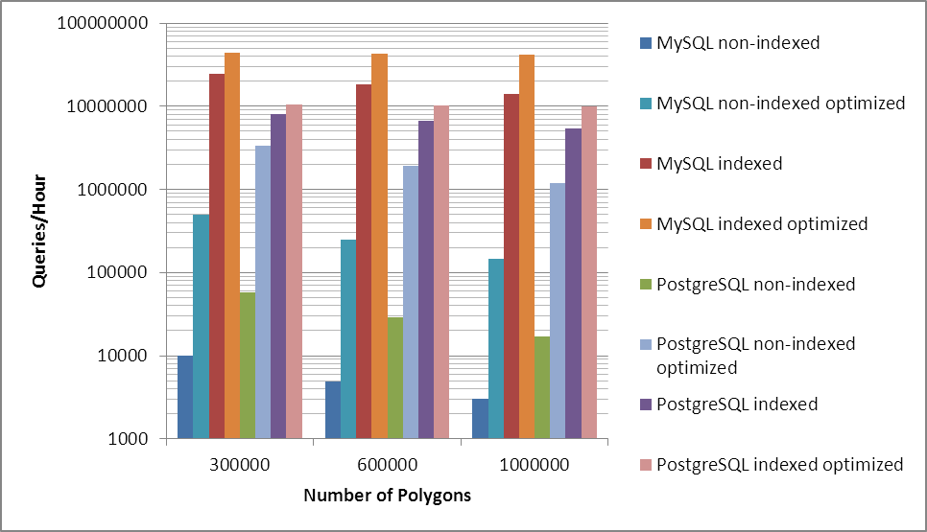
Figure 6. Comparison of one table database to regional optimization based on state division.
- The gains with non-indexed databases are significant. For example, in MySQL the performance increases by 4900% already with 300k polygons.
- With indexed MySQL the gain is 100%-400% with 300k-1M polygons

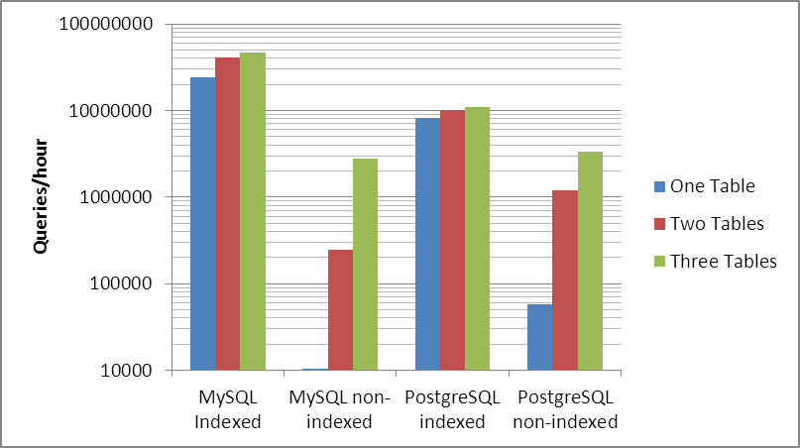
Figure 7. Comparison of one table database (300K polygons) with regional optimization of state division (two tables) and state and county division (three tables).
- By dividing cells also in counties performs even better than in states only, although there is one database query more (four queries in total including state query, county query, within query and near within query)
- These measurement use 300k 20-edged polygons in the database as comparison
- Again, with non-indexed databases the performance gains improve clearly the best but stay far behind from the performances of indexed databases
- With indexed MySQL the performance improvement compared to one table database is 195%. With two tables the gain is 183%.
  - E.g. with indexed MySQL query for state takes 0.00016s, query for county 0.000121 and query for 1000 base stations 0.00042s, which is 0.000658s in total. Querying for a cell from a table including 300k polygons takes on average 0.000762 s. The difference in measured average query times is 15%, but using multicore processor and several processes constantly executing queries makes the difference. Moreover, those small delays cannot be measured very accurately in Linux with a gettimeofday function call.
- With indexed PostgreSQL the gains of regional optimization are more than 100% as well, 130% and 135% with two and three tables, respectively
- Indexed MySQL performs over 400% better than indexed PostgreSQL attaining query load of 47M queries/hour with the three table optimization scheme

